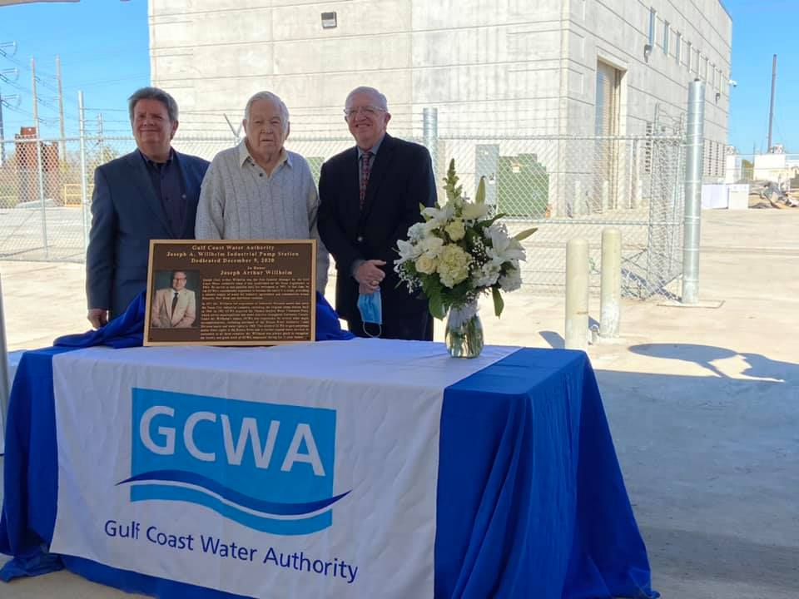
CAPTION: Brandon Wade, current general manager (left) with GCWA’s first general manager Joseph A. Willhelm (middle) and Ivan Langford (right) at the dedication of the authority’s new industrial pump station in Texas City

Gulf Coast Water Authority
3630 FM 1765
Texas City, TX 77590
(409) 935-2438
Representatives
Brandon Wade, General Manager

The Gulf Coast Water Authority (GCWA) has dedicated its new $19 million Industrial Pump Station in honor of its first general manager, Joseph A. (Joe) Willhelm.

“Mr. Willhelm spearheaded GCWA’s considerable expansion to become the wholesale water utility it is today, providing a reliable supply of water to industries, communities and agriculture across Brazoria, Fort Bend and Galveston counties,” GCWA Board President Russell C. Jones said at the Dec. 9 dedication ceremony.

The new Joseph A. Willhelm Industrial Pump Station provides water to major refining and petrochemical industries in Texas City. The single largest capital investment by the water authority in decades, this new pump station expands pumping capacity by almost 25 percent, ensuring long-term reliability and the capacity to accommodate future industrial growth. It replaces the original pump station built in 1949.

Willhelm was general manager when the water authority was established by the Texas Legislature in 1965. He led acquisition of Industrial Division assets in 1971 and of the Thomas Mackey Water Treatment Plant in 1981.

Brandon Wade, GCWA general manager and chief executive officer, said, “Today GCWA enjoys perpetual senior water rights from the Brazos River because Mr. Willhelm led the purchase of Brazos River Authority water rights and Canal Division assets in 1988. This allowed GCWA to further expand its services to customers in all three counties and to acquire a second office in Alvin, now home to our Canal Division.”

In his remarks, Willhelm, who retired in 1995, spoke of the dedication of GCWA employees to ensure reliable water delivery to their customers and of how much he enjoyed his years at the water authority.

GCWA maintains an extensive system of canals, pump stations, pipelines, reservoirs and a water treatment plant to deliver up to 200 million gallons of water a day from the Brazos River Basin to its customers. Read more at www.gulfcoastwaterauthoritytx.gov.

