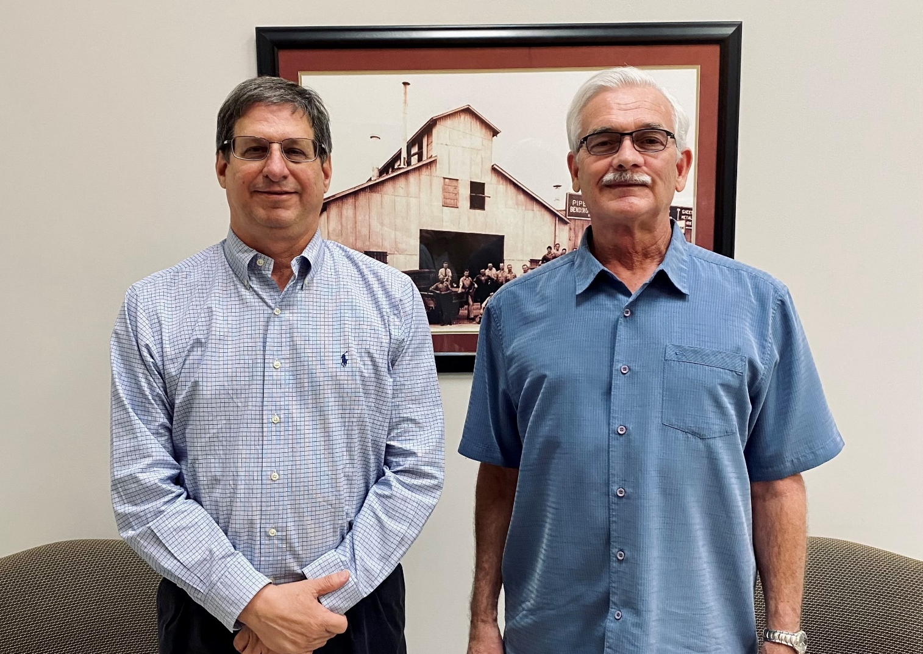

Richard Farmer - Co-President
Robert Farmer - Co-President

Farmers Copper Ltd.
9900 Emmett F Lowry Expressway
Texas City, TX 77591
(409) 765-9003
dfarmer@farmers-copper.com
Representatives-
Richard Farmer
Robert Farmer

Tell us about what your company does and its background. Farmers Copper is a family owned, stocking distributor and metals service center. In 1920, brothers Les Farmer Sr. and Sidney Farmer Sr. came to the U.S. from England. Starting with the Farmers Marine Copper Works, their love and dedication for the business has been passed down through four generations.
How has your business succeeded in the Texas City-La Marque region? Farmers Copper Ltd. is one of the oldest family-operated metal service centers in the U.S. In addition to its headquarters in Texas City, Texas, the company also has a branch warehouse in San Antonio.
What are some of your proudest accomplishments? Some of our proudest accomplishments are that we continue to service the United Sates Navy and fortune 500 companies, but we also help out our local machine and fabrication shops in the Galveston and Houston area. We live by our motto: “Truth, Quality and Service.”
What are you working on now?
Right now we are working on expanding our company though social media, launching a new website and adjusting to the new normal.

