HCA Houston Healthcare Mainland
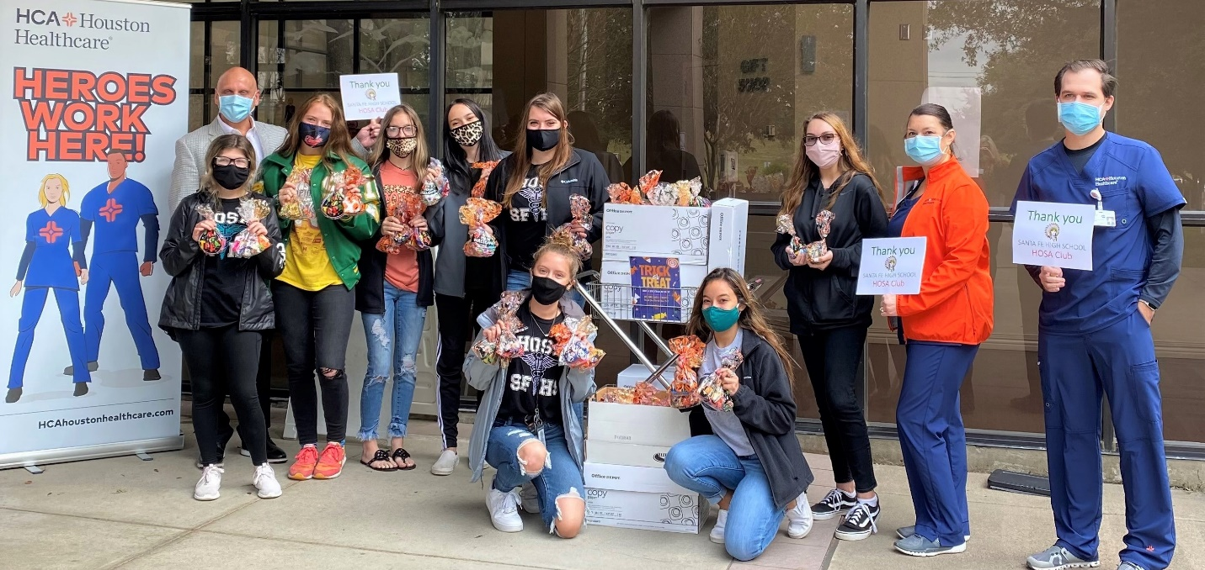
6801 Emmett F. Lowry Expy.
Texas City, TX 77591
HCAhoustonhealthcare.com/mainland

Representative
Jim Russell, FACHE RN
Chief Executive Officer

Stepping into a brand new role as Chief Executive Officer of a community hospital, at the start of a growing pandemic, would not be considered by most people as an ideal opportunity. For Jim Russell, CEO at HCA Houston Healthcare Mainland, it was a challenge he’d been preparing for all his life.
“The timing of my transition from Chief Operating Officer at HCA Houston Healthcare Clear Lake to CEO at HCA Houston Mainland, had been planned far in advance of the COVID-19 outbreak,” Jim explains. He assumed his CEO position on March 16, 2020. “Even with the complications the virus would bring to my new role, I knew I was up for the challenge. The process-based work experience I gained during my career at Boeing has proven to be a valuable asset as we began, and continue, to navigate the demands of the COVID patient surge.”
In addition to his engineering experience, Jim has a Bachelor of Science degree in nursing, and has several years of clinical experience. He was previously an OR director, where he gained experience applying Boeing strategies to create efficiencies to improve patient care.
“In my previous nursing roles, I got to take care of people. And now, as an administrator, I’m fortunate to take care of the people who take care of people,” Jim shares. He still maintains his nursing license, and had the honor of administering the first COVID vaccine to one of his employees.
Jim lives in Friendswood, with his wife Jenna and their two children – eleven year old Benjamin and Sophie, who is six. He has an older daughter, who is a nurse practitioner, and hopes his youngest children will follow the family healthcare career tradition.
“Sophie and I love to watch Doc McStuffins cartoons together,” he smiles. “I’m hoping this will be the start of her fascination with helping people feel better.”
When he is not busy leading his team of more than 700 healthcare professionals, Jim enjoys watching HGTV. In fact, he admits, he’s addicted. “I am the least handy person you will ever know, but I just love watching other people tackle do-it-yourself projects.”
Luckily for his patients and staff, Jim has many other useful talents.
You can learn more about Jim’s interests and experiences, including riding horses to school in Aubrey, TX, in a short, 3-minute video here.
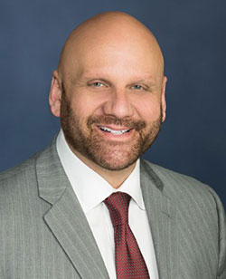
Jim Russell is the chief executive officer at HCA Houston Healthcare Mainland.
As an administrative leader, he oversees physician relations, business development and strategic planning for all areas of the facility.

