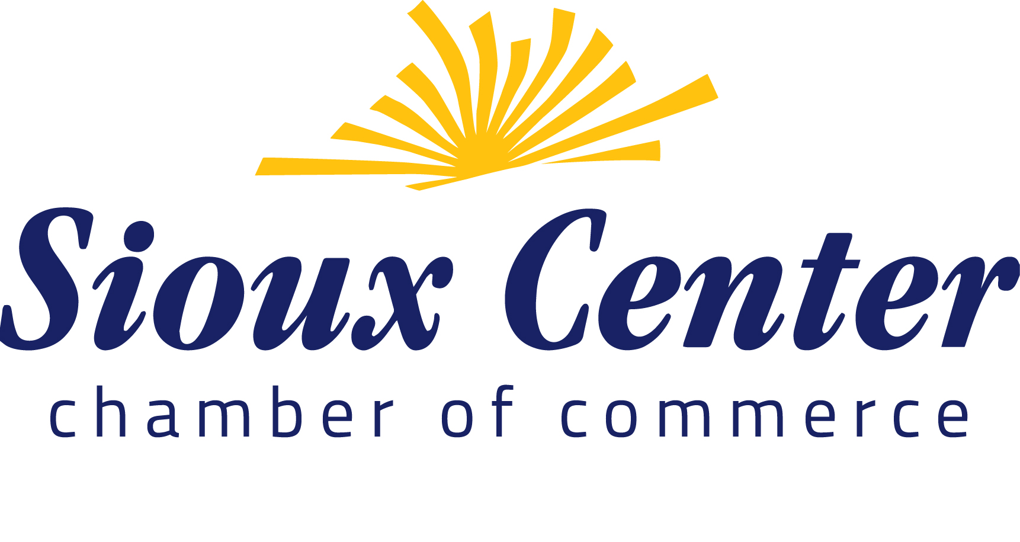
303 North Main ▪ Sioux Center, IA 51250

NEWS RELEASE

For more information contact:

Barbara Den Herder, Chief Executive Officer (712)722-3457 barbdh@siouxcenterchamber.com

March 16, 2020

The 60th Annual Sioux Center Indoor Fair is going Virtual! Due to the recommendations from the Iowa Department of Public Health to refrain from hosting or attending events drawing 50 or more people, the Executive Board of the Chamber and the Indoor Fair Committee have chosen to cancel the upcoming Indoor Fair that was to be held on March 25 and 26. We will instead feature a virtual Indoor Fair event that will highlight each of our amazing vendors and sponsors through social media.

It’s not lost on us the amount of time, effort and work that our vendors have put into preparing their booths for the Indoor Fair, and we want to recognize them for the amazing service they provide to our community. We will do this by highlighting our vendors on our social media platforms so that the public can easily see their product and shop their websites directly. During this time of uncertainty, the Sioux Center Chamber is committed to supporting and promoting our local business.

