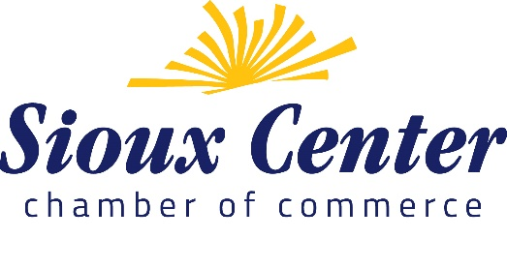
Press Release:
FOR IMMEDIATE RELEASE
April 30, 2020
For more information: Barbara Den Herder, 712-722-3457 barbdh@siouxcenterchamber.com

Sioux Center Chamber Announces $50,000 for Small Business Recovery Fund
SIOUX CENTER, IA – The Sioux Center Chamber of Commerce is pleased to announce the launch of a Small Business Recovery Fund (SBRF) in an immediate response to disaster situations and the challenges they present to small businesses. The Chamber of Commerce works to advance the economic development, vitality and growth of the Sioux Center community. To do this, it is imperative to support small businesses during times of need. This fund will help mitigate financial hardships that Sioux Center small businesses, whether a current Chamber member or not, may experience as a result of a disaster situation.

“This is another wonderful example of Progress through Cooperation that serves our community so well,” said Sioux Center Mayor David Krahling. “Sioux County has recently been recognized as one of the more generous counties in the country, so this sort of generosity is not surprising, but it still thrills me to see the community come together to support those small businesses that are profoundly impacted by this crisis.”

The SBRF provides an opportunity to adapt to evolving needs of small businesses and will provide flexibility to respond to needs that are not being met by existing non-profit, local, state and federal programs. Grants will range between $500-$5000 per qualifying business. Grant eligibility requirements and applications can be found at www.siouxcenterchamber.com. Applications are due at 12:00 p.m. on Monday, May 11, 2020.

With generous donations from numerous Sioux Center businesses already totaling over $50,000, the Chamber is actively working to grow the fund, with a goal to raise over $100,000. If community members and/or other businesses or organizations are interested and able to support small businesses through the fund, they are encouraged to find more information and give online at www.siouxcenterchamber.com.

About the Sioux Center Chamber: The Sioux Center Chamber of Commerce is an independent, 501(c)6 non-profit organization focused on the Sioux Center community. The Sioux Center Chamber is the primary organization in the community working in an organized effort to advance community growth and development. For more information on how to join the Chamber or get involved, please visit www.siouxcenterchamber.com

Other notes:
We've used 7 FTE equivalents as our threshold for large vs. small. 'Large' received $250 more than 'Small' and Members received at least $250 more than non-members.

Note from Grinnell: Even though we've raised about $75K, we made the determination to only distribute $30K the first month and then will have business reapply and/or try to more 'fully fund' their initial requests. We had originally planned to distribute more initially; however, as everything started being drawn out further we decided it was necessary to offer grants in multiple months rather than depleting funds in the first month.

