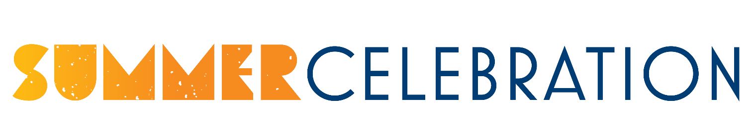
January 26, 2023
Dear Sioux Center Business/Organization,

We are excited to announce that our Steering Committee has started planning for the annual Summer Celebration event to be held on June 1-3, 2023. This event has been successful due in large part to the generous support of our sponsors!

This year will include many traditional favorites including the free Community Cook-Out, cruise night, children’s activities in the park, car show, parade, Gear Up for Summer Bike Ride, FREE street dance featuring local favorite The Ruralists and IV Play. And new this year, a Mega Trampoline Jump Show! This will be a fun-filled weekend!

One of the things that makes our Summer Celebration unique is that we keep this event FREE to families so everyone can take part in enjoying the festivities, and this year will be no exception. And this is where we need your help. We know that these events will attract visitors, alumni, and past residents to our community. Your support will not only help our event, but the recognition you would receive from being a sponsor would demonstrate your community spirit. All sponsors will be recognized at their level of sponsorship on social media, on table tents placed around the community, brochures, and in a thank-you advertisement in area newspapers.

Thank you for your continued support of Sioux Center and Summer Celebration! We look forward to hearing from you!

The Summer Celebration Committee
_ _ _ _ _ _ _ _ _ _ __ _ _ _ _ _ _ _ _ __ _ _ _ _ _ _ _ _ __ _ _ _ _ _ _ _ _ __ _ _ _ _ _ _ _ _ _ _ _
Please select one:

_____ DIAMOND SPONSOR ($2000 or more) of Summer Celebration
Logo included on all print advertising at the Diamond Level
_____ PLATINUM SPONSOR ($1000 to $1999) of Summer Celebration
Business name included on all print advertising at the Platinum Level
_____ GOLD SPONSOR ($500-$999) of the Summer Celebration
Business name included on all print advertising at the Gold Level
_____ SILVER SPONSOR ($300-$499) of the Summer Celebration
Business name included on all print advertising at the Silver Level
_____ BRONZE SPONSOR ($150-$299) of the Summer Celebration
Business name included on all print advertising at the Bronze Level
Please return your commitment by Monday, March 20, 2023. Payment appreciated by May 5, 2023.

Sioux Center Chamber of Commerce
14 3rd Street NW
Sioux Center, IA 51250
Name: ________________________________________________
Company: _____________________________________________

Sponsorship Amount: __________________________________

