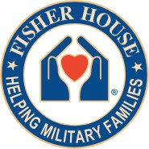
Orlando Fisher House

13800 Veterans Way, Orlando, FL 32827
WISH LIST ITEMS
- Gift Cards:
Most Needed Items

Publix, Walmart, Target, Lowe’s, Home Depot, etc.
- Monetary Donations

Cleaning/Laundry Supplies

- Spray Lysol
- Windex Glass Cleaner
- 409 Multi-purpose cleaner

- Lysol laundry sanitizer
- Weiman Granite Cleaner & Polish

Food & Miscellaneous Items

  - Bottled Water
  - Plastic storage bags (all sizes)
  - Individual snacks (cookies/chips)
  - Gatorade (Lemon Lime)

- Protein bars, Nutri-Grain bars
- Napkins
- Coffee creamer/k-cups
- Canned soups

*Due to health concerns, we do not accept clothing, blankets or used items*

For additional information please contact:
George Denby, Fisher House Manager, George.Denby@va.gov, (407)-631- 9800
Cynthia Phillips-Lewis, Cynthia.Phillips-Lewis@va.gov, (407)-631-9810

Updated 8/17/22

