Line Up Number
1
2
3
4
4
5
6
7
8
9
10
11
12
13
14
15
16
17

18
19
20
21
22
23

24
25
26
27
28
29
30
31
32
33
34
35
36
37
38
39
40

2022 Parade of Lights Line Up

Name of Float
Douglas High School Marching Band and Color guard Sheriff's Office Honor Guard and Mounted Posse Blind Dog Express-O
1928 Chevrolet National Coupe All About Youth Day Float Beach & Sons
Douglas Disposal
DTAppliance Santa's coming to heat your home! Hot Air For Hope
Hot Air for Hope Silent Secret Candy Stripers
Carson Valley Fastpitch 65 years old
Town of Minden
1929 Ford Model A Pickup Truck Big Daddy's Fire Truck Brew Mobile ADVENTURE IN CHAMPIONLAND LES SCHWAB
All About Dance Grand Marshal - RC Team Amigo
Birth of Jesus
Boys & Girls Clubs of Western Nevada Buckaroo's Christmas
stan kolbus
Candy Cane Construction Support Candy Cane Express
Mrs. Clause at the North Pole Carson Valley FFA
Christmas Candy Cane-nines
Town of Gardnerville Christmas on Main Street Cinderella Scholarship Pageant
Cotton Candy Clouds
DAWG's cats and canine Christmas Evolve Plumbing
Douglas County Community & Senior Center Controlled Burn & the Mutant Vehicle Misfits Extreme Life ( Extremes Del Baranco) Washoe Royalty
Gay Straight Alliance

2022 Parade of Lights Line Up
- Give From The Heart
- Grinch and the Elf
- Holiday Inn Club Vacations
- Home with a heart
- Horses with lights
- Illuminations
- Jeep Light of Way
- Keeping it Cool Carson Valley
- Kevin Eggleston
- Light the World
- MARTY'S APPLIANCE
- Maxton
- MORTGAGE MOBILE
- Candy Cane Lane on the Farm
- Peppermint Pal
- Samantha Elayne Tierney
- Perfectly Peppermint Public Pool Party
- Troop 495 BSA
- Santa's Helpers
- Service is SWEET!
- Washoe Tribe of Nevada and California
- Two Stone
- Santa - DCSO

- Jyr,r 'f/')t,
JrT'

,,Carson Valley·
��>' �
Chamber of Commerce

SUPl'OHl IOCAl.•IIUSINf:SS
FIRST

Thanks for signing up for the Parade of LightsI Here is almost all of the information you need for the event. It explains where and when to go for parade staging and what you should do at the end of the parade. Please look over the information carefully and call us If you have any questions. Remember, no throwing of candy and no live Santa Claus figures as part of your participation.

The last piece of information you will receive is your parade number and position, which will be sent to your e-mail no later than December ist.

We look forward to seeing you soon.

26th Annual Parade of Lights, "Candy Cane Christmas" Saturday, December 3, 2022
The following information is provided to facilitate the parade set-up (staging) and completion.

Staging will be On Gilman Avenue near Heritage Park beginning at 3:00 p.m., December 3, 2022. As in past years, we are asking parade floats to get to the staging area via Waterloo Avenue, making a left on to Harvest Avenue, then a left on to Chichester Dr. Follow Chichester to the end and make a left on to Gilman Ave. A map is enclosed. Plan to be In place on Gilman no later than 4:00 p.m.
If you are dropping off participants, be aware that Gilman will be closed at Chichester and at Heritage Park beginning at 4 p.m. You may come in from Hwy 395 on Mission Street to Courthouse Alley to Heritage Park. You can park in the marked spaces there; you can circle the park and use the dirt lot off of Ezell to park. You can also continue past Heritage Park to the parking area at Carson Valley Middle School.
Your Parade numbers should be placed on the vehicle in PLAIN SIGHT on the RIGHT SIDE AND LEFT SIDE to be seen by the judges. (THE JUDGES ARE LOCATED IN FRONT OF THE MUSEUM JUST PAST
HIGH SCHOOL STREET). Judging will be completed as soon as the last entry has passed the judges stand and votes are tallied.
In front of the Museum Is the only chance the Judges have to score your float for our 'Best' category awards. If you want to be judged most accurately, make sure you look and perform your absolute best in front of them at the Museum.

The Chamber of Commerce will present Santa in his sleigh as the grand finale. Please do not have a "live" Santa on your floats not to confuse the children and take away from the excitement of Santa at the end of the parade.

At the direction of the Douglas County Sheriff's Office, tossing candy from the floats Is strictly prohibited. We encourage you to have 'wall<ers' alongside your float handing out candy to the parade spectators.
Please follow the Instructions provided by the parade volunteers along Gilman. This will allow all entries to be in position and ready for the 5:00 pm start time.
All floats and children on floats must be attended at all times. Please ensure all children are aware of the float number and have adult supervision.
Should you arrive late at the staging area, you will be positioned at the end of the parade regardless of your predetermined number.
All entrants must complete the entire route. Do not pull off prior to the end of the parade.
For the parade to be as enjoyable as possible for you and the spectators, it is very important that the spacing between parade entries be consistent. Please stay between 25-35 feet behind the entry in front of you.
Douglas County Sheriff will be posted along and at the end of the route to assist with traffic flow. There is no transportation provided from Minden Park back to Gilman Avenue & Heritage Park. Children riding floats can be picked up at the end of the parade. Please keep children on float and attended until picked up by parent or responsible adult. No pick up at Minden Park. NO STOPPING OR UNLOADING UNTIL FLOAT REACHES THE END OF THE PARADE ROUTE ON MONO PAST 4TH STREET. THIS ALLOWS THE REST OF THE PARADE FLOATS TO COMPLETE THE PARADE ROUTE.
Restrooms will be open at Heritage Park near the staging area. Dress warmly!

Should you have any questions regarding the above feel free to call me at 782-8144, cell phone
775-450-4969 or email me at alicia@carsonvalleynv.org. Thank you for your participation; have a great time and HAPPY HOLIDAYS.
Sincerely,

Alicia A. Main Executive Director
Carson Valley Chamber of Commerce

pocuSlgnEnvolopo ID: A7201062•044U-4BC6·BF0/\•233FBB4li0B3A

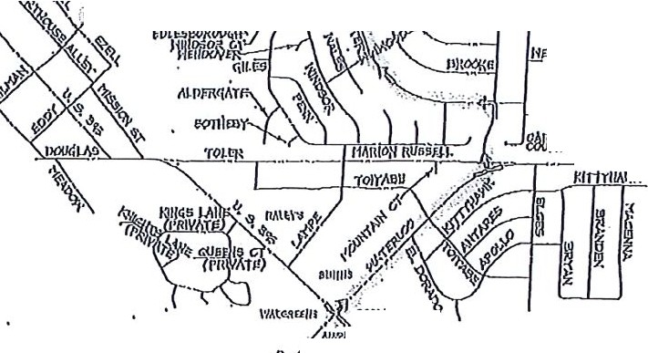
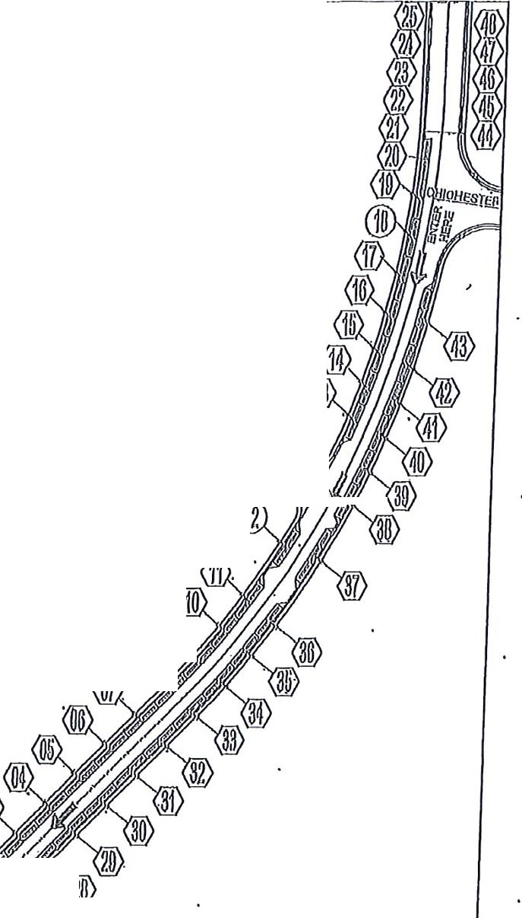
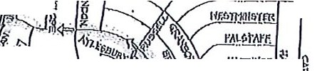
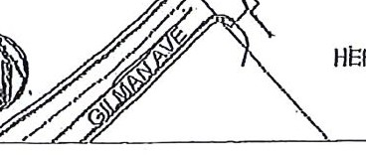
OocuSlgncnvolopo ID: DE030,\03-A2/\B-43F4-0CF.4-4303M600024

( 1,u,,:11, ""'-'\ ·,
ij!
I""'"" l'filt\JL._I_ •..Cl5Ji!I,_
!
'Irv-
,.

iluA•F }fY /\ -
rt ; !
• •• "- - (;J """' "
,,

li,!,lJlVIIY

l)lff '"',l'll

_.,.;,<..
ll<..Ull;• f - ,01MII
1ii:?11''-,
i / -
1,';/1/ - ts-,
r s'ri\GINGAccessRoure.f

li104
0%
·r°<! ,.
PARTICIPANT 7._-,1.,.llflt,
P/\Hl(IN0 ARF.A

lal)!ll .\ l IJO'.n. l;J!!_iil, 'Ali.6!'. 1/.)(•_Hiililaifo'Piul\bc11l11ntnnIl9l
( f.@ lii-lYUoInl (l>Y:Yiay,i:ltWritorto•ii.,
:l-,cil ·pJ1'H !XefsU,Joil!(jil f
Ill

:/\1:lltitf"-10

""'
@(O

PARTICIPANT
('<(' PARl<IN0 AREA •
HERITAC:lf.:PARI{ IS' 02 ":I:'.
NOR'ffl 01 /,1/ • .
Cl 0< "" ) '(23
'!;:' '-PAVl ION ,,, i 27.•
to . J<
PUBLIO 26
<$- RESTROOM /" 'UE01NPARl<IN0
"<i'.<<. · INS'lt\0IN0 AREA
' • ),. - OLOSl::0ILMAN '
\_ . • • \ PRIORTOPARADE_
( • H1'Rl1A :::RI( PARADE OF LIGHTS
soUTH STAGING PLAN

.,
IVIINDEN DOWNTOWN
PARADE OF LIGHTS

. ·-',, • , 1 •. F ..,. ,
OETjA;IL2
- ·:f .., , . ·.

Pl I I.lo'', • •/ • ·II ?1 f. m¥' ,y.; •,.1 ,1 t !•··.-, ...., / • · •'1/
I , A lf fr...:: ./ l tlJpliY Y?JIJp,Ol,lM r . / ,y ;,1If',.....:....- ,;': ·1ti/
1 :1,, ,,, 1/,'!1/
t •, ,,._ ',,, • I }·, "• ,I ,/ •
• , • ')-..'-.., rma b. • \ff' ₁} ; ,·.. ·••i• J) , . 1 ;i.'¥-·

·.I I
,I •
' )'/!i,l,'·•,<. "-;,J.., I..,'• "y'Ktl•'•t4i"l,1Y@, lfi'!n:·1:·<,.I.,,••• /.I•t///I I /
,llil.zlr:

, , I •
I
,,.::r. - -1-.,·-,... : ·{. ',- ·'.ti / , /1 , ·1
- , ' • • ... '"' ,. I •' I , .
I }

I t . • ·, . .' ·\wt•ti I . ..-- :-,_ •:. i.,, I.· ..' 1/ I.
- l'"'/
/,{·I,J₁ pU1·jl·r f...1' .1.//..'.J/,.r·o.r1,,,i,_l- -::,/.0:&i,.. .:. •1 .,. ,, 'f.!'l(iJJ'H:Q s�1��':,·?7.1.'

UIJUlnTO v, ·: :' , It I , ,
1 It • ·•!! • !• 1 I/
, 11
/I^{J}'

• I • • I I,'I1,1
' •···A,,'· \. •. • ,,),..' \, .. • • I,

/ • ·,·/i,•·, .·'..i.l :. ·o'. .'·> <·<....•·.:.:, ftI ,::\, •
I
1
·· - ( ov ij. 11,\:ifi'
I • £. ' I , \\ ' 1 I • l
'• I •I •• •, • ., I, ,•I
''{f/ i

l• ,,I c:t,^{I} .•...• ..•.,:I ·:.,
- ,,'.) .........
O •• I. I
--··,!·!.
,••1• 1•,'.,1.••.·.···., ..,,. I

, J • •• :F:,• • 1' 1 • • • I •'t • • ' , 1
' • .

• CS'. ••, ,•
- .,.., '
  - ' I ,''. "·,
•'/t., / / •
)^{i} :i •111 / /
- /'

( • • , t-.r, ,. .- /i 1 1 • . / ,• '.' • •:• • . r,lj,1 ., ; I
l

..•.• 1 ,. / / _·;/ 1.,;
i , 1,., 1 b.u.
v ,,. '{;/ ·1:1;tir lfY(bj{!t (!:; •'.:. / / .·.; 3/1' : if, i l,)Hl
.
!;7,
I ' , . .. y .• • .
i.- , ;r,.
'fl ._,.
I I. } , , 1,' • :f!i I 1 , 0 h ''., • ,' 'f ,fl 6,0'0
•.. ,· :_.. ( ., • . ,(? • ,{.,. • ., •
'
• I • , * ,'/
,>, •,
• •♦ I ' .•tii'J ' I /l I ., t • / '.' :., '

'• ..'
,-: .il , 1
1
//·-I! -•'
••,I ·(,.7 .j
'i ., I ,• • .r
• • • : I ·, I1·

• : :� ',i ' 1,l ,. V l /,. I· '·' I • .- i····. I I'·{ o·.:-..{1>,.•;,:. · ;
J IiI I ,. •/ . t-,....
••''· , •.I I• • ·,,.-•1' ,.'1"··• I'I ' ·
l::s; . I I / ·, - . I .I '/·
i ,I I• . ,·., 'f,..• ).'< ' .
;"/{.
.'.', ::-,.. . .• /'·
, .

,}•·/r ,',•, ••,,/• , /t/i•'/'.;. '/' • •i•
11
• • • • I / • I. >',. •. i •. l . . . . ' ' / ' I ' • . ,,
·}: <••.:••,./4• J�·,•:,•1•"
./0•,·,.•. •/··.
••1. •/1•I' , I ,/1•/•a,,, /

' •' l·' •.'-:
:' -·,'• •• ,·.' I ,/·,t':ti>,) .'.. '••¹ I' • ' • i '· ··•.·· / '
I'.' -..>.-. ; .

:111/.'1 l ·•.. - • l.1,i.1...I...;M_{)./..:.,r··,JI·I
•,,,\ •1· •I 1 .,...
/7. ··9--··"►· 1//,/ !' • ./,

.' .' '.. •
) •
&II
1
- i
f,--...•.•:�1'
l • • :'•/I
• l :- IJ: ..,/1-'·1:•1

·.:'··••/. .·•/.l / j :i_, .. • '.,_
,..:-. 1 .
•. • 1 • ••. • , - ron6 , .1' , .,;,... ,
.') '.:·_worukrt
·/.
•\ 1 • // ·g·\ P.j,i·., ,.:l;'li { •.
.•.·:

,f•l·•)•..,.. I ,
i • • •
·.,¹··. ./· ! I
J,"• .,.. i... . .,f
Itl ."•"P.{i .t :,,·••.. .I
t'f
... I
.0, :!:.'
. ., .:

• 1•.• •'•, = , •
'• i
·,. ••f } •
,•. '..#,-. 1 ·... ,•,,,· · · \
t.. .,1/,
t·.
·, • .

/••, . t<·,. I ' .-;..,.!, • I·' '• • :11 • ·I It: tf ·,; "'t,.. . ' ' ;(,'</1. 11 l '
. ' ' ,/ • \ '•' . . .. , ., ' . .. .. ' ' ,,,,.
.'( ' ..
i (_. / •·-ir,.:.:--.₁ ··i • ., /If:' .t..•••. ' .1• ;t, .'.'.· ;, /y:,· \:·•.. . i'i,7.·. rt{}Q hi1.efi 1,
' ·' '• '• •., • ' • •
1 • I I C\.,,1_ ':!.. " ,. ·:·) 1•
.,••• .,•• /'·•• ;: ./1 \( 1•'1 ...,,· l ''. •'') ' I / 1/:·t l / I• ·:;\ .I( II ' •,:!J·/ .
• ,l ·,, 'i\ \' l:.0:0·· I .• f· !II :, '•, •• .I I l. •·11 /2�'·:·,... / ..,I
• '·I •,: \ I/ ... I, ! •, I . ' ., .\ • •• •
!
·I I .I . . ,. ,'/ ·i .,

' :.
\ ,J
I I' I
I f'
- ( ;I
.I ·, ,/
G o;n!
'.. I :I ,•·I,,,' •, ,·, ·,, ·..'' · l

... • ' ii . . •.
1' '/ I

- EGl:NO

-PARADEROUTE
EVEN NUMBERED FLOAT BIDER DROPOFF
-ODDNUMBERED FLOATRIDER QROPPFF
- FLOAT RETURN ROUTE
Dnlo:11/20/20'10 Aulhor:LACOSTPrqJool: PARAOEOF LIGHTS
A ..A. Commonto:
A
v'\ iri: ""; MINDEN DOWNTOWN
n ROUTl:AND TRAEFICPLAN

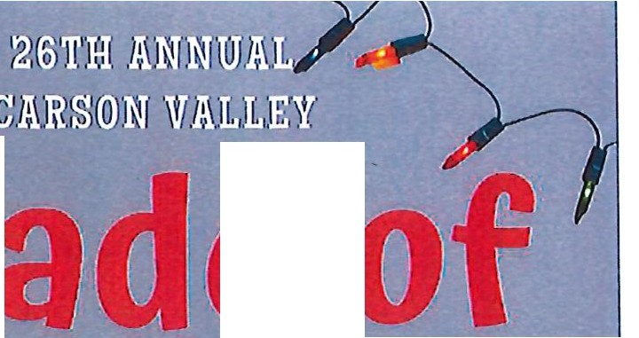
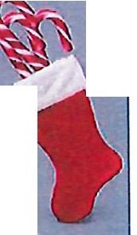
  - I • ,,
·r·.·,,··j
.
.i'
- 1
·'
,. ; I '··"·..-
is ..
-
·-
-
- -
e
!
'
'
; i ' I
' I I I •• '
    - • f ' t 'l. . l I .' l ,.

Satu;day·:_u .,e 3 d,'2 22a S,::10:pm
m,vrE··,·rn.1tl•E·'l'/f·E•, -rn· R·.'ffl-Mii'7Cf 'O'I[' K.R••·
�:&, .1 ,V•,fl. : J.Wll• t Ji..A�f,;11 ; : .fl"l1f!:}; ·1•,!il.·A'- · ~a9
PIR:tDiE 0.•F:1:,,1 · -1tS,!1IIS
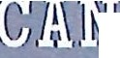
)
- - ---
fil]

'ii
Gr-a11111d' \M1a1.r.s1fJia1I

Join you .famil ·and lrieAds, gF,a'b, eur lllam1ke,tsiand oln1airs to watch tt,e Fleats.,.Marcl!llng Bin11ds;.Col'or-1G:uard and ot course our spe ia·I!G:we·st fre·m,tfle,No., h P·O'le f1make thei1r. way along High,p1ay 3.95 firom,Eddy St1:eet 4teIMinde11P1.ark
001/\I(O,I(IO JI I ( a

e rfR =s-=-=-= pOOiSOrS
■

(Accolades Trophies(
Ji. B11i;ra,·l11i; & <ar1s Ji.

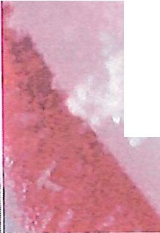

Chamber of Commerce
CARS LLEY •••.
- NevAoA • •
lllbti.tr.. .
0
4"'L. 0
•

GIFT SUGGESTIONS FOR PROJECT SANTA CLAUS TOY BOX
MOST REQUESTED | - LED LIGHTS  - LOL DOLL
LEGOS | - REGULAR SIZE  - DUPLO SIZE {FOR LITTLE KIDS)
GAMES FOR LITTLE KIDS | - MOUSETRAP  - OPERATION  - CONNECT 4  - SORRY  - KERPLUNK  Project Santa Claus already has a large supply of Candyland and Chutes and ladders games
'IGAMES FOR CHILDREN 8 | - MONOPOLY
AND OVER | - LIFE
 | - MINECRAFT: BUILDERS & BIONES STRATEGY BOARD GAME
 | - CLUE
 | - JENGA
IARTS & CRAFTS KITS | - RAINBOW MAGIC SCRATCH PAPER  - ROCK PAINTING, WINDOW ART, WIND CHIMES, SAND ARTS KITS  - SPIROGRAPH
DRAWING & PAINTING SUPPLIES | - PAINTS  - BRUSHES
 | - SKETCH BOOKS
 | - COLORED PENCILS & MARKERS
 | - SMALL CANVASSES, ETC.
PERSONAL ITEMS FOR TEENAGERS | - MAKEUP KITS {EYE SHADOW, BLUSH, BRUSHES, ETC.)  - HAIR ACCESSORIES {CURLING IRONS & STRAIGHTENERS)
 | - PEDICURE KIT
 | - TOILETRIES & TOILETRY BAG
 | - WATERPROOF GLOVES
 | - LED LIGHT STRIPS
MISCELLANEOUS | - DISCOVERY/ SCIENCE KITS  - WIRELESS EAR BUDS  - PUZZLES {ALL AGES)  - BASKETBALLS, FOOTBALLS, SOCCER BALLS, BASEBALL BALLS  - BASEBALL BATS & MITTS

!

I

