Re-Opening With Confidence
In light of the current COVID-19 pandemic, JAN-PRO of Columbus has additional capabilities and resources to assist business in the region. JAN-PRO has already been an industry leader for decades in providing quality cleaning services, utilizing innovative technology and best practices that their franchisees use as a part of their branded system to help keep facilities clean and healthy. With business remaining open as essential, re-opening in part or preparing to do so in the next few days, a heightened awareness of cleaning and disinfection protocols has become widely embraced and in demand.
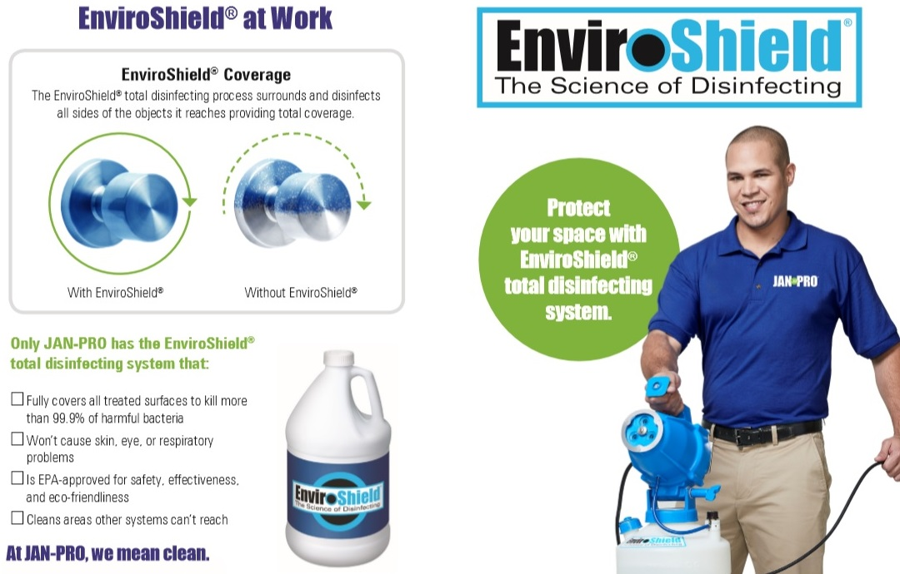
JAN-PRO is proud to offer their Enviroshield® disinfection service. This innovative disinfection technology is designed to kill covid-19 and other microorganisms using an EPA registered disinfectant solution in combination with an electrostatic spraying component. This system delivers a highly effective biocide that adheres to all surfaces including walls, ceilings, carpeted surfaces, keyboards, furnishings and even penetrating into nooks and crevices. The EnviroShield® system has 75 times greater force of attraction than gravity thereby enabling the disinfecting solution to wrap around and coat all objects completely. While it is the most comprehensive system for killing microorganisms, including Covid-19, the EnviroShield® system is completely safe for all occupants and is rated at level 4 toxicity on the EPA scale, making it one of the safest disinfecting solutions worldwide. It has latent effects up to 48 hrs. As an add-on service, Endure® can also be applied, which provides an antimicrobial barrier for up to 6 months on all sprayed surfaces. Both services require the facility to be vacant during application; however can be re-opened immediately after completion. JAN-PRO can provide this service either proactively or in response if needed. Contact Nathan.calhoun@jan-pro.com for pricing.
JAN-PRO has also worked to procure sufficient stock of liquid hand sanitizer in 2 liter bottles for public sale. Much in demand, current state guidelines and best practices require hand sanitizers throughout workplaces and business for both employees and customer usage. With traditional consumable supply resources strained, this alternative source can be used to refill existing pump dispensers as needed. JAN-PRO is making these bottles either individually at $49.00 per bottle or by the case for sale and pickup from their Gahanna office. Contact Allison.martin@jan-pro.com for sale information.
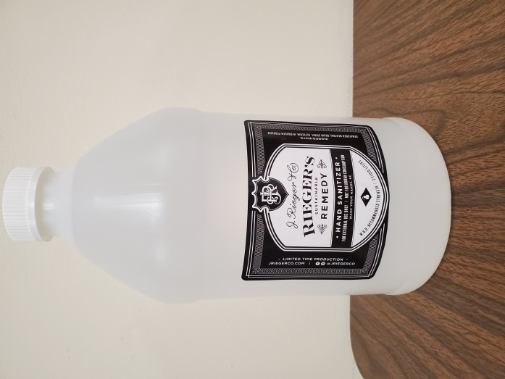
Finally, JAN-PRO views their customers as their partners in business. With the additional challenges and risks of operating in today’s environment it can be overwhelming very quickly. That is why they have made available a free 38 point checklist to assist with best practices for your staff and facility when re-opening. This free checklist can be accessed via a trusted download from https://drive.google.com/open?id=1UaZ78ZDSW4C1we4ytniOdb8N3AaP4KQl
