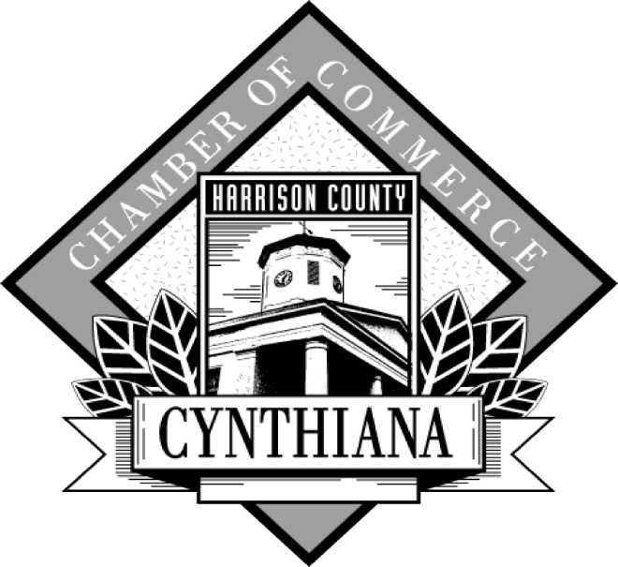

Investment
Opportunities
2018

The Total Resource Campaign is a vehicle the Chamber will use to showcase our many sponsorship opportunities throughout the year. One ask at one time for a few good reasons:

- See the breadth of opportunities available and cherry pick the programs that are most beneficial to you.
- Allows the chamber to focus on programming and providing services throughout the year.
- Allows the chamber to effectively plan and strategize for the upcoming year.

Sponsorships are first come, first serve. Our intent is to fill all sponsorships and marketing opportunities during this campaign so we can focus on other efforts throughout the year. Making your choices early will allow you to prepare for the expense and maximize your recognition. There are various options for invoicing (see the last page).

For more information, contact:
Tomi Clifford, Executive Director Chamber of Commerce
141 East Pike St.
Cynthiana, KY. 41031
cynchamber@gmail.com
859-234-5236
859-588-2612

As a member, I am:
Invested. Connected. Involved.
Make a name for yourself.

Sponsorship Opportunities

Membership Luncheons

Born to Run/Walk 5K Sponsorships

Summer Concert Series Sponsorships

Christmas Parade Sponsorships

Annual Community Awards Banquet Sponsorships

Other Special Event Sponsorships

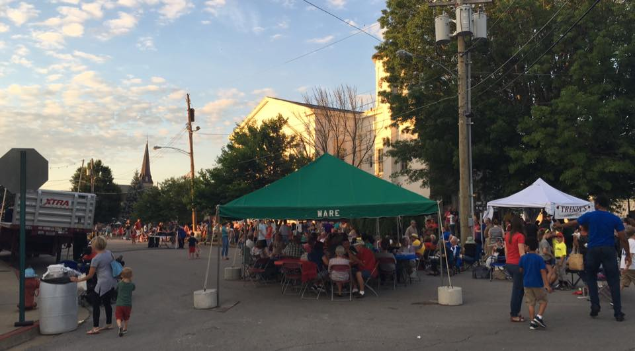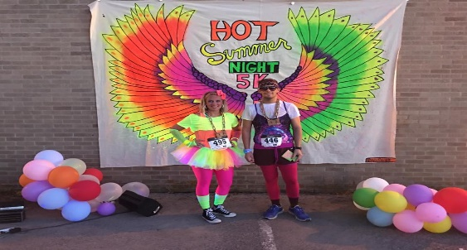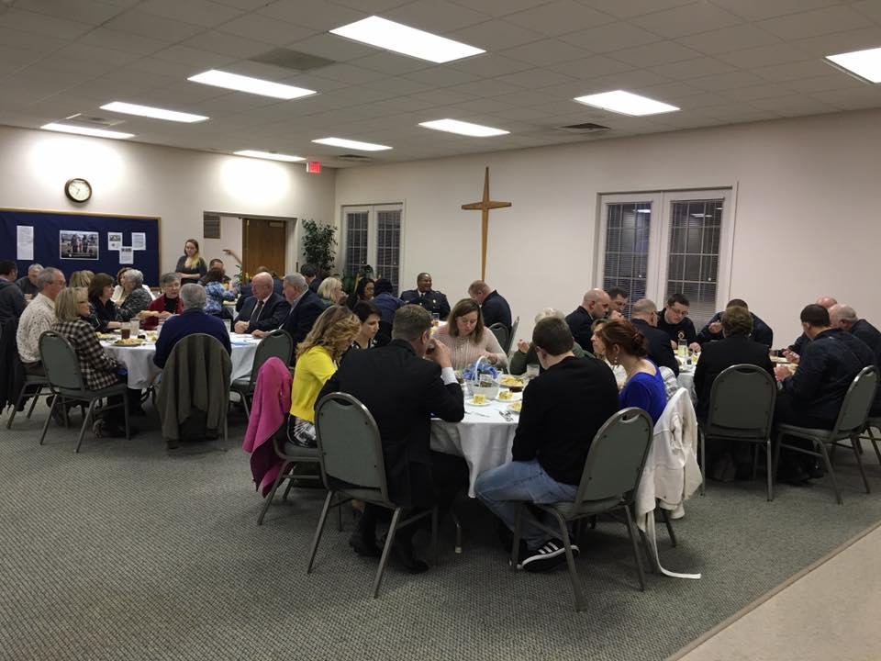

Membership Luncheon Sponsor Opportunities

The Chamber holds monthly membership luncheons throughout the year at different locations.

- Luncheon Sponsor- $300.00- You gain recognition on the entry table and announced at the luncheon, with the opportunity to speak about your business for a few minutes at the beginning of the presentation and bring in any promotional material.

Born to Run/Walk 5K Sponsor Opportunities

The Chamber will hold the Annual Born to Run/Walk 5K in September. There are two ways you can sponsor. Your business can advertise on the long sleeve shirts provided to participants or your business can add items to the goody bags that the participants receive.

To sponsor on the long sleeve shirt:
- $150- your business name and phone number will be listed on the back of the shirt.
- $200- your business logo will be listed towards the top of the shirt on the back.

Maiden City Medallion Hunt Sponsor Opportunities

- $250- Your business name will be listed on all advertisement and promotions for the medallion hunt. There will also be photo coverage with the winner and you and it posted on our social media sites and the Cynthiana Democrat.

Annual Community Awards Banquet Sponsor Opportunities

- Your business can sponsor a table at the Annual Awards dinner by providing a centerpiece/gift basket valued at $25.00 or higher and providing a small gift at each place setting at the table. You can also provide promotional information about your business on the table as well.

Summer Concert Series Sponsor Opportunities

The summer concert series is a once a month outdoor concert beginning in May and ending in August. Attendance is anywhere from 150-500 people each month, with food vendors, games, beer and more.

- $100 Level- Groupie Sponsor (only 4 sponsorships available)
-Sponsor will be recognized on Facebook and Twitter
-Sponsor will be recognized with verbal recognition on the stage each month

- $250 Level- Gold Album Sponsor (only 3 sponsorships available)
-Sponsor name placement on site signage (small, you provide)
-Facebook and other social media recognitions
-Verbal recognition on the stage each month

- $500 Level- Platinum Album Sponsor (only 4 sponsorships available)
-Sponsor name and logo placement on site signage (small, we provide)
-Sponsor name and logo placement on posters in local businesses and destinations
-Facebook and other social media recognitions
-Verbal recognition on the stage each month
-Signage to indicate your sponsorship of the concert series to be displayed in your business
-Sponsor name and logo placement on rack cards in businesses

- $1000 Level- Multi-Platinum Album Sponsor (only 1 sponsorship available)
-Sponsor name and logo placement on site signage (large, banner size)
-Sponsor name and logo placement on posters in local businesses and destinations
-A booth at the event to promote your business
-Sponsor name and logo on newspaper and WCYN ads
-Verbal recognition on the stage each month
-Facebook and Social media recognition
-Sponsor name and logo placement on rack cards in businesses
-Signage to indicate your sponsorship as part of the concert series to be displayed in your business

Christmas Parade Sponsor Opportunities

The Christmas parade sponsorships go towards the awards and prizes for the Christmas parade each year. You can choose to sponsor at 3 levels:

- Elf package: $50- Facebook and social media recognition as a sponsor.
- Santa’s Helper package: $150- Facebook and social media recognition, small signage at the judge’s station.
- Santa Claus package: $250- Facebook and social media recognition, large signage at the judge’s station and announced by the wcyn and the announcer throughout the parade.
2018 Investment Opportunity Application

Company Name:_____________________________

Company Contact:____________________________

Sponsorship Packages
Choose a package and then select your opportunities below

_____Platinum ($1000 and above)

_____Gold ($500-$999)

_____Silver ($200-$499)

_____Bronze ($199 and under)

_____A La Carte ( you choose amount/events to serve your needs)

Opportunities

___$1000 summer concert series ___$150 triple crown series

___$500 summer concert series ___$100 summer concert series

___$500 triple crown series ___$100 triple crown series

___$300 triple crown series ___$50 Christmas parade

___$250 summer concert series

___$250 Christmas parade

___$200 membership luncheon

___$150 Christmas parade

Total Amount:_________ Signature:______________ Date:___________

-

