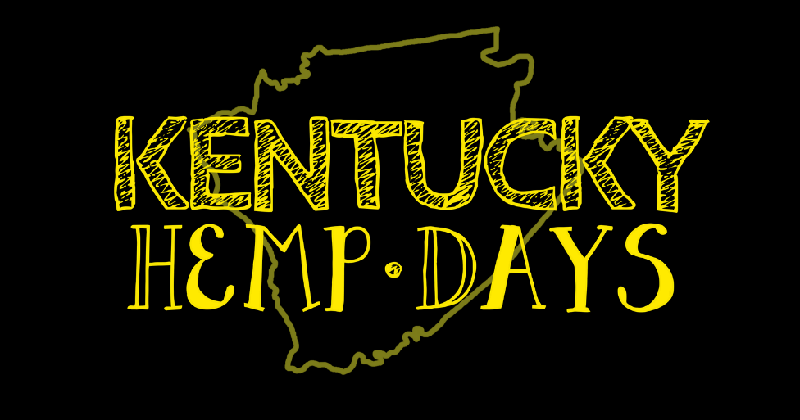
2020 Sponsorship Opportunities

$2000.00 Kentucky Hemp Days Corporate Dream Package (only one available)-Logo will appear on hemp tote bags given to the public and vendors, will receive two tickets to the Kentucky Hemp Days Dinner or the Farmers Rise and Shine Breakfast,Logo will appear on all posters and event flyers, will be featured on a banner at the live music stage and the large banner at the courthouse for the educational forums and the hand fans with the printed schedule. Will include two premiere booth spaces and a slot to speak at the educational forum. as well as social media spotlight recognition.
$1000.00 Sponsor Package-Logo will appear on all posters and event flyers, appear on a banner at the live music stage and the large banner at the courthouse for the educational forums and the hand fans with the printed schedule. Will include two premiere booth spaces as well as social media spotlight recognition.
$500.00 Sponsor Package- Logo will appear on hand fans and all social media, will include one premiere booth space and signage outside educational panels.

Farmers Rise and Shine Breakfast Sponsorships
The Farmers Rise and Shine Breakfast will take place the morning of Kentucky Hemp Days at 9am Downtown Cynthiana. Breakfast will be steak, eggs, hashbrowns, fruit, coffee and juice. We will have a speaker from the Department of Agriculture.

$1000.00 Sponsor-Main Sponsor, only one available. Logo will be on all signage and promotion of the event along with table décor and social media.
$500.00 Sponsor-Logo will be on banners at event and on social media.

