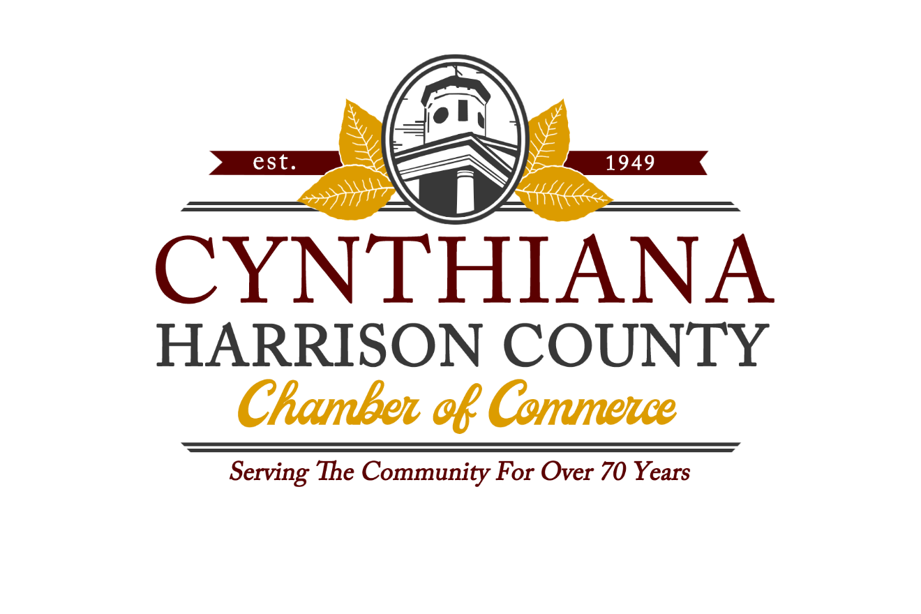

Investment
Opportunities
2022

The Total Resource Campaign is a vehicle the Chamber will use to showcase our many sponsorship opportunities throughout the year. One ask at one time for a few good reasons:

- See the breadth of opportunities available and cherry pick the programs that are most beneficial to you.
- Allows the chamber to focus on programming and providing services throughout the year.
- Allows the chamber to effectively plan and strategize for the upcoming year.

Sponsorships are first come, first serve. Our intent is to fill all sponsorships and marketing opportunities during this campaign so we can focus on other efforts throughout the year. Making your choices early will allow you to prepare for the expense and maximize your recognition. There are various options for invoicing (see the last page).

For more information, contact:
Tomi Clifford, Executive Director Chamber of Commerce
141 East Pike St.
Cynthiana, KY. 41031
cynchamber@gmail.com
859-234-5236
859-588-2612

As a member, I am:
Invested. Connected. Involved.
Make a name for yourself.

Sponsorship Opportunities

Membership Breakfast/After Hours

Annual Golf Scramble

Summer Concert Series

Breakout Leadership Conference

Annual Community Impact Awards

Other Special Events

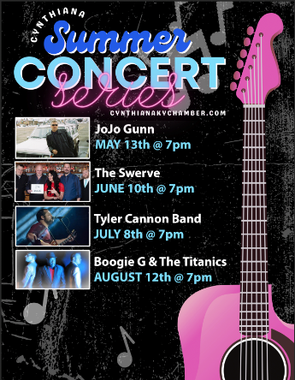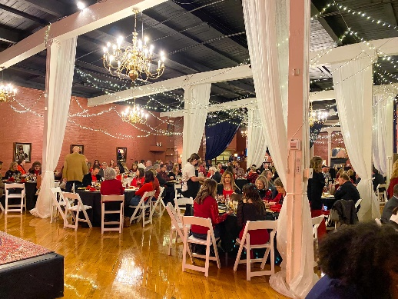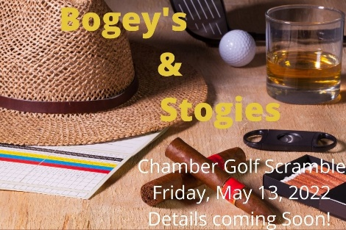

Membership Luncheon Sponsor Opportunities

The Chamber holds monthly membership meetings throughout the year at different locations.

- Luncheon Sponsor- $300.00- You gain recognition on the entry table and announced at the luncheon, with the opportunity to speak about your business for a few minutes at the beginning of the presentation and bring in any promotional material. Featured on social media and entry sign.

Summer Concert Series Sponsor Opportunities

The summer concert series is a once a month outdoor concert beginning in May and ending in August. Attendance is anywhere from 500-1500 people each month, with food vendors, games, beer and more. This is the most popular event during the summer and these sponsorships go fast!

- Kids Area Sponsor (4 available, one for each month)
This is a great way to showcase your business or organization. Your company will provide any games (it can be from chalk and balloons to mechanical bull and petting zoo!) for kids during the concert series. It’s a great time to brand and get your name out there.

- $250 Level- Gold Album Sponsor (only 3 sponsorships available)
-Sponsor name placement on banner at event
-Facebook and other social media recognitions

- $500 Level- Platinum Album Sponsor (only 4 sponsorships available)
-Sponsor name and logo placement on site signage
-Sponsor name and logo placement on posters in local businesses and destinations
-Facebook and other social media recognitions as well as entry sign
-Signage to indicate your sponsorship of the concert series to be displayed in your business

- $1000 Level- Multi-Platinum Album Sponsor- ONLY 1 AVAILABLE!
- ( Thank you Field and Main Bank and Palmer Hampton Realty!)
-Sponsor name and logo placement on site signage (large, banner size) and on the site banner
-Sponsor name and logo placement on posters in local businesses and destinations
-A booth at the event to promote your business
- Headlining Sponsor name on newspaper and WCYN ads
-Introduce band that month
-Facebook and Social media recognition as well as entry sign
-Signage to indicate your sponsorship as part of the concert series to be displayed in your business

Annual Golf Scramble Sponsorships Opportunities
May 13, 2022

PLATINUM SPONSOR-$1000 SOLD OUT- Thank you Thwaites Realtors!
- One foursome (includes greens fee, cart & lunch)
- 30 oz Yeti Tumblers (4)
- Prize Sponsor (Banner display at the winners circle)
- Premium exposure on event related communications (print, email, radio, website, social media, etc)
- Opportunity to set up a table for your business at registration
- Logo displayed at designated hole
- Sponsor recognition during event and inclusion of logo on signage at registration

GOLD SPONSOR-$600 (2 AVAILABLE)
- One foursome (includes greens fee, cart and lunch)
- Titleist Tour hats (4)
- Premium exposure on event related communications (print, radio, website, email, social media, etc.)
- Sponsor recognition during event and inclusion of logo on large event signage at registration
- Opportunity to set up a table for your business at registration

LUNCH SPONSOR $300 (1 AVAILABLE)
- Signage at the lunch pickup
- Brochures on the tables of your business
- Exposure on event related communications, social media, website, email, etc)

PUTTING GREEN SPONSOR/COOLER GIVEAWAY SPONSOR $300 (1 AVAILABLE)
- Signage at the putting green
- Signage at the registration table for the golf tee count/cooler giveaway
- Exposure on social media, website and other event related communications

HOLE SPONSOR $50 ( multiple available)
- Logo displayed on signage by the hole
- Social media recognition

GAME SPONSOR $50 (plus winning prize $50 minimum) (4 Available)
- Signage at the hole game site
- Sponsor is in charge of the game played and of the prize at the end of the scramble
- Social media exposure
- Recognition on the banner at winners circle

DOOR PRIZE DONATION
- Social media recognition and on site recognition
Breakout Leadership Conference
(September 2022)

This leadership conference will be like one you’ve never been to before! With keynote speakers such as Jason Roberts from Better Blocks and the Public Works Director of the Cincinnati Zoo, the day will be action packed and open your mind to creative, thinking out of the box leadership. Be ready to laugh, learn and become a changemaker!

Avant Garde-$2000.00-1 Available-SOLD OUT Thank you City of Cynthiana!
Definition: The Avant Garde are people or works that are experimental, radical, or unorthodox with respect of art, culture or society. What you get: logo and name on all print advertising and banners, social media recognition, recognition on the entry sign on Bridge Street, verbal on stage recognition, front row reserve seating for five, lunch for five and five exclusive event t-shirts with your logo.

Trailblazer-$1000.00- 2 Available.
Definition: A person or persons who makes a new track through wild country. What you get: Logo and name on all print advertising and banners, social media recognition, verbal on stage recognition, recognition on the entry sign at Bridge Street, front row seating for two, lunch for two and two event t-shirts.

Innovator-$500.00- ONLY 2 LEFT! Thank you Field and Main Bank!
Definition: A person or persons who introduces new methods, ideas or products. What you get: Social media recognition, recognition on the entry sign at Bridge Street, verbal on stage recognition, one ticket and one t shirt.

Groundbreaker-$250.00- 4 Available.
Definition: A person who is an originator, innovator or pioneer in a particular activity. This sponsor is the Breakout Session Sponsor level. What you get: Signage at the Breakout Session on the banners and verbal recognition at the breakout session.

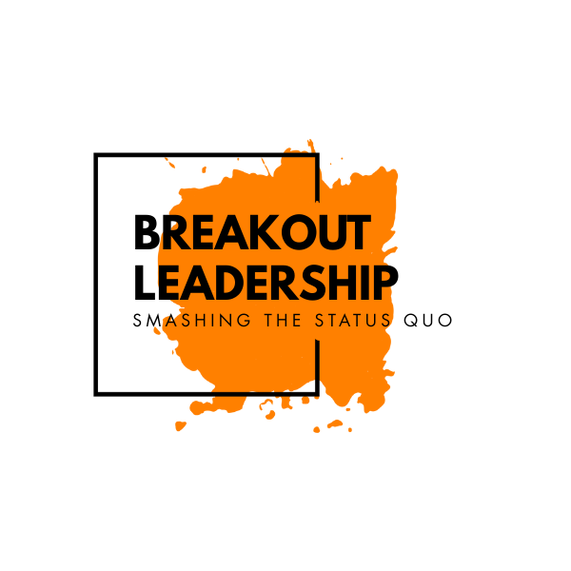

Chamber Magazine Ad opportunities
Commitment needed by March 4th
The annual Chamber Magazine and Directory is distributed to businesses throughout the county and available in the gift shop, city office and court house. It is a great reference tool and showcase of our chamber and our members. Deadline for
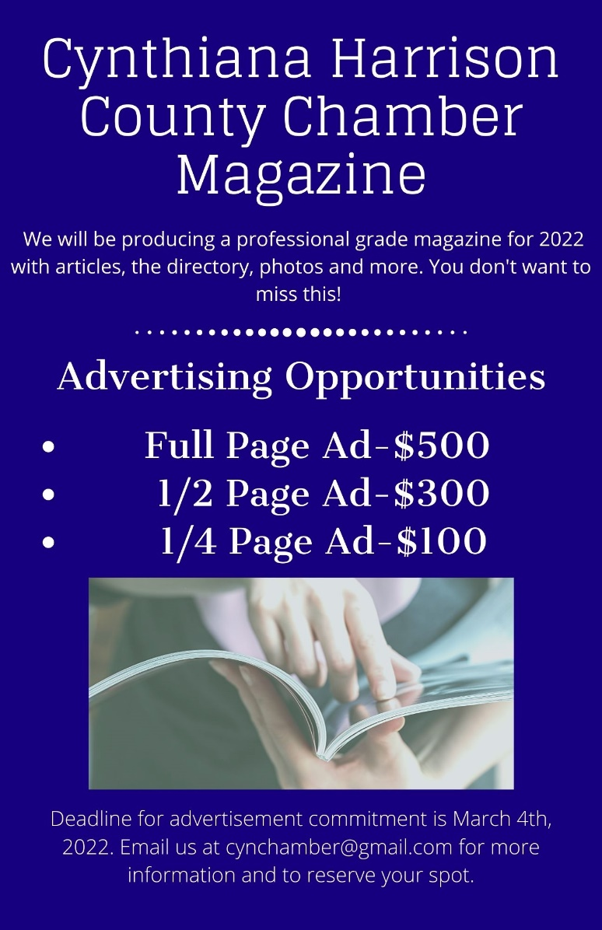
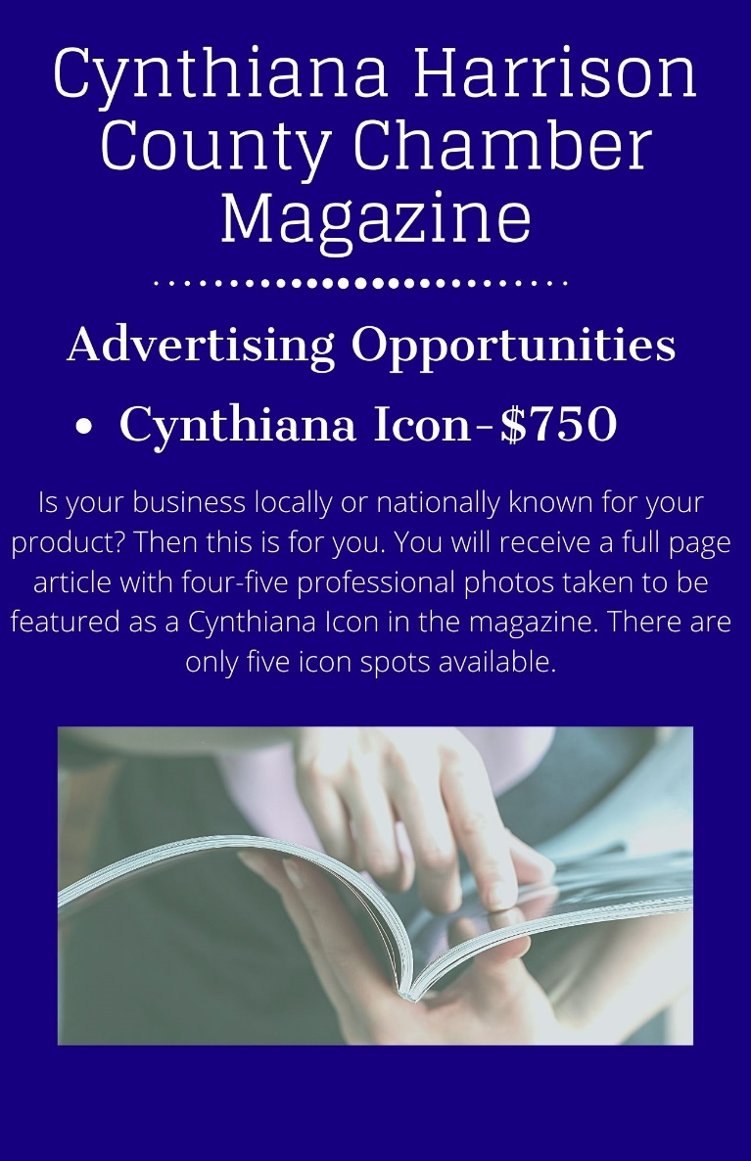

Chamber Entry Sign/ Website Bundle

Advertise on our Entry Sign and with a website banner for only $200 a month! Our entry sign is located in the busiest intersection in town. Our website has over 1,000 visitors a month. This is a steal!

2022 Investment Opportunity Application

Company Name:_____________________________

Company Contact:____________________________

Please let us know below which events you plan to sponsor and what level and submit this form by email with your updated logo for promotion. Thank you!

Total Amount:_________ Signature:______________ Date:___________

-

