RESOURCE SHEET
These are the resources and links mentioned in my workshop:

- Grants4Good Blog Articles: https://www.grants4good.com/blog/
  - The 5% Rule
  - How to Find Grants Quickly and Easily
  - Making Friends with Logic Models

- DUNS (Data Universal Numbering System) number: http://fedgov.dnb.com/webform
- SAM (System for Award Management) registration: www.sam.gov
- Federal Grants: www.grants.gov

- Instrumentl, www.instrumentl.com [Use coupon code: GRANTS4GOOD50 to get $50 off]

- Community Foundation locator: https://www.cof.org/community-foundation-locator

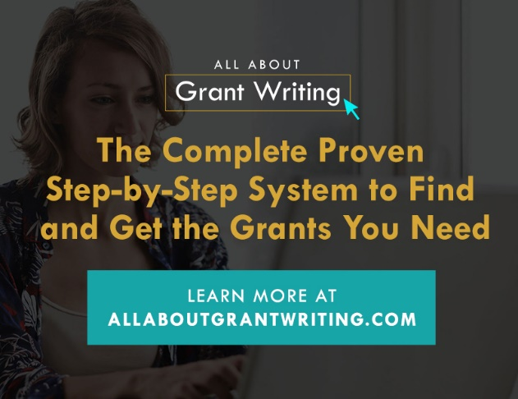
Ready to exceed all your grant funding goals?
Grants4Good has a comprehensive 8-module self-paced online course for you. Check it out at: www.allaboutgrantwriting.com.
Special BONUS: Use coupon code: GRANTS100 to receive $100 off your course purchase!
Expires: July 31, 2021
Email me with course questions: Margit@grants4good.com

Margit Brazda Poirier, M.S., is a nationally certified grant professional (GPC) and Owner/CEO of Grants4Good LLC, a grant development consulting company that specializes in training and grant strategies.

