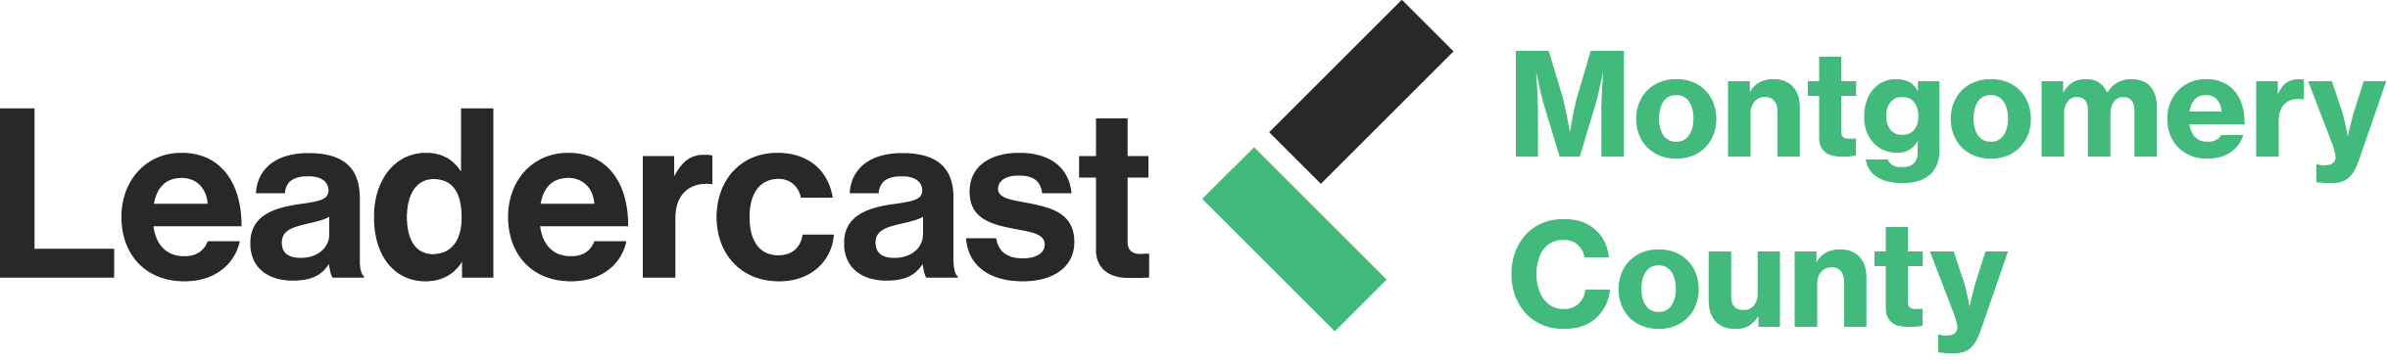

Leadercast 2020 Positive Disruption May 7, 2020

New Host Site: Dave & Buster’s Conference Center – Plymouth Meeting
Centrally located and easily accessible!
Payment can be made by check payable to EMCCC or online at www.emccc.org.
Questions, call the chamber office at 215-887-5122

Sponsorship Opportunities
Platinum Level: $2500 SOLD Penn Community Bank
- Opportunity to welcome and address the audience (2 minute maximum either morning, lunch or break) prior to simulcast going live
- Opportunity to place standing retractable banner in conference area
- 5 reserved premier seats (includes option to purchase 4 additional tickets at $119 group rate until March 31)
- Inclusion of one full page ad in Attendee Welcome Booklet (ad must be received by March 31)
- Exhibitor table in premium location (main room all day)
- Promo item to be placed at each attendees seat
- Logo on Leadercast EMCCC registration page
- Logo featured in Power Point as Platinum Level sponsor
- Receive spreadsheet after event of all attendees with contact information
- Mention as lead sponsor in press releases
- Mention from stage twice during the event

Gold Level: $2000
- Opportunity to place standing retractable banner in conference area
- 4 reserved premier seats (includes option to purchase 4 additional tickets at $119 group rate until March 31)
- Inclusion of one full page ad in Attendee Welcome Booklet (ad must be received by March 31)
- Exhibitor table in premium location (main room all day)
- Logo on Leadercast EMCCC registration page
- Logo featured in Power Point as Gold Level sponsor
- Receive spreadsheet after event of all attendees with contact information
- Mention as sponsor in press releases
- Mention from stage twice during the event
Breakfast Sponsor $1500 (Exclusive limited to 1 sponsor)
Signage at entrance to networking breakfast reception, and at buffet with your business logo
- May put out promotional items in breakfast buffet area
- 3 reserved event seats (includes option to purchase 3 additional seats @ $119 group rate until March 31)
- Inclusion of one ½ page ad in Attendee Welcome Booklet (ad must be received by March 31)
- Exhibitor table in premium location (main room all day)
- Logo featured in Power Point as Breakfast sponsor
- Mention from stage twice during the event
Silver Level: $1000 (3 available)
- 2 reserved event seats (includes option to purchase 3 additional seats @ $119 group rate until 3/31)
- Inclusion of one ½ page ad in Attendee Welcome Booklet (ad must be received by March 31)
- Exhibitor table (welcome to bring giveaways and additional marketing materials for display)
- Logo featured in Power Point as Silver Level sponsor
- Mention from stage twice during the event
Name Tag Sponsor: $1000 SOLD iSolutions Insurance Advisors
- Business logo to go on every attendee name tag worn throughout the day
- 2 reserved event seats (includes option to purchase 3 additional seats @ $119 group rate until 3/31)
- Inclusion of one ½ page ad in Attendee Welcome Booklet (ad must be received by March 31)
- Logo featured in Power Point as Name Tag sponsor
- Mention from stage twice during the event

Snack & Beverage Sponsor $750 SOLD Gary Kozick ElderCare Solutions, LLC &
Temple University
- Business logo featured on signs next to Snack table and beverage station all day long
- Option for your company to provide candy snack at entrance to conference room with your company logo
- 1 reserved event ticket (includes option to purchase 2 additional tickets @ $119 rate until 3/31)
- Inclusion of one ½ page ad in Attendee Welcome Booklet (ad must be received by March 31)
- Logo featured in Power Point as Snack & Beverage sponsor
- Mention from stage twice during the event

Bronze Level: $500 (5 available) Monarch Staffing
- 1 event ticket (includes option to purchase 2 additional tickets @ $119 rate until 3/31)
- Inclusion of one business card size ad in Attendee Welcome Booklet (must be received by March 31)
- Exhibitor table (welcome to bring giveaways and additional marketing materials for display)
- Logo featured in Power Point as Bronze level sponsor
- Mention from stage once during the event
Fees/Admission:
Ticket Prices (inclusive of breakfast, lunch, snacks, program book, and networking)
Super Early Bird up to December 31: $119
Early Bird up to February 28: $129
March Madness Up to March 1- March 31: $139
Standard (April 1-May 7): $149
Group Discount Available for purchase of 15+ tickets: $129

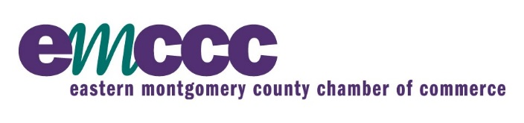
Presented by:

