2021 Annual Water Quality Report

WSID #0010000

Spanish (Espanol)
Este informe contiene informacion muy importante sobre la calidad de su agua beber. Traduscalo o hable con alguien que lo entienda bien.

Is my water safe?
We are pleased to present this year's Annual Water Quality Report (Consumer Confidence Report) as required by the Safe Drinking Water Act (SDWA). This report is designed to provide details about where your water comes from, what it contains, and how it compares to standards set by regulatory agencies. This report is a snapshot of last year's water quality. We are committed to providing you with information because informed customers are our best allies.

Do I need to take special precautions?
Some people may be more vulnerable to contaminants in drinking water than the general population. Immuno-compromised persons such as persons with cancer undergoing chemotherapy, persons who have undergone organ transplants, people with HIV/AIDS or other immune system disorders, some elderly, and infants can be particularly at risk from infections. These people should seek advice about drinking water from their health care providers. EPA/Centers for Disease Control (CDC) guidelines on appropriate means to lessen the risk of infection by Cryptosporidium and other microbial contaminants are available from the Safe Water Drinking Hotline (800-426-4791).

Where does my water come from?
The City of Baxley takes it's water from three deep wells. These wells are about 700 feet deep and feed from what is termed as the Upper Floridian Aquifer. We are lucky to be able to draw from this aquifer. It enables us to have an adequate supply of good water at a minimum cost. We add chlorine for disinfection purposes and fluoride for strong bones and teeth.

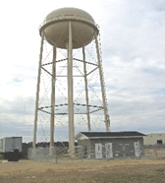

Source water assessment and its availability
The City of Baxley has a Well Head Protection and Vulnerability Assessment Plan designed to assess our water requirements. Our plan was adopted on June 25,1997 and establishes a 100-foot parameter around each well which prohibits any type of activity that could potentially contaminate our water source.

Why are there contaminants in my drinking water?
Drinking water, including bottled water, may reasonably be expected to contain at least small amounts of some contaminants. The presence of contaminants does not necessarily indicate that water poses a health risk. More information about contaminants and potential health effects can be obtained by calling the Environmental Protection Agency's (EPA) Safe Drinking Water Hotline (800-426-4791). The sources of drinking water (both tap water and bottled water) include rivers, lakes, streams, ponds, reservoirs, springs, and wells. As water travels over the surface of the land or through the ground, it dissolves naturally occurring minerals and, in some cases, radioactive material, and can pick up substances resulting from the presence of animals or from human activity:
microbial contaminants, such as viruses and bacteria, that may come from sewage treatment plants, septic systems, agricultural livestock operations, and wildlife; inorganic contaminants, such as salts and metals, which can be naturally occurring or result from urban stormwater runoff, industrial, or domestic wastewater discharges, oil and gas production, mining, or farming; pesticides and herbicides, which may come from a variety of sources such as agriculture, urban stormwater runoff, and residential uses; organic Chemical Contaminants, including synthetic and volatile organic chemicals, which are by-products of industrial processes and petroleum production, and can also come from gas stations, urban stormwater runoff, and septic systems; and radioactive contaminants, which can be naturally occurring or be the result of oil and gas production and mining activities. In order to ensure that tap water is safe to drink, EPA prescribes regulations that limit the amount of certain contaminants in water provided by public water systems. Food and Drug Administration (FDA) regulations establish limits for contaminants in bottled water which must provide the same protection for public health.

How can I get involved?
The Baxley City Council meets the second and fourth Wednesday at 8:30A.M. each month. They meet in the Council Chambers at City Hall located at 282 East Parker Street. The public is invited to attend the meeting and can be on the agenda, please notify the City several days in advance.

Results of radon monitoring
Radon is a radioactive gas that you can't see, taste, or smell. It is found throughout the U.S. Radon can move up through the ground and into a home through cracks and holes in the foundation. Radon can build up to high levels in all types of homes. Radon can also get into indoor air when released from tap water from showering, washing dishes, and other household activities. Compared to radon entering the home through soil, radon entering the home through tap water will in most cases be a small source of radon in indoor air. Radon is a known human carcinogen. Breathing air containing radon can lead to lung cancer. Drinking water containing radon may also cause increased risk of stomach cancer. If you are concerned about radon in your home, test the air in your home. Testing is inexpensive and easy. Fix your home if the level of radon in your air is 4 picocuries per liter of air (pCi/L) or higher. There are simple ways to fix a radon problem that aren't too costly. For additional information, call your state radon program or call EPA's Radon Hotline (800-SOS-RADON).

Additional Information for Lead
If present, elevated levels of lead can cause serious health problems, especially for pregnant women and young children. Lead in drinking water is primarily from materials and components associated with service lines and home plumbing. City of Baxley is responsible for providing high quality drinking water, but cannot control the variety of materials used in plumbing components. When your water has been sitting for several hours, you can minimize the potential for lead exposure by flushing your tap for 30 seconds to 2 minutes before using water for drinking or cooking. If you are concerned about lead in your water, you may wish to have your water tested. Information on lead in drinking water, testing methods, and steps you can take to minimize exposure is available from the Safe Drinking Water Hotline or at http://www.epa.gov/safewater/lead.

Water Quality Data Table
In order to ensure that tap water is safe to drink, EPA prescribes regulations which limit the amount of contaminants in water provided by public water systems. The table below lists all of the drinking water contaminants that we detected during the calendar year of this report. Although many more contaminants were tested, only those substances listed below were found in your water. All sources of drinking water contain some naturally occurring contaminants. At low levels, these substances are generally not harmful in our drinking water. Removing all contaminants would be extremely expensive, and in most cases, would not provide increased protection of public health. A few naturally occurring minerals may actually improve the taste of drinking water and have nutritional value at low levels. Unless otherwise noted, the data presented in this table is from testing done in the calendar year of the report. The EPA or the State requires us to monitor for certain contaminants less than once per year because the concentrations of these contaminants do not vary significantly from year to year, or the system is not considered vulnerable to this type of contamination. As such, some of our data, though representative, may be more than one year old. In this table you will find terms and abbreviations that might not be familiar to you. To help you better understand these terms, we have provided the definitions below the table.

Contaminants | MCLG  or  MRDLG | MCL,  TT, or  MRDL | Detect In  Your Water | Range |  | Sample  Date | Violation | Typical Source
 |  |  |  | Low | High
Disinfectants & Disinfection By-Products
(There is convincing evidence that addition of a disinfectant is necessary for control of microbial contaminants)
Chlorine (as Cl2) (ppm) | 4 | 4 | 1.4 | 1.1 | 1.4 | 2021 | No | Water additive used to control microbes
Haloacetic Acids (HAA5) (ppb) | NA | 60 | 1.5 | NA | NA | 2021 | No | By-product of drinking water chlorination
TTHMs [Total Trihalomethanes] (ppb) | NA | 80 | 12 | NA | NA | 2021 | No | By-product of drinking water disinfection
Inorganic Contaminants
Barium (ppm) | 2 | 2 | .088 | NA | NA | 2021 | No | Discharge of drilling wastes; Discharge from metal refineries; Erosion of natural deposits
Fluoride (ppm) | 4 | 4 | .75 | .7 | .75 | 2021 | No | Erosion of natural deposits; Water additive which promotes strong teeth; Discharge from fertilizer and aluminum factories
Microbiological Contaminants
Total Coliform (RTCR) | NA | TT | NA | NA | NA | 2021 | No | Naturally present in the environment
Radioactive Contaminants
Radium (combined 226/228) (pCi/L) | 0 | 5 | 1.83 | NA | NA | 2020 | No | Erosion of natural deposits

Contaminants | MCLG | AL | Your  Water | Sample  Date | # Samples  Exceeding AL | Exceeds AL | Typical Source
Inorganic Contaminants
Copper - action level at consumer taps (ppm) | 1.3 | 1.3 | .14 | 2020 | 0 | No | Corrosion of household plumbing systems; Erosion of natural deposits
Lead - action level at consumer taps (ppb) | 0 | 15 | 0 | 2020 | 0 | No | Corrosion of household plumbing systems; Erosion of natural deposits

Violations and Exceedances

Unit Descriptions
Term | Definition
ppm | ppm: parts per million, or milligrams per liter (mg/L)
ppb | ppb: parts per billion, or micrograms per liter (µg/L)
pCi/L | pCi/L: picocuries per liter (a measure of radioactivity)
% positive samples/month | % positive samples/month: Percent of samples taken monthly that were positive
NA | NA: not applicable
ND | ND: Not detected
NR | NR: Monitoring not required, but recommended.

Important Drinking Water Definitions
Term | Definition
MCLG | MCLG: Maximum Contaminant Level Goal: The level of a contaminant in drinking water below which there is no known or expected risk to health. MCLGs allow for a margin of safety.
MCL | MCL: Maximum Contaminant Level: The highest level of a contaminant that is allowed in drinking water. MCLs are set as close to the MCLGs as feasible using the best available treatment technology.
TT | TT: Treatment Technique: A required process intended to reduce the level of a contaminant in drinking water.
AL | AL: Action Level: The concentration of a contaminant which, if exceeded, triggers treatment or other requirements which a water system must follow.
Variances and Exemptions | Variances and Exemptions: State or EPA permission not to meet an MCL or a treatment technique under certain conditions.
MRDLG | MRDLG: Maximum residual disinfection level goal. The level of a drinking water disinfectant below which there is no known or expected risk to health. MRDLGs do not reflect the benefits of the use of disinfectants to control microbial contaminants.
MRDL | MRDL: Maximum residual disinfectant level. The highest level of a disinfectant allowed in drinking water. There is convincing evidence that addition of a disinfectant is necessary for control of microbial contaminants.
MNR | MNR: Monitored Not Regulated
MPL | MPL: State Assigned Maximum Permissible Level

For more information please contact:
Contact Name: Mark Durden Jr
Address: 148 Copeland Rd
Baxley, Ga 31539
Phone: 912-367-8314

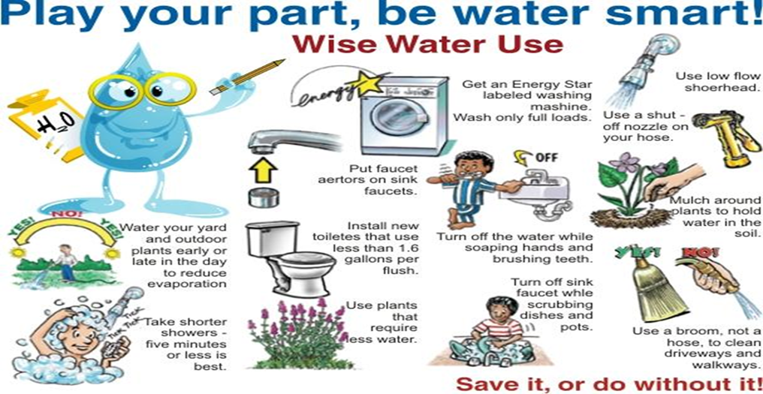

CONSERVATION TIPS
Did you know that the average U.S. household uses approximately 400 gallons of water per day or 100 gallons per person per day? Luckily, there are many low-cost and no-cost ways to conserve water. Small changes can make a big difference – try one today and soon it will become second nature.
- Take short showers – a 5 minute shower uses 4 to 5 gallons of water compared to up to 50 gallons for a bath.
- Shut off water while brushing your teeth, washing your hair and shaving and save up to 500 gallons
a month.
- Use a water-efficient showerhead. They’re inexpensive, easy to install, and can save you up to 750
gallons a month.
- Run you clothes washer and dishwasher only when they are full. You can save up to 1,000 gallons
a month.
- Water plants only when necessary.
- Fix leaky toilets and faucets. Faucet washers are inexpensive and take only a few minutes to replace.
- To check your toilet for a leak, place a few drops of food coloring in the tank and wait. If it seeps into the toilet bowl without flushing, you have a leak. Fixing it or replacing it with a new, more efficient model can save up to 1,000 gallons a month.
- Adjust sprinklers so only your lawn is watered. Apply water only as fast as the soil can absorb it and during the cooler parts of the day to reduce evaporation.
- Teach your kids about water conservation to ensure a future generation that uses water wisely. Make it a family effort to reduce next month’s water bill!
- Visit www.epa.gov/watersense for more information.

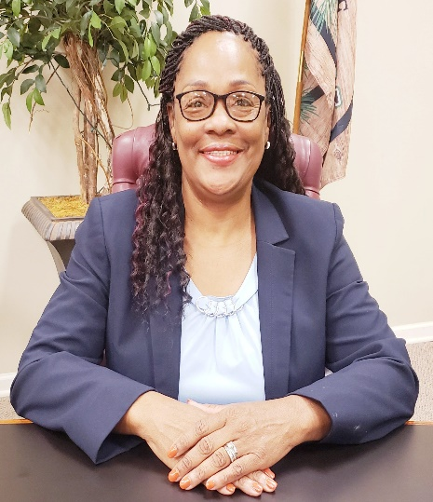

District 1, Santina Fryer District 2, Ora Hall District 3, Mickey Bass

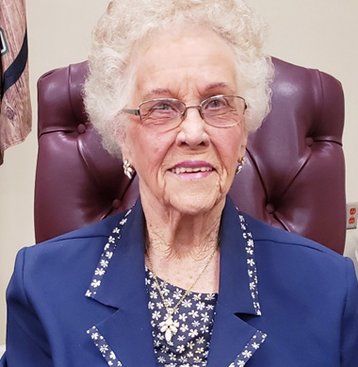

District 4, Adam Thomas District 5, Betty Livingston District 6, Pat Williams

City Manager, Reid Lovett City Clerk, Jessica McLellan Mayor, Tim Varnadore

Baxley City Council Meetings
The Baxley City Council meetings are held the second and fourth Wednesday of each month at 8:30 AM in the Council Chambers of City Hall. If you would like to make a presentation to the Council, please contact City Hall no later than the Wednesday before the meeting is to take place.

