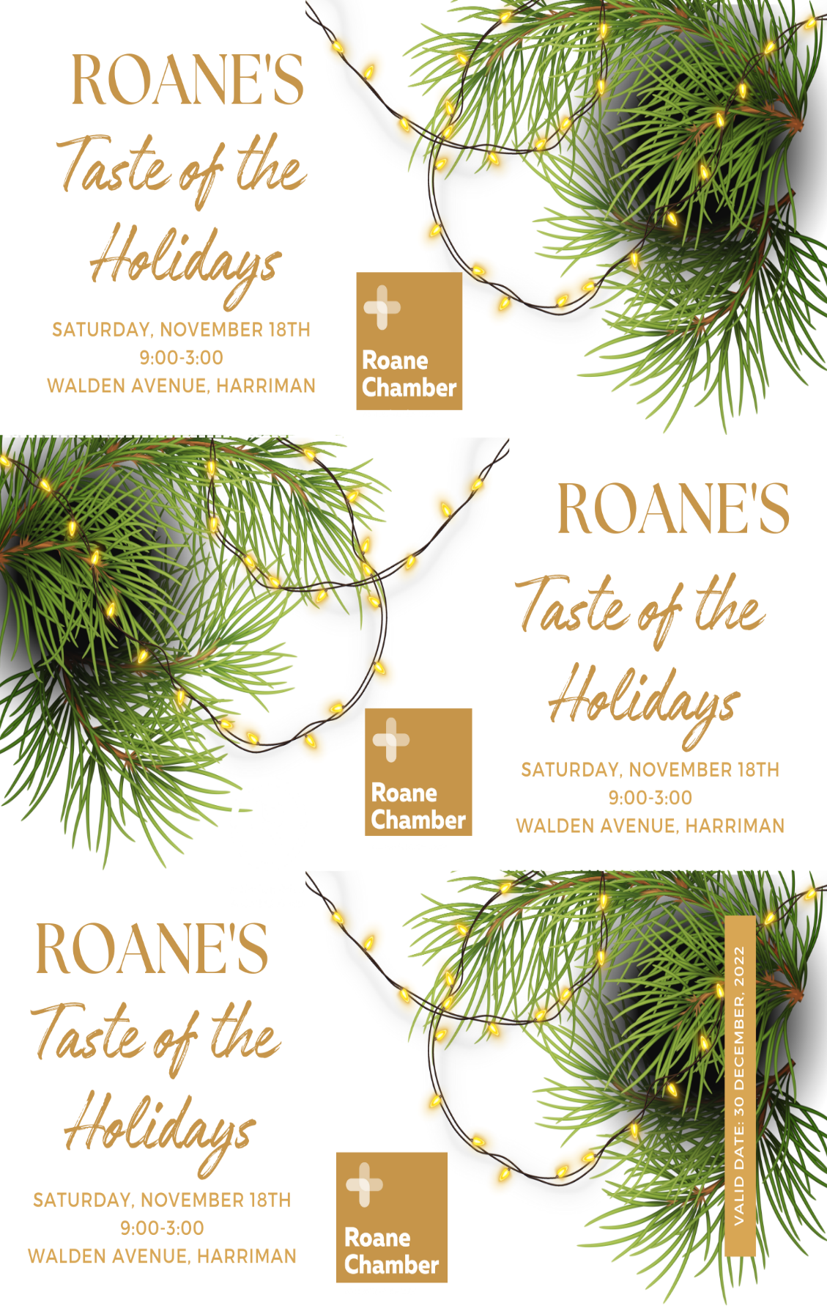

Calling all makers, crafters, homegrown, vintage, online and local retailers! The Roane Chamber invites you to participate in Roane’s Taste of the Holidays Event on Walden Avenue in Harriman on Saturday, November 18 from 9 to 3 pm. Booth prices starting at $50!

This is a FREE shopping event and open to the public. Advertising has already begun in the East Tennessee area. The first 300 guests/families will receive a special Taste of the Holidays shopping bag. A program with a vendor list and map will also be provided.

The City of Harriman has graciously opened their arms and closed Walden Avenue for this outdoor event for vendors to showcase their merchandise. For shoppers, Christmas music will get them in the holiday spirit. They can enjoy popular food trucks, have time with Santa and enjoy children’s activities in the Holiday Kid Zone.

Don’t miss this unique opportunity to sell your merchandise at this amazing and festive location!

**Booth Sizes & Prices:**

* 10’x10’ Outdoor booth space: Roane Chamber Members $50; non-members $75
* Food Truck Spots: Roane Chamber Members $75; non-members $100

**Upon payment of vendor fees, you agree to the following terms:**

* In order to participate vendors must be a retailer, with items for sale at the event;
* Roane Chamber member businesses will be given priority placement for their booth, but you do not have to be a member to participate;
* Setup begins at 7:30 am on Sunday, November 8, with all booths set up before 9:00 am;
* Vendors are responsible for their own tables, chairs and other setup needs;
* Vendors are responsible for setting up and tearing down;
* Teardown is not permitted until 3 pm;
* All booths need to be completely empty and clean by 4:30 pm;
* Electricity will not be provided, and is only available for a limited number of food trucks and must be reserved in advance, on a first-come, first-serve basis;
* For those with electricity reserved, food trucks are responsible for their own heavy-duty extension cords;
* The Roane Chamber or the City of Harriman are not liable to vendors for lost or stolen items;
* Vendors are responsible for making their own sales, using credit cards and having plenty of change for cash;
* Booth fees are NONREFUNDABLE - this event is rain or shine;
* No resale of booth space permitted;
* Vendors are responsible for all income tax reporting.