AIIA Webinar Registration Form (Required for each attendee)
Full Name Click here to enter text. National Producer Number (NPN) Click here to enter text.
Agency Name: Click here to enter text.
Agency Mailing Address: Click here to enter text.
Telephone: Click here to enter text. Email: Click here to enter text.
Payment Options: ☐Visa ☐MasterCard ☐American Express
☐Enclosed is my check made payable to Alabama Independent Insurance Agents
Card #: Click here to enter text. Exp. Date: Click here to enter text. CVC: Click here to enter text.
Billing Address of Cardholder: Click here to enter text.
Name as it Appears on Card: Click here to enter text. Cardholder’s Signature: Click here to enter text.
Please register me for the following AIIA webinar(s): (All classes offer 3 hour credit)
Date | Topic |  | Member  Registration Fee | Non-Member Registration Fee
Click here to enter a date. | Click here to enter text. |  | ☐$45 | ☐$70
Click here to enter a date. | Click here to enter text. |  | ☐$45 | ☐$70
Click here to enter a date. | Click here to enter text. |  | ☐$45 | ☐$70
Click here to enter a date. | Click here to enter text. |  | ☐$45 | ☐$70
Please verify the course number.  You cannot repeat a course within your current continuing educational cycle. |  | Total Payment | $Click here to enter text. | $Click here to enter text.

Cancellation Policy: A written request for a one-time transfer of the full registration fee to another scheduled AIIA webinar or a refund less a $10 cancellation fee may be made up to 24 hours before the beginning of the webinar for which the individual is registered. Substitutions are welcome – lease email notification of name, National Producer Number (NPN), and email address for receiving login information.
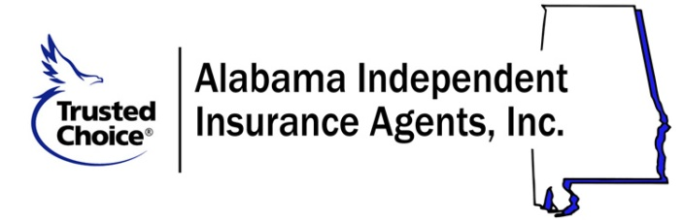
Alabama Independent Insurance Agents
141 London Parkway, Birmingham, AL 35211
Phone: 205.326.4129 / Fax: 205.326.3086
Email: tunderwood@aiia.org / Web: www.aiia.org

