Young Agents

Committee Organization

Committee Day is held twice a year. Please choose a committee
Membership Development | This committee develops and implements a marketing plan to member agencies with the goal of obtaining more involvement in the organization. The membership committee works in conjunction with Young Agent Regional Directors to identify, market, and recruit new members.  This committee supports various community outreach programs.
Young Agents Conference | This committee is responsible for the annual Young Agents Conference; its program, marketing, attendance, and sponsor development.
Legislative  &  Big I Pac Golf Tournament | The legislative committee is responsible for working with the Big I PAC Golf Tournament Committee to assist with its program, marketing, attendance and sponsor development.  This committee will also work towards obtaining more involvement from the Young Agents Committee at the National Legislative Conference in Washington and develop plans to enable more Young Agents Committee members to join the many other state associations with strong Young Agents Committee attendance.  The Chair shall also promote and solicit the Young Agents for InsurPac contributions and strive to obtain 100% of the Young Agent Committee participation. This committee also supports the Big I PAC Golf Tournament.
Excalibur Education Foundation (Clay Shoot) | This committee is composed of members of the Excalibur Foundation Board and other Young Agents to keep ideas fresh regarding fund raising opportunities to fund annual scholarships for Troy University & University of Alabama students studying Risk Management Insurance Majors.

Committees are formed from scratch each year, so please complete and return the reply form if you want to continue your service on a committee.

COMMITTEE REPLY FORM

YOR NAME: ________________________________________________________________________

AGENCY/COMPANY: _________________________________________________________________

ADDRESS: __________________________________________________________________________

CITY/STATE/ZIP______________________________________________________________________

TELEPHONE: ________________________________________________________________________

EMAIL: _____________________________________________________________________________

Choose One (1) Committee

_____ MEMBERSHIP DEVELOPMENT

_____ YOUNG AGENTS CONFERENCE

_____ LEGISLATIVE/BIG I PAC GOLF TOURNAMENT

_____ EXCALIBUR EDUCATION FOUNDATION – CLAY SHOOT

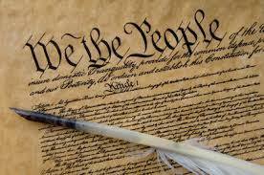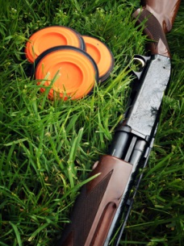

Once your committee has met; feel free to sit in on other meetings that have not concluded

FAX REPLY to (205) 326-3086 or EMAIL RESPONSE to ekelley@aiia.org

Alabama Independent Insurance Agents
141 London Parkway, Birmingham, AL 35211

