

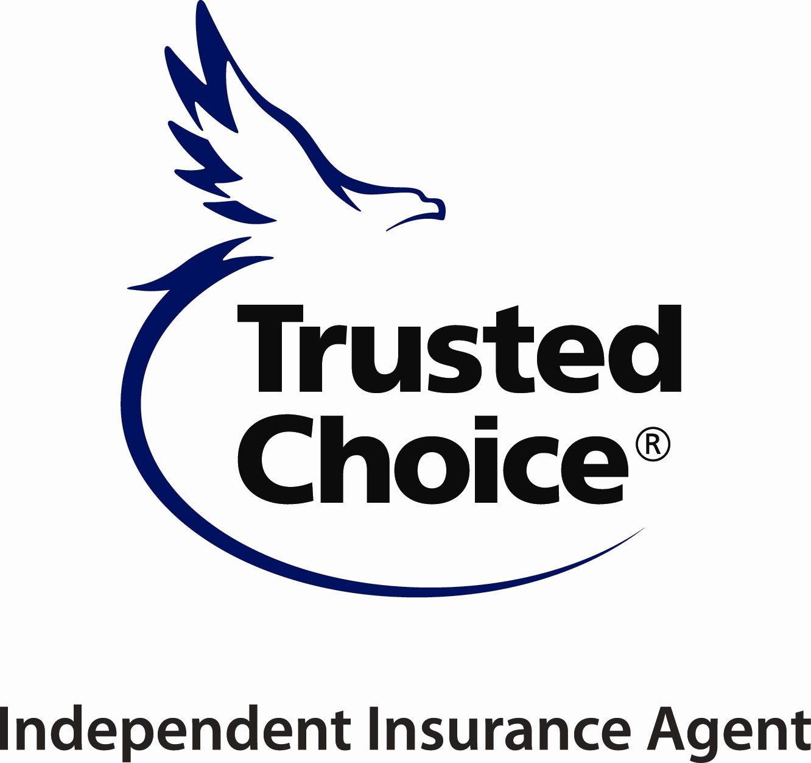

**2022 ANNUAL YOUNG AGENTS**

**SUMMER CONFERENCE**

**July 28 – July 30, 2022**

**SCHEDULE OF EVENTS**



John Immordino

**Thursday, July 28**

11:00a Golf at Tiger Point sponsored by AiA

2:00p Registration Desk Opens

7:00p Reception/Dinner

**Friday, July 29**

8:30a Breakfast Buffet

9:00a – 11:30a Roundtable “Meet & Greet” Exhibits & Door Prizes

Afternoon & Evening         Lunch on Your Own/Cornhole Tournament/Dinner on Your Own

**Saturday, July 30**

8:30a Breakfast Buffet

9:00a – 10:30a                 Cyber Presentation with John Immordino of Arlington/Roe

10:45a – 12:15p                Past / Current Young Agents Panel with Q&A

Lunch on Your Own – Cornhole Tournament on Beach

7:00p Closing Reception & Awards Banquet - *with Cornhole Finals*

***All dress for YA Conference is resort casual (No jeans/t-shirts please)***

## 

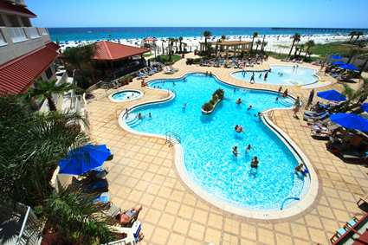

## HILTON Pensacola Beach Gulf Front Hotel

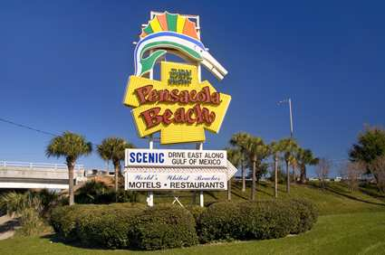

**CALL: (866) 916-2999 ASK FOR RESERVATIONS/GROUP CODE**: **YAC**

*Run of House/Standard:* ***$269****/room/night – single/double 1-Bedroom Suite:* ***$339*** *room/night*

*Gulf Front*: **$279**/room/night – single/double

*(Tax & SRIA Fees: 12.78% total (Subject to change) (Check-in: 4 p.m. Check-out: 11 a.m.*

**HOTEL ROOM BLOCK IS FILLING UP – BOOK ASAP**

Book Online: <http://www.hilton.com/en/hi/groups/personalized/P/PNSPEHF-YAC-20210728/index.jhtml>

**REGISTRATION FORM** First Time? ____ Yes ____ No

**Please type or print clearly**.

____ Member Agent/Sponsor $150 ____ Associate Member-$250 (Not Sponsor-No Roundtable)

____ Spouse/Guest Registration $150 ____ Kids 5-12 $ 60 (No fee Ages 1-4)

____ Non-Member Agent $175 ____ Non-Member Company $300

____ Roundtable Fee $250 ____ Roundtable Representative Fee $100

Name: _________________________ Designations: ___________ Spouse/Guest Name:____________________

# of Children Attending: ______ Ages: ___________ Names: _________________________________________

Agency/Company Name: ________________________________________Email:_________________________

Address: __________________________________City_______________ST____Zip______Phone: __________

**PAYMENT INFORMATION**

A $35 processing fee for all cancellations will apply. No refunds after 07/23/2021 - No Shows: No refund/full fee billed.

Check enclosed (made payable to AIIA) $ ____________ (Mail to 141 London Parkway, Birmingham, AL 35211)

Credit Card Please charge my VISA/MC/AMEX $ _____________

Card #: ______________________________________________________________ Ex. Date: __________________

Name as it appears on the card: ____________________________ CVC______________ ZIP ________________

Authorized signature: _____________________________________________________________________________

**►** Arriving early -Thursday, July 28th ? If you would like to play golf–check box and someone will call.

**Cell Phone No.:__________________________**

**►** If you would like to play in the Cornhole Tournament- check box.

**Hotel Cut Off Date June 27, 2022** Hotel reservations must be made directly with Hilton Pensacola at (866) 916-2999

Please return Registration & Payment to AIIA, 141 London Pkwy, Birmingham, AL 35211 - Or Email [ekelley@aiia.org](mailto:ekelley@aiia.org)

**REGISTRATION AVAILABLE ONLINE AT** [www.aiia.org](http://www.aiia.org) **under Education/Events Registration Calendar**

YA Conference located at Hilton Pensacola Beach Front, 12 Via De Luna Drive, Pensacola Beach, Florida 32561