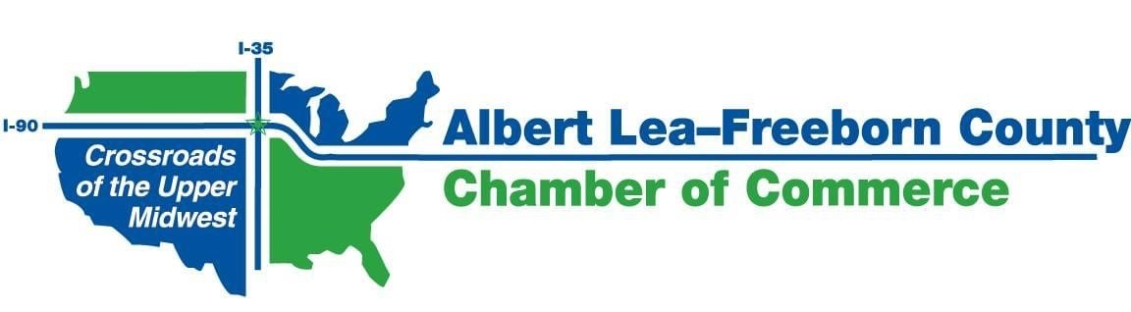
MONTHLY CHAMBER BOARD MEETING
ZOOM Video Conference Call
Wednesday, July 22nd, 2020; 7:30 a.m.

7:30 a.m. Welcome George

7:35 a.m. Reports
- City of Albert Lea Jerry Gabrielatos
- Freeborn County Tom Jenson
- CVB Holly Karsjens
- ALEDA Phillip Johnson
- Ag Committee (minutes attached) Bobbie Jacobs
- Ambassador Committee (minutes attached) Melissa Barr/Kathy Leidal

7:55 a.m. Consent Items George
- June Meeting Minutes*
- June 2020 Financial Reports*
- Budget items – Shari
  - Credit Card Fees – Monthly Noncompliance Fee
  - Past Due Member Dues

8:00 a.m. Other Committee Meetings – FYI only
- Worksite Wellness (Meeting was held - no agenda – no minutes)

8:05 a.m. Old Business
- Albert Lea Leadership Shari

8:15 a.m. New Business
- Biodigester and Biodiesel projects* Mike
- MN Auto Dealers Association (MADA) “California Clean Cars” initiative - TBD
- Code of Conduct* Shari
- Strategic Plan - City/County Branding Shari
- Annual Meeting - - Alternate plan Shari

9:00 a.m. Adjourn

* Included in documents emailed with agenda

The next meeting will be held on Wednesday, August 26, 2020 @ 7:30 am via ZOOM Video Conference

