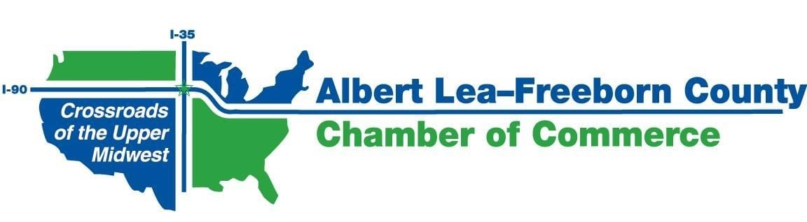
MONTHLY CHAMBER BOARD MEETING
ZOOM Video Conference Call
Wednesday, August 26th, 2020; 7:30 a.m.

7:30 a.m. Welcome George

7:35 a.m. Reports
- City of Albert Lea Jerry Gabrielatos
- Freeborn County Tom Jenson
- CVB Holly Karsjens
- ALEDA Phillip Johnson
- Worksite Wellness Ellen Kehr

7:55 a.m. Consent Items George
- July Meeting Minutes*
- July 2020 Financial Reports*

8:00 a.m. Old Business
- Biodigester and Biodiesel projects
- Code of Conduct
- Strategic Plan - City/County Branding
- Annual Meeting - - Alternate plan

8:15 a.m. New Business
- August and September member invoices
- Ambassador CD
- County Nonprofit Grant
- Member Benefits
- Board Seats – Recruitment

8:30 a.m. Adjourn

* Included in documents emailed with agenda

The next meeting will be held on Wednesday, September 23, 2020 @ 7:30 am via ZOOM Video Conference

