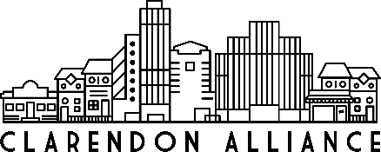

Clarendon Alliance – Board Meeting
Wednesday, December 18, 2019 / 6:30pm-8:00pm
Buena Vida Restaurant

Board Minutes

The Clarendon Alliance Board had a special Board meeting and holiday dinner at Buena Vida restaurant, in place of the regular December meeting. Scott Pedowitz opened the Board meeting by welcoming the group. We were not able to approve the November minutes so we pushed that to the next meeting. Elizabeth Crocker gave a brief overview of the month’s activities including spring events and business engagement. Elizabeth mentioned that she had met with Jumpin Joeys, Renegade, East West, Select Concierge and the Arlington Ombudsmen, in recent weeks. She has also been doing reconciliation with Wendroff & Associates. She noted the closing of both Gallery Clarendon and Clarendon Ballroom.

Nolan and Elizabeth Crocker gave a brief summary of the end of the calendar year financials and the final numbers from Clarendon Day. Scott asked the Board to reflect on how far the organization had come in one year, since there was no Executive Director in place at the same time the previous year. Several Board members spoke about the progress made over the course of the year. Scott and Elizabeth also both thanked Board Member Nora Bankert for helping to arrange the space for the dinner. The Board meeting/dinner ended at 8:00pm.

