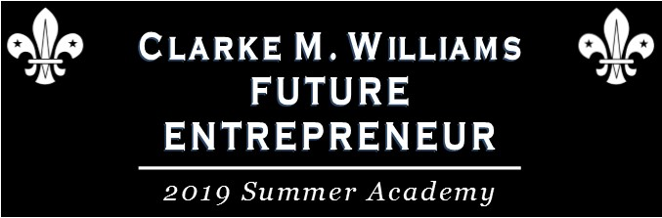

July 15-18, 2019 ~ 8:30 a.m. - 12:30 p.m.
Participant Application
PLEASE COMPLETE AND RETURN THIS FORM TO THE WMWO CHAMBER OF COMMERCE BY JULY 1, 2019.
A COMPLETED FORM WITH A PARENT/GUARDIAN SIGNATURE IS REQUIRED TO PARTICIPATE IN THE PROGRAM.

ABOUT THE PROGRAM
The West Monroe-West Ouachita Chamber of Commerce, CenturyLink, Ouachita Parish School System, and
Louisiana Delta Community College are committed to the growth and success of our community and the cultivation
of future business leaders and entrepreneurs. The Clarke M. Williams Future Entrepreneur 2019 Summer Academy
is designed to teach the basics of what it means to be an entrepreneur to interested high school students. This FREE four-day academy will be held at the West Monroe Campus of LDCC, located at 609 Vocational Pkwy., off Camp Road in West Monroe. To participate, students (entering grades 9-12) must complete and return this form to the West Monroe-West Ouachita Chamber of Commerce office by July 1, 2019. Limited seats are available.

PERSONAL DATA
Name: |  |  |  |  | Age:
 | Last | First
School: |  |  | Entering Grade:
Phone: | ( ) |  | Email:

Emergency Contact:
Name Relationship Phone Number

Please complete and return form to:  WMWO Chamber of Commerce  112 Professional Drive  West Monroe, Louisiana 71291 | For more information, please contact the  Chamber of Commerce at (318) 325-1961  or info@westmonroechamber.org
Parent and Student must read, initial, and sign the second page of this application.

STUDENT AGREEMENT
Please read carefully. Each item must be read and initialed by student and parent, and the application must be signed. For the purpose of this agreement, West Monroe-West Ouachita Chamber is otherwise known as WMWOC and Ouachita Parish School System is otherwise known as OPSS.

I understand that I am participating in this program voluntarily and in consideration of the acceptance of my application for this program:

Initial Here
I hereby waive, release, and discharge any and all claims for damages for personal injury, property damages, or which may hereafter occur to me as a result of participation in said event.
I agree to be present for all four days of instruction in the program.
I agree to act in a professional manner and abide by the rules, regulations, policies, and procedures of the facility.
I agree to dress appropriately as described by my school dress code (no shorts, tanks, camisoles, or hats in class).
Student Signature Date

PARENTAL CONSENT
Your son or daughter is applying to participate in a five-day Entrepreneur Academy. He or she will participate in a classroom setting with other students from the area, where they will learn key strategies for becoming an entrepreneur in today’s business climate. Please read carefully. Each item must be read and initialed by the parent, and the application must be signed.

Initial Here
My child has permission to participate in the Clarke M. Williams Future Entrepreneur 2020 Summer Academy, and I hereby waive, release, and discharge any and all claims for damages for personal injury, property damages, or which may hereafter occur to me or my child as a result of participation in said event.
My child’s information form can be shared with staff of WMWOC and OPSS for purposes of participation in the academy, and I grant the program organizers and sponsors of the program, permission to photograph/video my son/daughter for promotional and educational purposes, including but not limited to press releases, future marketing, use on social media and intranet sites, and use in other materials that the program organizers and may use internally or externally to promote the program and/or program sponsors. I understand there is no monetary compensation for using said photographs/videos.
I hereby give my consent for treatment by emergency personnel, a physician, or surgeon, in case of sudden illness or injury while participating in the above mentioned program. It is understood that WMWOC and OPSS will provide no medical insurance for such treatment, and the cost thereof will be at my expense.
Does your child require any special accommodations due to medical limitations, disability, dietary constraints, allergies—food or other,
physical limitations, or other restrictions?
NO YES--If yes, please explain:
I attest that I am the legal parent/guardian of the child, and as such permitted to sign this consent and release form.

( )
Printed Name of Parent/Guardian Best Contact Number

Parent/Guardian Signature Date

