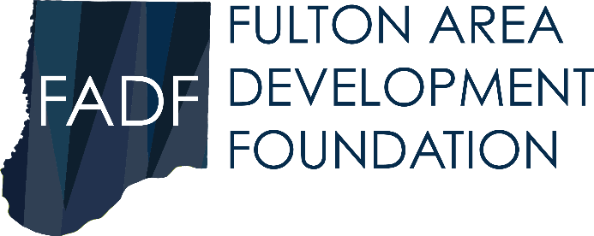
Marketing Recovery Grant for Small Business
Purpose:
To assist small businesses in Callaway County with marketing needs after being adversely impacted by COVID-19.
Qualifications:
- Small Business with 50 or less employees
- Business was adversely impacted and/or the business was closed during some period in 2020 due to COVID-19
What qualifies as marketing?
Examples: updating website, commercials (TV or radio), newspaper ads, banner ads, social media ads, etc.
To Apply:
- Complete Application
- Attach marketing plan
- Provide copy of current 2020 business license or 2020 Certificate of Good Standing
- Have application notarized

Marketing Recovery Grant for Small Business

Date of Application: _________________

Legal Business Name: _______________________________________
(must be the same business license)

Business Physical Location: __________________________________

Phone: ______________________

Type of Business: _________________________________________

Primary Business Contact: ________________________________

Title: ________________________

Email:______________________________________________________

Business Website: ___________________________________________________

Business Facebook: __________________________________________________

Other Social Media : __________________________________________________

# of employees _______________ (full-time) __________________ (part-time)

Are you applying for a business that is located in Callaway County?
- Yes
- No

Has your business applied for other grants related to COVID-19?
- Yes Please list: _______________________________________________
- No

How do you plan to market your business? Please use additional sheet to explain your marketing plan.

_______________________________________
Applicant Representative Signature

________________________________
Title

__________________________________
Date

Subscribed and sworn to before me this ______ day of ________,2020

_______________________________
Notary

Return application and all required documents to:
Tamara Tateosian
Executive Director
Callaway Chamber of Commerce
510 Market Street, Fulton, MO 65251

All applications must be mailed or dropped off at the Chamber of Commerce. Electronic submissions will not be accepted.

OFFICE USE ONLY

Date Received: _______________________ Received By:_____________________

FADF Decision: __ YES __ NO Date Awarded: ___________________

Comments: ____________________________________________________________

_______________________________________

