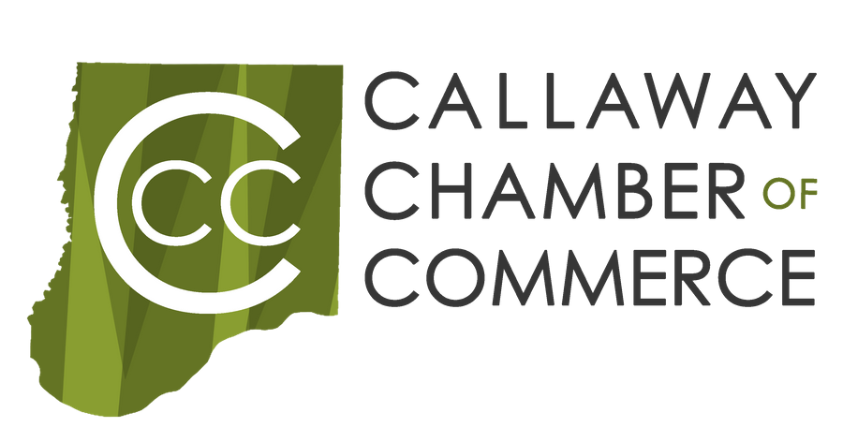
Callaway Evolution

Business Name:

Address:

Website:

Contact Name:

Contact Email:

Phone Number: Alternate Number:

Please provide the following information about your business:

When did you open your business?

Do you have a current business license? Date of renewal?

Who are the registered owners of the business?

Is the applicant authorized to make sole decisions on behalf of the company?

What business category best describes your business?

Do you rent or own your current location?

-If you rent, are you authorized to make changes to the building?

What are your hours of operation?

Are you willing to work on this project outside of business hours?

Do you have a business plan?

-If so, did you create it or receive assistance?

-If you received assistance, from who?

Describe your main product or service in 2-3 sentences.

What is the current software you use?

How do you market your business?

Challenges your business is facing:
Ex: Lighting, Systems, Marketing, Signage, etc

What steps have you taken to improve your business?
Ex: Additional Financial Investment, Marketing Platforms, Attended Classes, Worked with SBDC or MOWBC, etc

What solutions do you believe will fix these problems?

How many employees do you have?
________ Full Time
________ Part Time

How much is your gross revenue the past 3 years?
________ 2021
________ 2020
________ 2019

How much can you contribute to completing this project?
_____ $0-$500
_____ $500-$1500
_____ $1500-$5000

_____ I understand that a team of experts will assist in addressing these challenges.

_____ I understand that I will be asked to have follow up coaching for continued improvements.

_____ I understand that I will be asked to provide a copy of business license, proof of insurance, and certificate of Good Standing.

_____ I am willing to have a follow up after the project is completed with a photo release.

_____ I understand that FADF has the right to stop consultation at their discretion.

_____ I understand that there is no guarantee that the completion of the project will result in increased sales.

I certify that the information provided on this application is accurate. I understand that withholding of information or giving false information will result in a disqualification and forfeiture of all funding.

Print Name:

Signature:

Date:

