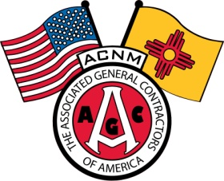
Associated Contractors of New Mexico

Contractor Assessment Monthly Report

Reporting Date:
ACNM Member Name:
Your Name & Title:

Projects Reported:
Project Name Contract Value

Per the Associated Contractors of New Mexico Bylaws, ACNM contractor members that prime bid projects will pay assessments on the contract value awarded. This assessment will be determined based on contract award date and apply to NMDOT, municipal and private construction work. Each month ACNM shall send ACNM members a contractor assessment report in which each prime contractor member shall fill this report out and fax or e-mail this report to the ACNM, if no contract awarded in a specific month then contractor shall report zero (0) for the corresponding month. ACNM shall invoice each member based on the information listed on this report. Any questions regarding this contractor assessment report shall be addressed to the ACNM Executive Director. Please refer to the ACNM contractor assessment fee schedule for details on assessments.

PO Box 25384 Phone: 505-344-2072
Albuquerque, NM 87125 Email: information@aconm.org Fax: 505-344-1554

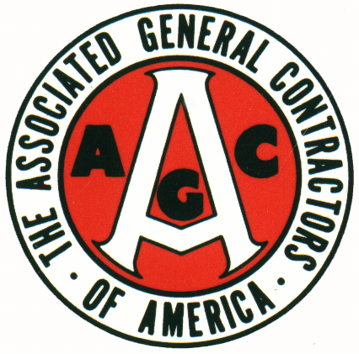 SKILL – INTEGRITY – RESPONSIBILITY 