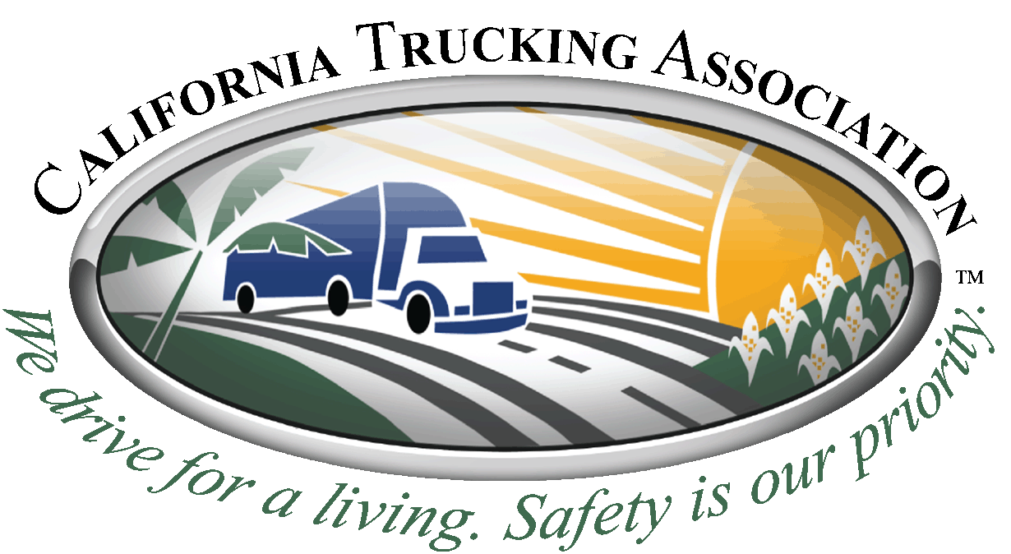

Permit Feedback Form
Please fill out as much information as you can. If crucial information is not included it may be difficult to review and submit to Caltrans.
- Date of incident: ________________________________________

- Incident involved: Permits Office Vehicle Inspectors
(Circle one)

- Type of Permit: Single Trip/ STARS/ Annual/ Variance/ Director Crossing
(Circle all that apply)

- How long did it take to receive an approval for your request? ____________________________

Please provide accurate details (below) regarding the incident:

(Attach a separate document if more space is needed)
Please circle all included attachments:
- Original Permit and/or Duplicate Permit

- Denied Permit Application

- Vehicle Inspection Report

- Route Survey

- Form 59

- Miscellaneous

Fax all applicable information including complaint form to (916) 373-3637.

