Thank you for exhibiting at Opportunities Doncaster LIVE 2021!

How it works
This year’s event will be virtual, and requires no physical presence from exhibitors.

The virtual platform – and your stand – will be live for one week.

OD Live – Exhibition Stand content requirements

Please complete the following table.
The information you submit will be what is on your virtual stand. We recommend providing as much information as possible to help make the stand engaging for visitors.
There are optional opportunities to engage with students live on the 19th May. If this is of interest, please detail in the relevant box and we will be in touch.

Company Name
Contact details, to be shown on website
Can include, email, website address and phone number
Company bio – 500 words maximum
Videos
Please send any company videos or careers related content that will aim to both inspire and educate students on either your organisation or sector.

Format for Videos below
- H264
- 1080HD 25 frames per sec
- 16:9 ratio

Downloadable resources for schools
.doc / .xls / .pdf

We would like you to send any material that you would typically use at a ‘Face to Face’ careers event over to us, so we can upload to the virtual platform so schools can download and utilise.

Suggested Resources to include-
Careers flyers
Job specifications
Interactive careers related content
Have a go activities

We are looking for businesses in each of the below sectors to provide ‘Employer Led Table Talks’ to a group of students in around 7-10 classes. Each talk will aim to be 25 mins in length and between the suggested times;

Session 1- 9.45am-11.00am
Session 2- 12.30pm-1.30pm

Sectors to include –
- Creative and Digital
- Transport and Logistics
- Culture, Art, Media and Sport
- Health, Social Care and Public Sector
- Leisure, Tourism, Hospitality/Catering and Retail
- Construction, Manufacturing & Engineering
- Financial and Professional Services

Suggested Topics to cover-
- Careers available in your organisation
- A day in the life of
- Overview of organisation
- Inspiring career stories
- Interactive educational workshops

If this is something, you feel you are able to support, please provide details on the session you are able to support with and we will be in touch. If not, please leave this section blank.

Jobs board-

Please confirm any live vacancies or future opportunities that you would like to share with the expected 3000 students who will be attending Doncaster Careers Week.

- Links to job vacancies on company websites
- Apprenticeship Adverts
- Company Careers Pages

Here is an example of what your stand will look like:
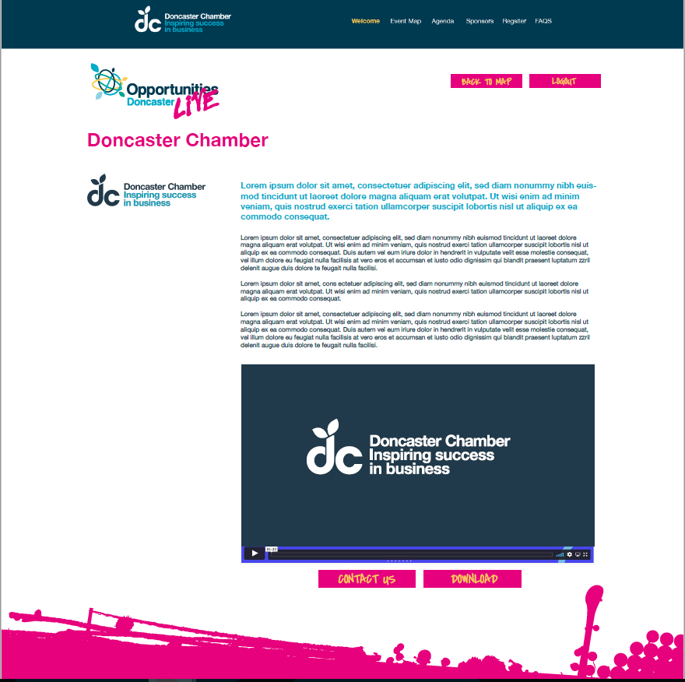

What next?
Please email your completed form, along with any video and downloadable content, to mlawrie@doncaster-chamber.co.uk .
In your email, please include a list of email addresses for representatives from your organisation who require access to the platform between 17-21 May.

