**AMFA iS looking for manufacturers to host tours**

* 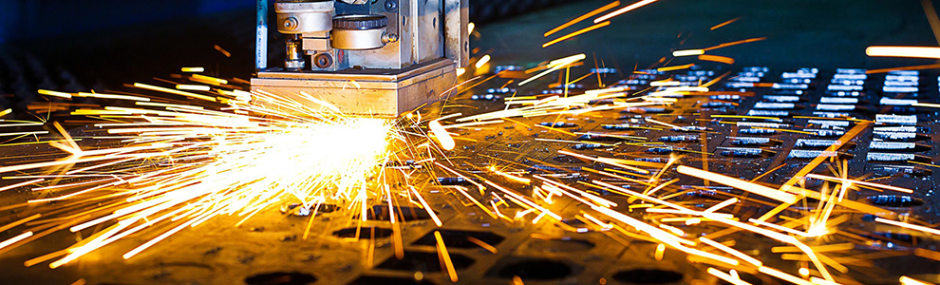

Attached you will find a help checklist and questionnaire please check off all opportunities you are willing to help with. If different dates work better for you, please indicate that at the end of the checklist.

Please return the attached checklist by September 29th to [alisa@midwestmanufacturers.com](mailto:alisa@midwestmanufacturers.com)

Tour of Manufacturing October 26th-27th

**Check all that apply**

* Host Manufacturing Tours
* Manufacturing Classroom Speaker
* Provide Snacks/Giveaways at Your Tour
* Volunteer on AMFA Education Committee
* Sponsor Tour of Manufacturing

1. Name of Company
2. Primary Contact for Tours
3. Primary’s Phone #
4. Primary’s Email Address
5. What do you primarily manufacture?

1. How long would a tour of your facility take? Please be as accurate as possible.

1. How many students can tour at one time?

8. Would your company provide the necessary safety

gear to wear or would the schools need to provide?

9. Please provide the time range that will work for your facility to provide tours on one or more dates:

Thursday, October 26th ______________________________________________

Friday, October 27th ______________________________________________

Alternate date and time ______________________________________________

10. Are there any limitations?

If there is any additional information that we should know about touring your facility, please share it here.

**General Safety Instructions that go out to teachers:**

* No open-toed shoes; Closed toed shoes only
* No heels
* Long hair should be tied back