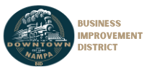
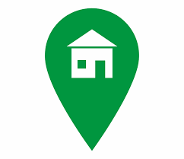
Location: 17 12th Ave S

Date: 9/13/2022
Time: 7:30am

Nampa Business Improvement District #2
Board Meeting Agenda

- Welcome / Call to Order: [Matt Lind]

- Roll Call / Introductions of Guests: [Matt Lind]

- Approval of Past Meeting Minutes [July 2022]:
    - ACTION: Move to approve minutes as presented.

- Reports:
  - Financial: [Jordan Baker]
    - ACTION: Move to approve reports as presented.

  - BID:
    - Mainstreet Manager Reports

  - City: [City Staff]
    - Code Compliance downtown buildings
    - Update on hiring for parking and code enforcement downtown
    - Vacant building ordinance
    - Strategic Planning Update
    - Vandalism

  - Beautification / Cleanliness:
    - Seasonal Décor Committee
- Old Business:
  - Update from Downtown Manager on collections contract
  - Planters (keeping item on agenda until mechanism in place to maintain knowledge)
  - Sound System Committee
  - Furnishings Committee (need to set up members and mandate)

- New Business:
- Annual Meeting Date - 24 October?
- Action – Motion to purchase trick-or-treat items
- General Discussion:

- Announcements:
  - Next Executive Board Meeting Tuesday October 4th, 10:30am – TBD
  - Next Monthly Board Meeting Tuesday October 11th, 7:30am – TBD

- Adjournment:

