PRESS RELEASE
“This program provides over
2 billion meals and snacks to over 4.9 million children and adults daily.”

DATE: Date
TO: Local Newspaper
FROM: Your Sponsorship Name
Address
FOR: IMMEDIATE RELEASE
SUBJECT: National Child & Adult Care Food Program Week: March 13-19, 2022
The primary goal of the Child and Adult Care Food Program (CACFP) is to serve nutritious meals to children attending child care homes and centers. Secondary goals are: 1. The establishment of positive eating habits at the earliest stages of development. 2. Reduction of future health care and education costs due to lack of proper early development. 3. Training and support of local child care personnel. Research also indicates that the CACFP is one important factor in providing quality child care.
During National CACFP Week, (Your Company Name), a (Your State) based nonprofit sponsor of the CACFP joins with (Your State or Area) family child care providers, center staff, and afterschool programs, in acknowledging the many ways our community benefits from the CACFP.
Children that are cared for by providers participating in the CACFP benefit by being fed nutritious USDA regulated meals that ensure their proper development. These children gain from early nutrition education that helps them establish positive eating habits that will enrich the quality of their diet throughout their life.
Parents of children in child care are assured that their child(ren) receives high quality meals. With proper nutrition, the child is less likely to experience illness and fatigue and will develop at a normal physical and intellectual pace. Good nutrition is the recipe for an all-around happier child.
Providers receive nutrition education and support services from their CACFP sponsor that help them serve nutritious meals and create a positive eating environment for children. The quality of child care provided in our community is improved due to educational and financial resources available to caregivers through the CACFP.
This program provides over 2 billion meals and snacks to over 4.9 million children daily in child care centers, family care homes, and after-school programs; over 115,000 elderly persons in Adult Day Care; over 62,000 child care centers; 115,000 family child care providers working with 800 sponsors use CACFP to provide children with high quality nutrition and learning experiences.
Please join us in honoring all CACFP providers for their invaluable work done on behalf of (Your State) children.
CONTACT: (Your Name, Phone, Email Address)
MORE INFO: www.cacfp.org

CHILD AND ADULT CARE FOOD PROGRAM: AVERAGE DAILY ATTENDANCE
Data from FY 2019
State/Territory | Number of Children Served |  | State/Territory | Number of Children Served
Alabama | 68,976 |  | Montana | 11,982
Alaska | 9,124 |  | Nebraska | 38,389
Arizona | 40,857 |  | Nevada | 21,262
Arkansas | 55,660 |  | New Hampshire | 10,969
California | 626,057 |  | New Jersey | 97,071
Colorado | 42,400 |  | New Mexico | 35,927
Connecticut | 24,613 |  | New York | 306,740
Delaware | 36,728 |  | North Carolina | 132,546
District of Columbia | 30,598 |  | North Dakota | 15,935
Florida | 314,925 |  | Ohio | 118,181
Georgia | 153,98 |  | Oklahoma | 63,284
Guam | 289 |  | Oregon | 47,766
Hawaii | 10,671 |  | Pennsylvania | 154,479
Idaho | 11,709 |  | Puerto Rico | 20,547
Illinois | 139,256 |  | Rhode Island | 12,210
Indiana | 99,801 |  | South Carolina | 51,673
Iowa | 42,130 |  | South Dakota | 15,035
Kansas | 48,526 |  | Tennessee | 87,704
Kentucky | 82,480 |  | Texas | 790,776
Louisiana | 90,988 |  | Utah | 32,742
Maine | 11,568 |  | Vermont | 11,870
Maryland | 94,688 |  | Virginia | 118,336
Massachusetts | 77,921 |  | Virgin Islands | 888
Michigan | 72,709 |  | Washington | 78,817
Minnesota | 104,025 |  | West Virginia | 23,994
Mississippi | 52,024 |  | Wisconsin | 58,783
Missouri | 87,863 |  | Wyoming | 6,865
 |  |  | TOTAL | 4,795,270
Source: USDA Food and Nutrition Service
Data are subject to revision.

LETTER TO CONGRESS
(Date)
Senator (First and Last Name)
(Address)
(City, ST Zip)
Dear Senator (Last Name):
March 13-19, 2022 is National Child & Adult Care Food Program (CACFP) Week. The CACFP is a partnership between parents, children, providers, and the CACFP sponsor emphasizing the important role that the CACFP plays in promoting lifelong healthy eating habits in children and also emphasizes the importance of the CACFP to promote physical activity in family child care homes and child care centers. The CACFP has been cited both in academic studies and in government reports for the contributions it makes to the well-being of children being cared for in our child care system. This program provides over 2 billion meals and snacks to over 4.9 million children and adults.
Because this program is so important to the constituents in your state, I want to remind you about the goals of the program and obtain your support during National CACFP Week.
The primary goal of the CACFP is to serve nutritious meals to children attending child care homes and centers, especially those from lower economic circumstances. Proper nutrition is vital to the physical, intellectual, and emotional development of young children. Secondary goals of the CACFP are: the establishment of lifelong, positive eating habits, reduction of future health care and education costs due to lack of proper early development, and training and support of local child care personnel. The CACFP benefits our state in the following ways:
FOR THE CHILD
Proper nutrition during the early years of childhood ensures appropriate development and reduces physical and educational problems later in life. Eating patterns and habits established during these years help determine the quality of one’s diet throughout life. Children participating in the CACFP enjoy meals that meet USDA nutrition requirements. These nutritionally complete meals help the child learn and grow and are the foundations that will help them achieve their fullest potential in the future.
FOR THE PARENT
Parents are assured that their children receive high quality, well-balanced meals. A well-nourished child is less likely to experience fatigue and illness, which requires parents to be absent from work. Children are more likely to be healthy, happy and develop at a normal physical and intellectual pace. The children are also sharing handouts with the parents, like fun and easy recipes that they can make together at home.
FOR THE PROVIDER
Providers receive valuable nutrition education that helps them identify the proper foods to feed in amounts appropriate for young age groups. They obtain help in understanding how to encourage positive eating habits that end up benefiting a child throughout life. The financial reimbursement helps them to be able to afford to serve nutritionally complete foods.
FOR THE COMMUNITY
Within our state, approximately (enter number) children directly benefiting from the food program. The CACFP in our state meets the nutritional needs of young children while they are in out-of-home care, resulting in significant enrichment and improvement of the quality of child care provided in our community.
In 1997, welfare reform legislation was implemented that made significant cuts in the CACFP. This resulted in a reduction of participation by family child care providers and thus reduced the number of children benefiting from nutritionally complete meals. We must all work together to assure children receive the nutritious meals they need to grow and eat well for a lifetime.
Sincerely,

(Your Name)
(Your Organization)
SAMPLE REQUEST FOR PROCLAMATION

WHEREAS: One of the basic rights of children, as set forth in the Universal Declaration of Human Rights by
Eleanor Roosevelt in 1948, is their right to basic nutrition. Caring for the children must be our nation’s first priority; and

WHEREAS: Since the inception of the Child & Adult Care Food Program (CACFP) in 1968, it has granted our children the best possible foundation in life and benefited many adults, which is vital to our state’s long-term health; and

WHEREAS: The two fundamental goals of the CACFP are that children serviced by this program will be well
nourished during their crucial years, while concurrently learning healthy eating behaviors that will last their lifetime. Emotional, mental and physical health originates with nutritious eating; and

WHEREAS: We acknowledge the child and adult care providers, nutrition educators, program specialists and staff, state and federal professionals and parents who contribute to the success of this outstanding program, The Child & Adult Care Food Program; and

WHEREAS: The CACFP will continue its commitment to the benefits of nutritious eating for children and adults. Together, as Americans, we can make a difference in the lives of our children.

Now therefore, I, _________________________________________________, Governor of the State
of _________________________________, do hereby proclaim this week of March 13-19, 2022 to be
CHILD AND ADULT CARE FOOD PROGRAM WEEK.

IN WITNESS WHERE OF, I have hereunto set my hand and caused the Great Seal of the State of _________________________ to be affixed at the State Capitol this __________ day of March in the year
of our Lord, ______________,

______________________________________
Governor’s Signature

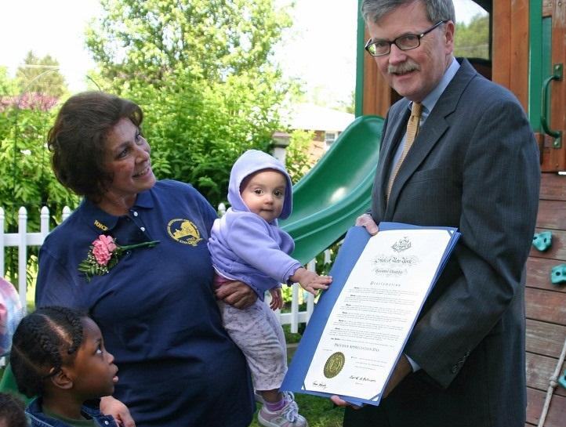
Ask Your Governor to Issue a State Proclamation
Share these outreach materials with your state governor’s office now, and together with other sponsors and providers from across the state, petition for a state proclamation to coincide with National CACFP Week. It’s a grassroots effort that, when fulfilled, will serve to raise awareness in your state government as well as community members across your state.

