PRESS RELEASE
“This program provides over
1.8 billion meals and snacks to over 4.5 million children and adults daily.”

DATE: Date
TO: Local Newspaper
FROM: Your Organization Name
Address
FOR: IMMEDIATE RELEASE
SUBJECT: National Child & Adult Care Food Program Week: March 12-18, 2023
The goal of the Child and Adult Care Food Program (CACFP) is to serve nutritious meals to children in care in child care homes and centers and in afterschool programs. The CACFP also serves adults in day care. Secondary goals are: 1. The establishment of positive eating habits at the earliest stages of development. 2. Reduction of future health care and education costs due to lack of proper early development. 3. Training and support of local child care personnel. Research also indicates that the CACFP is an indicator of quality child care.
During National CACFP Week, (Your Organization Name) joins with all other organizations nation-wide working in the CACFP in acknowledging the many ways our community benefits from the program.
Children and adults that are cared for by providers participating in the CACFP benefit from the nutritious meals that follow the CACFP meal pattern that ensure proper development. Children in CACFP receive meals that are nutritionally superior to those served to children in comparable child care settings not participating in the CACFP. These children benefit from early nutrition education that helps them establish positive eating habits that will enrich the quality of their diet throughout their life. Research shows that CACFP reduces food insecurity and plays a vital, clear role in promoting nutrition security.
Parents of children in child care are assured that their child(ren) receives high quality meals. With proper nutrition, the child is less likely to experience illness and fatigue and will develop at a normal physical and intellectual pace. Good nutrition is the recipe for an all-around happier child. By expanding access and strengthening CACFP, working families can ensure that their children are well cared for and receive the nutrient-rich diet and tools they need to be healthy.
Providers receive nutrition education and support services from their CACFP sponsor that help them serve nutritious meals and create a positive eating environment for children. Reimbursement for CACFP participation supports providers in offering nutritious meals to those in their care. As a result, CACFP providers serve more fruits, vegetables, and milk than non-CACFP child care providers.
This program provides over 1.8 billion meals and snacks to over 4.5 million children daily in child care centers, family day care homes, after-school programs, and over 137,000 adults in adult day care. Over 62,000 child care centers and 115,000 family day care providers work with 800 sponsors to use CACFP to provide children with high quality nutrition and learning experiences.
Please join us in honoring all CACFP providers for their invaluable work done on behalf of (Your State) children.
CONTACT: (Your Name, Phone, Email Address)
MORE INFO: www.cacfp.org

CHILD AND ADULT CARE FOOD PROGRAM: AVERAGE DAILY ATTENDANCE
Data from FY 2022
State/Territory | Number of Children Served |  | State/Territory | Number of Children Served
Alabama | 59,594 |  | Montana | 10,349
Alaska | 5,837 |  | Nebraska | 29,537
Arizona | 58,537 |  | Nevada | 16,246
Arkansas | 45,080 |  | New Hampshire | 7,727
California | 669,415 |  | New Jersey | 75,300
Colorado | 62,009 |  | New Mexico | 27,441
Connecticut | 20,832 |  | New York | 192,888
Delaware | 36,134 |  | North Carolina | 97,936
District of Columbia | 37,000 |  | North Dakota | 13,851
Florida | 318,515 |  | Ohio | 97,190
Georgia | 111,722 |  | Oklahoma | 59,609
Guam | 908 |  | Oregon | 30,936
Hawaii | 8,253 |  | Pennsylvania | 98,513
Idaho | 10,165 |  | Puerto Rico | 11,798
Illinois | 150,218 |  | Rhode Island | 11,590
Indiana | 74,856 |  | South Carolina | 37,930
Iowa | 35,586 |  | South Dakota | 11,036
Kansas | 36,692 |  | Tennessee | 72,297
Kentucky | 65,007 |  | Texas | 883,293
Louisiana | 90,296 |  | Utah | 29,095
Maine | 9,659 |  | Vermont | 8,236
Maryland | 210,071 |  | Virginia | 95,102
Massachusetts | 69,440 |  | Virgin Islands | 361
Michigan | 52,497 |  | Washington | 52,075
Minnesota | 148,380 |  | West Virginia | 22,322
Mississippi | 40,402 |  | Wisconsin | 45,754
Missouri | 112,093 |  | Wyoming | 5,803
 |  |  | TOTAL | 4,583,508
Source: USDA Food and Nutrition Service
Data are subject to revision.

LETTER TO CONGRESS
(Date)
Senator (First and Last Name)
(Address)
(City, State Zip)
Dear Senator (Last Name):
March 12-18, 2023 is National Child & Adult Care Food Program (CACFP) Week. The CACFP is a federal program that provides reimbursements for nutritious meals and snacks to participating child care centers, afterschool programs, family day care homes, and adult day care centers. The CACFP has been cited both in academic studies and in government reports for the contributions it makes to the well-being of children being cared for in our child care system. This program provides over 1.8 billion meals and snacks to over 4.5 million children and adults and is an indicator of quality child care.
Because this program is so important to the constituents in your state, I would love you to join me in celebrating the goals of the program and am requesting your support during National CACFP Week.
The primary goal of the CACFP is to serve nutritious meals to children attending family day care homes and centers and afterschool programs especially those from lower economic circumstances. The CACFP also serves adults in adult day care. Secondary goals of the CACFP are: the establishment of lifelong, positive eating habits, reduction of future health care and education costs due to lack of proper early development, and training and support of local child care personnel. The CACFP benefits our state in the following ways:
FOR THE CHILD
Proper nutrition during the early years of childhood ensures appropriate development and reduces physical and educational challenges later in life. Eating patterns and habits established during these years are vital to positive health outcomes. Children participating in the CACFP enjoy meals that meet the evidence-based USDA nutrition requirements that help combat hunger and improve nutrition security
FOR THE PARENT
Parents are assured that their children receive high quality, well-balanced meals. A well-nourished child is less likely to experience fatigue and illness, which requires parents to be absent from work. Children are more likely to be healthy, happy and develop at a normal physical and intellectual pace. Resources sent home with the children, like easy and highly nutritious recipes that they can make at home, contribute to the nutrition security of the entire household.
FOR THE PROVIDER
Providers receive valuable nutrition education that helps them identify the proper foods and proportions necessary to provide nutrient-rich meals and snacks to the children and adults in their care. They obtain help in understanding how to encourage positive, lifelong eating habits. The financial reimbursement helps them to afford to serve meals that are nutritionally superior to those served to children in comparable child care settings not participating in CACFP.
FOR THE COMMUNITY
Within our state, approximately (enter number) children and adults directly benefit from the food program. The CACFP in our state meets the nutritional needs of children and older adults while they are in out-of-home care, resulting in significant enrichment and improvement of the quality of child care provided in our community.
We must all work together to continue to strengthen and provide equitable access to the CACFP.
Sincerely,

(Your Name)
(Your Organization)
SAMPLE REQUEST FOR PROCLAMATION

WHEREAS: One of the basic rights of children, as set forth in the Universal Declaration of Human Rights by Eleanor Roosevelt in 1948, is their right to basic nutrition. Caring for the children must be our nation’s first priority; and

WHEREAS: Since the inception of the Child & Adult Care Food Program (CACFP) in 1968, it has granted our children the best possible foundation in life and benefited many adults, which is vital to our state’s long-term health; and

WHEREAS: The two fundamental goals of the CACFP are that children serviced by this program will be well nourished during their crucial years, while concurrently learning healthy eating behaviors that will last their lifetime. Emotional, mental, and physical health originates with nutritious eating; and

WHEREAS: We acknowledge the child and adult care providers, nutrition educators, program specialists and staff, state and federal professionals and parents who contribute to the success of this outstanding program, The Child & Adult Care Food Program; and

WHEREAS: The CACFP will continue its commitment to the benefits of nutritious eating for children and adults. Together, as Americans, we can make a difference in the lives of our children.

Now therefore, I, [Name], Governor of the State of [your State], do hereby proclaim the week of March 12-18, 2023, to be NATIONAL CHILD AND ADULT CARE FOOD PROGRAM WEEK. I urge our citizens and all agencies and organizations interested in meeting every child’s nutritional needs to unite on that week in the observance of the necessity of child and adult care food programs to provide quality child care and nutrition security to children and older adults in our community.

______________________________________ ________
Governor’s Signature Date

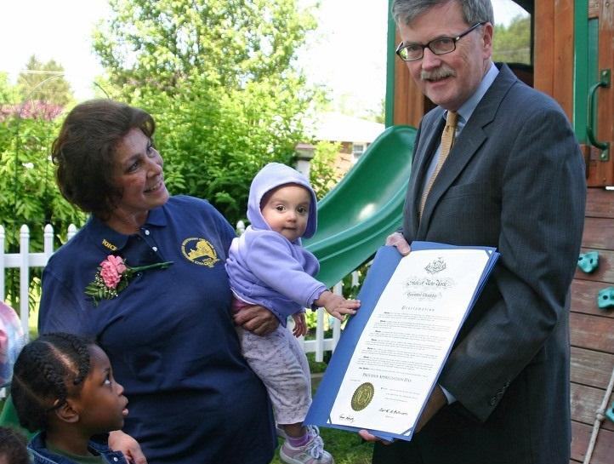

Ask Your Governor to Issue a State Proclamation
Share these outreach materials with your state governor’s office now, and together with other sponsors and providers from across the state, petition for a state proclamation to coincide with National CACFP Week. It’s a grassroots effort that, when fulfilled, will serve to raise awareness in your state government as well as community members across your state.

SAMPLE REQUEST FOR PROCLAMATION

WHEREAS: One of the basic rights of children, as set forth in the Universal Declaration of Human Rights by Eleanor Roosevelt in 1948, is their right to basic nutrition. Caring for the children must be our nation’s first priority; and

WHEREAS: Since the inception of the Child & Adult Care Food Program (CACFP) in 1968, it has granted our children the best possible foundation in life and benefited many adults, which is vital to our state’s long-term health; and

WHEREAS: The two fundamental goals of the CACFP are that children serviced by this program will be well nourished during their crucial years, while concurrently learning healthy eating behaviors that will last their lifetime. Emotional, mental, and physical health originates with nutritious eating; and

WHEREAS: We acknowledge the child and adult care providers, nutrition educators, program specialists and staff, state and federal professionals and parents who contribute to the success of this outstanding program, The Child & Adult Care Food Program; and

WHEREAS: The CACFP will continue its commitment to the benefits of nutritious eating for children and adults. Together, as Americans, we can make a difference in the lives of our children.

Now therefore, I, [Name], [Elected Official Title], do hereby proclaim the week of March 12-18, 2023, to be NATIONAL CHILD AND ADULT CARE FOOD PROGRAM WEEK. I urge our citizens and all agencies and organizations interested in meeting every child’s nutritional needs to unite on that week in the observance of the necessity of child and adult care food programs to provide quality child care and nutrition security to children and older adults in our community.

______________________________________ ________
(Insert Elected Official’s Title) Signature Date

Ask Your Local Elected Official to Issue a City Proclamation
Share these outreach materials with your local elected official’s office now, and together with other sponsors and providers from across the city, petition for a city proclamation to coincide with National CACFP Week. It’s a grassroots effort that, when fulfilled, will serve to raise awareness in your city government as well as community members across your city.

