SAMPLE REQUEST FOR PROCLAMATION

WHEREAS: One of the basic rights of children, as set forth in the Universal Declaration of Human Rights by Eleanor Roosevelt in 1948, is their right to basic nutrition. Caring for the children must be our nation’s first priority; and

WHEREAS: Since the inception of the Child & Adult Care Food Program (CACFP) in 1968, it has granted our children the best possible foundation in life and benefited many adults, which is vital to our state’s long-term health; and

WHEREAS: The two fundamental goals of the CACFP are that children serviced by this program will be well nourished during their crucial years, while concurrently learning healthy eating behaviors that will last their lifetime. Emotional, mental, and physical health originates with nutritious eating; and

WHEREAS: We acknowledge the child and adult care providers, nutrition educators, program specialists and staff, state and federal professionals and parents who contribute to the success of this outstanding program, The Child & Adult Care Food Program; and

WHEREAS: The CACFP will continue its commitment to the benefits of nutritious eating for children and adults. Together, as Americans, we can make a difference in the lives of our children.

Now therefore, I, [Name], Governor of the State of [your State], do hereby proclaim the week of March 10-16, 2024, to be NATIONAL CHILD AND ADULT CARE FOOD PROGRAM WEEK. I urge our citizens and all agencies and organizations interested in meeting every child’s nutritional needs to unite on that week in the observance of the necessity of child and adult care food programs to provide quality child care and nutrition security to children and older adults in our community.

______________________________________ ________
Governor’s Signature Date

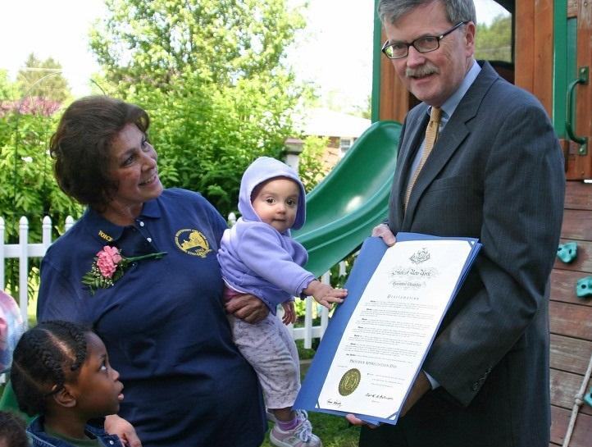
Ask Your Governor to Issue a State Proclamation
Share these outreach materials with your state governor’s office now, and together with other sponsors and providers from across the state, petition for a state proclamation to coincide with National CACFP Week. It’s a grassroots effort that, when fulfilled, will serve to raise awareness in your state government as well as community members across your state.

SAMPLE REQUEST FOR PROCLAMATION

WHEREAS: One of the basic rights of children, as set forth in the Universal Declaration of Human Rights by Eleanor Roosevelt in 1948, is their right to basic nutrition. Caring for the children must be our nation’s first priority; and

WHEREAS: Since the inception of the Child & Adult Care Food Program (CACFP) in 1968, it has granted our children the best possible foundation in life and benefited many adults, which is vital to our state’s long-term health; and

WHEREAS: The two fundamental goals of the CACFP are that children serviced by this program will be well nourished during their crucial years, while concurrently learning healthy eating behaviors that will last their lifetime. Emotional, mental, and physical health originates with nutritious eating; and

WHEREAS: We acknowledge the child and adult care providers, nutrition educators, program specialists and staff, state and federal professionals and parents who contribute to the success of this outstanding program, The Child & Adult Care Food Program; and

WHEREAS: The CACFP will continue its commitment to the benefits of nutritious eating for children and adults. Together, as Americans, we can make a difference in the lives of our children.

Now therefore, I, [Name], [Elected Official Title], do hereby proclaim the week of March 10-16, 2024, to be NATIONAL CHILD AND ADULT CARE FOOD PROGRAM WEEK. I urge our citizens and all agencies and organizations interested in meeting every child’s nutritional needs to unite on that week in the observance of the necessity of child and adult care food programs to provide quality child care and nutrition security to children and older adults in our community.

______________________________________ ________
(Insert Elected Official’s Title) Signature Date

Ask Your Local Elected Official to Issue a City Proclamation
Share these outreach materials with your local elected official’s office now, and together with other sponsors and providers from across the city, petition for a city proclamation to coincide with National CACFP Week. It’s a grassroots effort that, when fulfilled, will serve to raise awareness in your city government as well as community members across your city.

