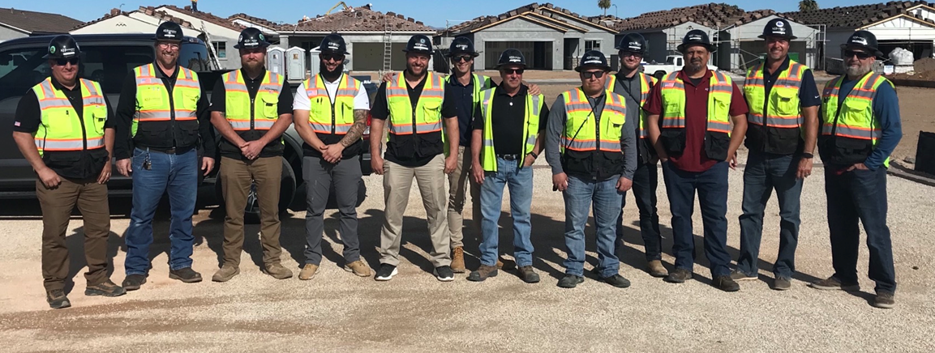

Overview

**What is personal protective equipment?**

Personal protective equipment, commonly referred to as "PPE", is equipment worn to minimize exposure to hazards that cause serious workplace injuries and illnesses. These injuries and illnesses may result from contact with chemical, radiological, physical, electrical, mechanical, or other workplace hazards.

If PPE is to be used, a PPE program should be implemented. This program should address the hazards present; the selection, maintenance, and use of PPE; the training of employees; and monitoring of the program to ensure its ongoing effectiveness.

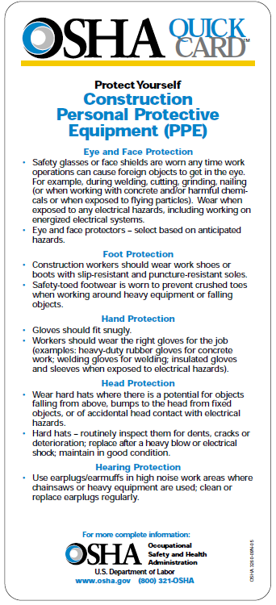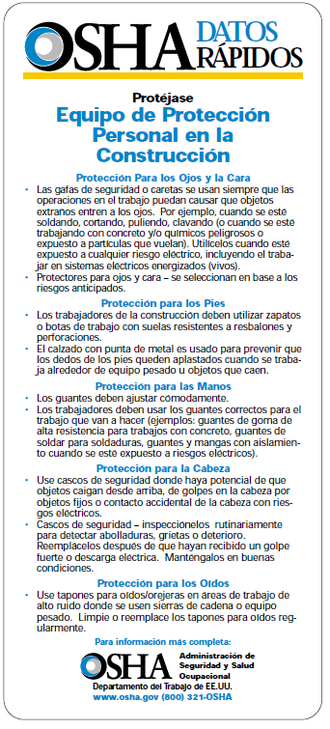

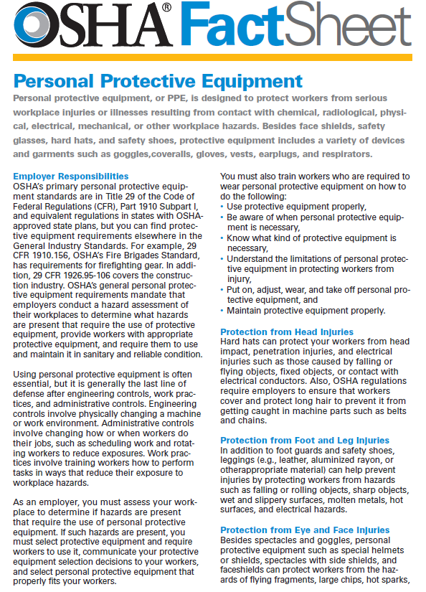

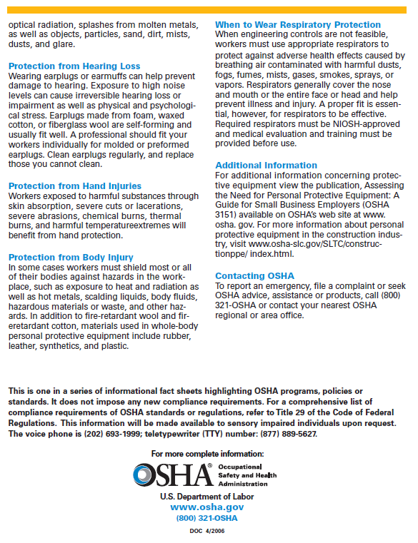

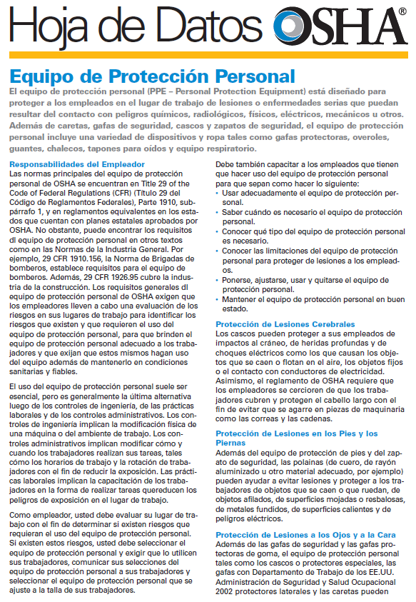

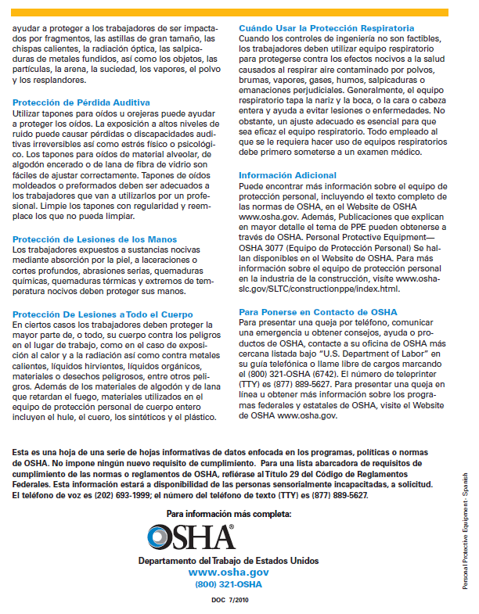

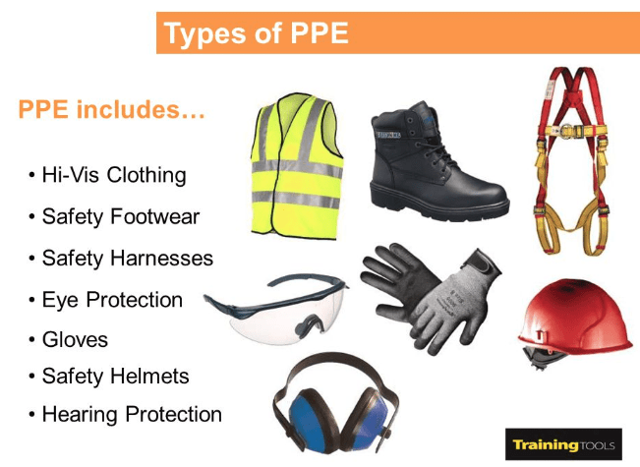

**Additional Information:**

* [29 CFR 1926 Subpart E](https://www.osha.gov/pls/oshaweb/owastand.display_standard_group?p_toc_level=1&p_part_number=1926#1926_Subpart_E), Personal protective and lifesaving equipment. OSHA Standard.
  + [1926.100](https://www.osha.gov/pls/oshaweb/owadisp.show_document?p_table=STANDARDS&p_id=10663), Head protection
    - [1926.100(a)](https://www.osha.gov/pls/oshaweb/owadisp.show_document?p_table=STANDARDS&p_id=10663#1926.100(a))
  + [1926.102](https://www.osha.gov/pls/oshaweb/owadisp.show_document?p_table=STANDARDS&p_id=10665), Eye and face protection
    - [1926.102(a)](https://www.osha.gov/pls/oshaweb/owadisp.show_document?p_table=STANDARDS&p_id=10665#1926.102(a)), General
* [29 CFR 1926 Subpart H](https://www.osha.gov/pls/oshaweb/owastand.display_standard_group?p_toc_level=1&p_part_number=1926#1926_Subpart_H), Materials handling, storage, use, and disposal. OSHA Standard.
  + [1926.250](https://www.osha.gov/pls/oshaweb/owadisp.show_document?p_table=STANDARDS&p_id=10685), General requirements for storage
    - [1926.250(a)](https://www.osha.gov/pls/oshaweb/owadisp.show_document?p_table=STANDARDS&p_id=10685#1926.250(a)), General
* [29 CFR 1926 Subpart L](https://www.osha.gov/pls/oshaweb/owastand.display_standard_group?p_toc_level=1&p_part_number=1926#1926_Subpart_L), Scaffolds. OSHA Standard.
  + [1926.451](https://www.osha.gov/pls/oshaweb/owadisp.show_document?p_table=STANDARDS&p_id=10752), General requirements
    - [1926.451(h)](https://www.osha.gov/pls/oshaweb/owadisp.show_document?p_table=STANDARDS&p_id=10752#1926.451(h)), Falling object protection
* [29 CFR 1926 Subpart CC](https://www.osha.gov/pls/oshaweb/owadisp.show_document?p_table=STANDARDS&p_id=14212), Cranes and Derricks in Construction. OSHA Standard.
  + [1926.1431(e)(10)](https://www.osha.gov/pls/oshaweb/owadisp.show_document?p_table=STANDARDS&p_id=97#1926.1431(e)(10)), Hoisting personnel