988: The 24/7 Lifeline for Emotional, Mental, or Substance Misuse Support
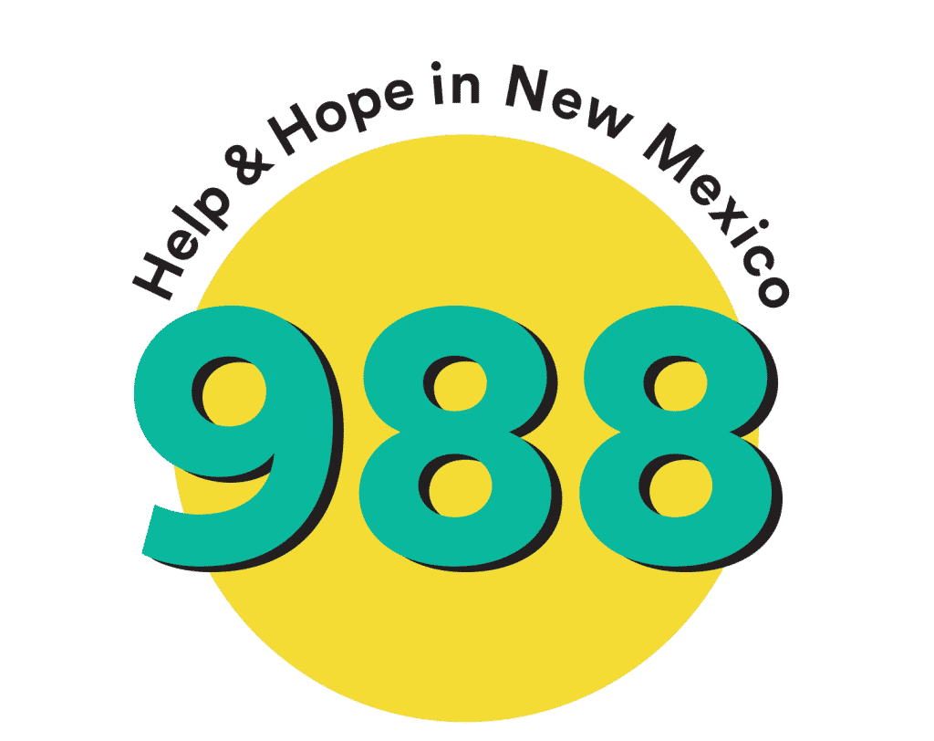

FREE & Confidential

More Than a Suicide Hotline

Real-Time Access
Call
When calling 988, callers first hear a greeting message while their call is routed to the local network crisis center (based on the caller’s area code).
You will also be given three options. Press 1 to connect to the Veterans Crisis Line or Press 2 to connect with the Spanish network.
Trained behavioral health professional will answer the phone, listen to the caller, understand how their problem is affecting them, provide support, and share resources if needed. If the local crisis center is unable to take the call, the caller will be automatically routed to a national backup crisis center.
Text
People who text “TALK” to 988 are currently connected to crisis centers equipped to respond to texts. This service will expand over the next few years to increase local and state-level response. Once connected, a behavioral health professional will listen to you, work to understand how your problem is affecting you, provide support, and share resources that may be helpful.
Chat
What happens when I chat via 988?
Chat is available through the Lifeline’s website https://suicidepreventionlifeline.org/chat
People seeking chat services are provided a pre-chat survey before connecting with a counselor that identifies the main area of concern. If there is a wait to chat with a crisis counselor, a wait-time message will appear. If demand is high, individuals can access the 988 “helpful resources” while waiting or call 988. Once connected, a behavioral health professional will listen to you, work to understand how your problem is affecting you, provide support and share resources that may be helpful.
No Insurance
Embrace PO Box 4425 575-840-1075
Serenity Club 1000 E. Bland St. 575-625-0868
Sliding Fee Scale/Medicaid
Alianza NM 1200 S. Richardson Ave. 575-623-1995
ENM Medical Center Sunrise Behavioral Health 405 W. Country Club Rd. 575-622-8170
Hope Youth Services 200 W. First St. 505-625-6909
La Casa Community Based Behavioral Health 110 E. Mescalero St. 575-755-2272
NM Rehabilitation Center 72 Gail Harris Ave. 575-347-3400
Presbyterian Medical Services 1105 Memorial Dr., Artesia, NM 575-746-9848
Private
Nirvana Mental Healthcare Services 400 Pennsylvania Ave. Suite 6700 202-852-8000
Behavioral Medicine Associates 1010 N. Virginia Ave. 575-623-9322
The Or Factor 400 N. Pennsylvania Ave, St. 670B 575-623-7336
Recovery Services of Southern NM 1107 S. Atkinson St. 575-578-4826
Turquoise Health and Wellness 110 E. Mescalero Rd. 575-623-1480
Private Therapists
Marla K. Anaya, LADAC, LPCC 105 W. 3rd St. Suite 429 575-637-1899
Dr. Lynn B. Daugherty, PhD 200 W. 1st St., Suite 323 505-623-1943
Susanna Rand, LPCC 500 N. Main St. Suite 610 505-623-9660
Medication Assisted Treatment
Dr. Melissa Bethany 1627 S. Union 575-755-5555
La Casa Behavioral Health 110 E. Mescalero Rd. 575-755-2272
Dr, Evan Nelson 1511 S. Grand 575-627-9500
Dr. Barnie Rodriguez, PA 1600 S.E. Main St. 575-623-1303
Dr. Loretta Sparkman 313 W. Country Club Rd. Suite 5 866-559-8607

