Rockwall Area Chamber of Commerce 2021 Ambassador Application

Thanks for joining this fun, active and distinguished group of Chamber partner volunteers. Below is an overview of the Ambassador Program.

What are the benefits of being an Ambassador?
- You receive immediate news of the community and first networking opportunities with new partners and businesses.
- You receive a listing on the chamber website with your company name and business website.
- You can promote and market your business first-hand to new and existing partners.
- You can network your business with Chamber partners, the community and its leaders.
- You can make a positive difference in the Chamber, Rockwall and in your business.
- Ambassadors will be eligible for recognition along the way.
- Ambassadors are listed in all signature event programs and on Audio Visual presentations when available.
- Ambassadors Cards are included in New Partner Welcome packets and Renewal Thank You letters.

What are the roles and responsibilities of an Ambassador?

All of the following must be fulfilled to remain an Ambassador of the Chamber
- Be a Partner (Member) of the Chamber for at least 6 months- in good financial standing.
- Ambassadors will pay a $25 annual fee upon execution of Ambassador Agreement.
- If the Ambassador chooses to purchase an Ambassador name tag the cost is an additional $15
- Ambassadors will earn a minimum of 180 points per quarter, January 1, 2021. This can be attained through partner follow up, attending luncheons, breakfasts, and business after hours, ribbon cuttings, volunteering for events or at the Chamber office, recruiting new members, renewing existing members or collecting past dues. If the Ambassador does not meet the required point submission in any given quarter their name will be removed from all Ambassador promotions, luncheon advertisements, partnership e-mails, etc. until the minimum points are tracked.
- Ambassadors must attend at least 2 Ambassador meetings per quarter. The Ambassador Team meets at the Chamber at 4:00 p.m. on the 1st Wednesday of every month. If the Ambassador does not meet the required attendance in any given quarter their name will be removed from all Ambassador promotions, advertisements, partnership e-mails, etc. until the minimum points are tracked.
- Ambassadors must attend at least 1 Chamber Academy per year.
- The Ambassador team serves as the Partner Appreciation Event committee
- Chamber Champions are Ambassadors who achieve over 1000 points within a 12 month period ending on 12/31/2021

Initial

Ambassador Role
Ambassadors are the face of the Chamber, and without you we could not be successful in what we do. As a Rockwall Area Chamber of Commerce Ambassador, you will be able to facilitate and introduce Chamber Partners at their Ribbon Cuttings, get engaged in social media advertisements on behalf of the Rockwall Chamber, and maintain current partner relationships with “Pop In’s” and Phone Check ins with Partners. Ambassadors will also have multiple opportunities to be an active in our Ribbon Cuttings, Chamber Networking Events, and volunteer at special events. Ambassador presence is expected whether the event is virtual or in person. There are still many ways to connect!
Especially during these times of not hosting large in person events, we need partners connecting with each other. The more you can help facilitate these connections, the greater success we will all achieve. The Chamber is not just about events but providing resources and information to our Partners and you get to be lead and be a part of the delivery of that.

What are the Chamber’s responsibilities to Ambassadors?
- To welcome you as a new Ambassador through our newsletter and announcements
- To recognize your efforts through our Newsletter, Website and Social media
- To prepare and distribute a monthly calendar and keep you informed in advance of upcoming activities, resources and iniatives related to the Chamber & Community
- To provide you with contacts to reach out to for various Chamber related business activities

Annual membership fee and engaged, documented participation is required to maintain an active role.

For up-to-date Ambassador notifications Text notify rockwallchamber ambassadors to 313131

Please complete and return the information below if you agree to meet the roles and responsibilities of a Rockwall Area Chamber Ambassador.

Name: Company: Primary/Mobile Number: Email: Signature: Date:

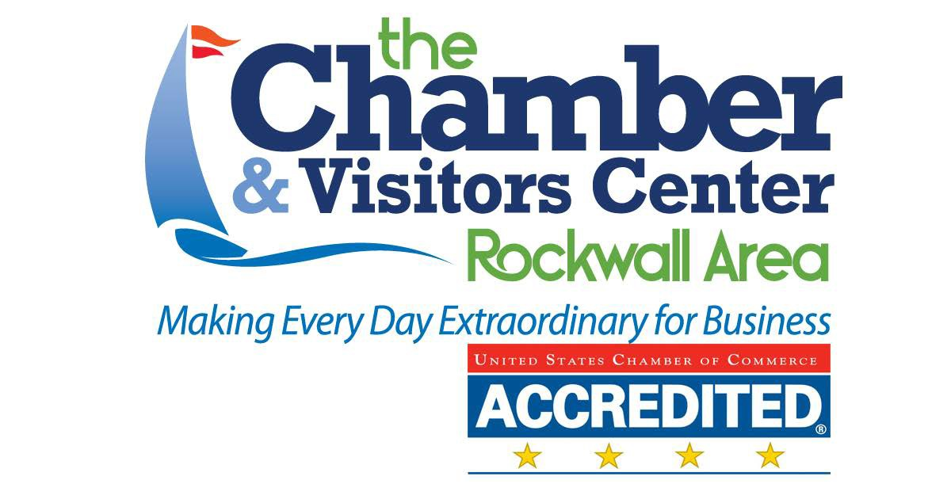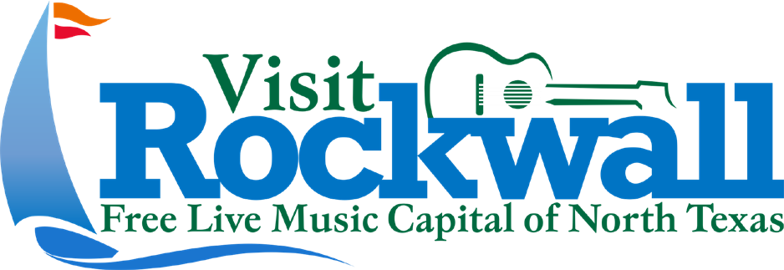
2021 Ambassador Points System

Points | Activity
2 pt. | Social Media Post, Share, & Comment (Count once per event) (Must do all three to receive points)
5 pt. | Prospect/Inactive Member Interaction-bring a prospect or inactive member to a chamber function, must be documented as other with name/event listed
5 pt. | Turn in points early/on-time (End of Business-Last day of the Month)
5 pt. | Attend an Ambassador Meeting or Chamber Committee Meeting
10 pt. | Current Partner “Pop In” – in Person or Phone
10 pt. | Committee Chair (Per Month)
10 pt. | Volunteer – each hour worked earns 10 pts. (maximum 8 hours per day)
10 pt. | Attend Ribbon Cutting, BAH, Partner Breakfast, Luncheon or Special Chamber Sanctioned Event  (Virtual or in person)
20 pt. | Secure or Refer a Sponsorship from another business under $500
20 pt. | Ambassador Referral
40 pt. | Secure or Refer a Sponsorship from another business over $500
25 pt. | Upgrade a Partner to higher Membership Investment Tier
25 pt. | Refer New Partner - Entrepreneur or Business level
50 pt. | Refer New Partner at Corporate or President’s Club level
75 pt. | Refer New President’s Club Partner or New Chairman’s Circle Partner
100 pt. | Refer New Partner to a Strategic Partner Alliance Partnership

*Keep this page.

