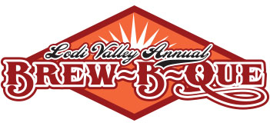

Saturday September 18, 2021

Downtown-Lodi-Main Street

**Salsa Contest Entry Form**

* Salsa Maker Name__________________________________________
* Salsa Name ________________________________________________
* Phone Number ______________________________________________
* Email Address _______________________________________________
* Contest Information:
* No Entry Fee
* Must have been canned in a hot bath, 3 Quarts for VIP Tasting and Judging
* Drop Off Time 9-9:30 am
* Labeled with Salsa Name, Heat (Inferno, Hot, Mild) & possible allergens, dairy, nuts or gluten
* Award Ceremony 4:30+ pm
* Container Pick–up/ 3:30 pm , LLWCC is not responsible for lost or stolen containers
* Prizes include: Cash Prizes, Metal Trophy, Bragging Rights, and Limitless Internet Fame
* Questions: Doug Meek @ (608) 576-7425 or [info@lodilakewisconsin.org](mailto:info@lodilakewisconsin.org)
* Copy and mail to Lodi Lake Wisconsin Chamber
* P.O. Box 43, Lodi , WI 53555

Please cut along line and return with payment

----------------------------------------------------------------------------------------------------------------------------------------------------------------

Chef Name: ________________________________ Phone Number: ________________________________

Email Address: __________________________________________

I plan to enter in other competitions:

* Salsa (Free to Enter)
* Ribs ($150 to enter)
* Home Brew ($20 for one entry; $10 each for more than one)

Please complete the form and mail it to:

Lodi & Lake Wisconsin Chamber of Commerce

P.O. Box 43

Lodi, WI 53555

*If you have any questions please call the Chamber Office at 608.592.4412 or email [info@lodilakewisconsin.org](mailto:info@lodilakewisconsin.org).