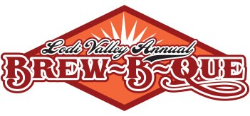
Application Chili Contestant

Thank you for your interest in the chili competition at our Brew-B-Que! This year’s event will be held on Saturday September 17, 2022 on Main Street in downtown Lodi Wisconsin. The event will officially begin at 10 am, however your entry for the chili competition should arrive between 8 & 9 am. The Chili Station will be located on Main Street, just in front of the Police Department. You are welcome to park behind City Hall and use the alley to bring your chili up. You must provide 3 gallons of Chili in a Nesco container for judging. We will provide the crackers and supplies to go with it.
Please fill out this entry form to reserve your spot. We will be getting back to you with additional details.

Name:______________________________________________________________________________
Chili Entry Name:__________________________________________________________________
Mild Chili Hot Chili With Meat Meatless
Contact Phone:_____________________________________________________________________
Contact Address____________________________________________________________________
Contact Email:_____________________________________________________________________

Yes, I’d like to sign up for the Chili Competition – fee $20.00

Please mail your entry form and check made payable to Lodi & Lake Wisconsin Chamber of Commerce to PO Box 43 Lodi WI 53555. You can direct any questions to Heidi LeHew at info@lodilakewisconsin.org.

