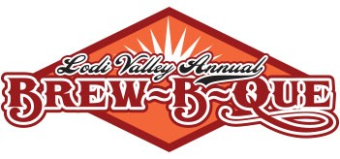
Application for Homebrew Contestant

Thank you for your interest in the Homebrew Competition at our Brew-B-Que! This year’s event will be held on Saturday September 17, 2022 on Main Street in downtown Lodi Wisconsin. The event will officially begin at 10 am, however your entry for the Homebrew Competition should be dropped off at the Chamber of Commerce Office located at 114 N. Main Street by Friday September 16th. You must provide qty 12, 12 ounce bottles of beer per entry (144 ounces total) for judging. We will provide the necessary items to go with it.
Please fill out this entry form to reserve your spot. We will be getting back to you with additional details.

Name:______________________________________________________________________________
Contact Phone:_____________________________________________________________________
Contact Address:___________________________________________________________________
Contact Email:_____________________________________________________________________

You can enter more than one homemade brew by using just this one form. Additional entries are offered at a discount.
I have one entry for the Homebrew Competition – fee $20.00
Name of Brew Entry :___________________________________________
Type of Brew:__________________________________________________
2nd Brew Entry – fee $10.00
Name of Brew Entry :___________________________________________
Type of Brew:__________________________________________________

Please mail your entry form and check made payable to Lodi & Lake Wisconsin Chamber of Commerce to PO Box 43 Lodi WI 53555. You can direct any questions to Heidi LeHew at info@lodilakewisconsin.org.

