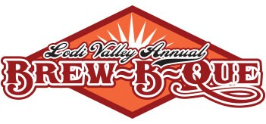
Application Salsa Contestant

Thank you for your interest in the salsa competition at our Brew-B-Que! This year’s event will be held on Saturday September 17, 2022 on Main Street in downtown Lodi Wisconsin. The event will officially begin at 10 am, however your entry for the salsa competition should be submitted by Friday September 16th. All entries can be dropped off at the Chamber of Commerce Office located at 114 N. Main Street in Lodi. Email Heidi at info@lodilakewisconsin.org to set up a time. You must provide 3 quarts of salsa for samples and judging. We will provide the chips and supplies to got with it.
Please fill out this entry form to reserve your spot. We will be getting back to you with additional details.

Name:______________________________________________________________________________
Salsa Entry Name:__________________________________________________________________
Mild Salsa Hot Salsa
Contact Phone:_____________________________________________________________________
Contact Address____________________________________________________________________
Contact Email:_____________________________________________________________________

Yes, I’d like to sign up for the Salas Competition – fee $20.00

Please mail your entry form and check made payable to Lodi & Lake Wisconsin Chamber of Commerce to PO Box 43 Lodi WI 53555. You can direct any questions to Heidi LeHew at info@lodilakewisconsin.org.

