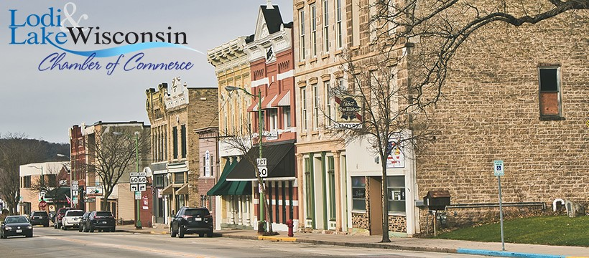

|  |  |  |
| --- | --- | --- |
| Lodi & Lake Wisconsin Chamber of Commerce  A Guide to Membership, Value & a look into 2023 |  | Chamber Membership at a Glace |
|  |  |  |
| A Note from the Executive Director By Heidi LeHew  So much can change in such a little amount of time! The last year for the Lodi & Lake Wisconsin Chamber of Commerce has been full of growth. In our membership, our reach, our relationships and our ability to serve our members. We have learned so much and leaned on the community for support and guidance through it all. From that experience, we have made bold decisions that will elevate our offerings to new levels in 2023.  If you are a member for the first time or have been with the Lodi & Lake Wisconsin Chamber for years, we invite you to read more about your membership in this document. Without a doubt our events will be stronger, our offerings to members will continue to diversify and enhance and the support you will continue to receive from us will be unmatched. In 2023, our goal is to be better. To do better. And to do all things with you in mind, our members. |  | Contents |
| 2023 Calendar of events  Flagship Events, Special & Networking Events & Event Sponsorship Opportunities  Member Value  Why join our Chamber?  (and stay here)  Membership  Dues, Inclusions, Sponsorship Opportunities & Perks |

|  |  |  |
| --- | --- | --- |
| 2023 Events A look into the year  Lodi and our surrounding areas are rich in tradition and community. We love that so much about where we live, work and play. As a Chamber of Commerce, our role is to balance supporting our business community while also playing an active role in those events.  Although not an event organization per se, it is important for us to drive additional traffic to our area via several flagship events throughout the year. We are happy to host them and enjoy seeing the uptick in business and smiles when we do.   * Annual Awards Dinner – Saturday February 25th * Annual Golf Outing – Wednesday June 14th * Susie the Duck Day – Saturday August 12th * Brew-B-Que – Saturday September 16th * Business Trick or Treat – Friday October 27th * Sip & Shop – Friday November 10th * Shop Small Saturday – Saturday November 25th * Spring Street Market – seasonal Farmer’s Market     **Sponsorships are available for ALL of our flagship events in 2023! Levels vary and details can be sent separate from this document! We cannot thank our sponsors enough for their continued support!** |  | Special Events & Networking Opportunities Additional events for you, as a member, to enjoy!    Networking is an important part of your chamber membership! Through Chamber of Commerce hosted events, we are happy to help you make connections, continue your education, learn about the community you support and so much more! Here are a few of the fun, monthly events you can partake in!  Lunch & Learn Events – A mid-day break to listen and learn from experts in their fields.  Chamber After 5 – Networking opportunity for all members.  Business Brainstorms – Complimentary, private meeting space that’s exclusive to our members!  Member Mondays – Monthly member meetings to discuss Chamber happenings  Open Houses – Join our members for tours, open houses & on-site gatherings. |

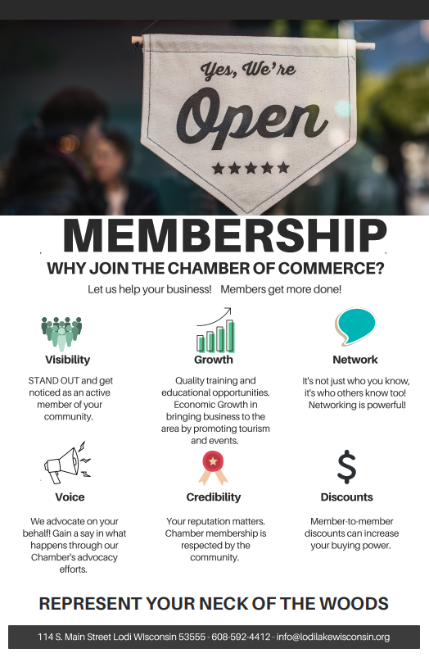

120 Portage Street – Lodi WI 53555 – 608-592-4412 – info@lodilakewisconsin.org

|  |  |  |  |
| --- | --- | --- | --- |
| Annual Membership Dues 2023 dues based on number of full-time equivalents (FTE)  40 hrs/week = 1 FTE; 2 part-time staff @20 hrs/week = 1 FTE  1 – 4 full time employees $250.00  5-10 full time employees $300.00  11 – 20 full time employees $500.00  20 – 80 full time employees $700.00  80+ full time employees $1,000.00  ------------------------------------------------------------------------------  Community & Service Organizations $150.00 Not-for-profit organizations and clubs, schools & churches.  Associate $300.00 Individuals located outside of the Lodi School District but also provides a service to the community.  *All Chamber of Commerce Volunteers qualify for $50 credit**on annual dues! An opportunity to get involved and save dollars on your membership at the same time!* | |  | What does my membership include? 2023 Membership Values    Personalized business website listing at www.lodilakewisconsin.org. You can customize your site, add job listings, events, hot deals and more! **$250.00 value**  Year-round access to the private Chamber of Commerce meeting space located at 120 Portage Street (free WiFi available too!) **$100.00 min value**  Referral calls and emails; business referrals.  Access to members-only events such as the Lunch & Learn’s, Chamber After 5’s, Business Brainstorms, Member Monday’s and our Annual Awards dinner.  Free access to communication and promotion through bi-weekly newsletters.  Access to promote events via our online community calendar as well as specials and hot deals publicly on the chamber website.  Brochure and card placement in the Chamber of Commerce building.  Ribbon cuttings, grand openings and social media support for all new members. |
| Services You are eligible for additional support as a member of the Chamber of Commerce. | Our Chamber of Commerce is an extension of our business community. We are here to support you in any way we can. Here are a few additional ways we can help!   * Access to Membership Lists & Reports * Access to advice on social media and digital marketing projects * Social Media promotion and event support * Reduced printing costs on flyers, brochures and marketing materials via the Chamber of Commerce print center. | | |
|  | Application for Membership or Annual Renewal | | |

Thank you for your consideration in joining the Lodi and Lake Wisconsin Chamber of Commerce. We are proud to serve our business community and look forward to helping your business thrive here in the peaceful valley.

In order to set up your new membership account, please head to [www.lodilakewisconsin.org](http://www.lodilakewisconsin.org). You’ll enter the below information online and at the same time set up your very own internal website, specific to your organization. Payments can all be made online as well. This online account will help promote your organization and gain access to many online benefits. If you do not have access to that, you are able to submit applications via mail to 120 Portage Street Lodi Wisconsin 53555. All checks are payable to Lodi and Lake Wisconsin Chamber of Commerce.

Business Name:­­­­­­­­­­­­­­­­­____________________________________ Contact Person____________________________

Additional Contacts (if any):___________________________________________________________________

Mailing Address:____________________________________________________________________________

Location Address (if different):_________________________________________________________________

Phone:_______________________ Email:________________________________________________________

Fax (if used):____________________________ Website Address: ____________________________________

Social Media:_______________________________________________________________________________

**All memberships are calculated based on number of FULL TIME equivalents (FTE).**

**40 hours per week = 1 FTE or 2 part time staff @ 20 hours per week = 1 FTE**

|  |  |  |
| --- | --- | --- |
| **Number of FTE** | **Annual Dues** | **Total Amount Due** |
| 1 – 4 | $250.00 |  |
| 5 - 10 | $300.00 |  |
| 11 - 20 | $500.00 |  |
| 20 – 80 | $700.00 |  |
| 80 + | $1,000.00 |  |
| Community & Service Organization | $150.00 |  |
| Associate | $300.00 |  |

Total number of full-time employees = _________

Total number of part-time employees = ________

Total full-time equivalent = __________________



1. **Annual Membership Dues**

Please select the number of Full-Time equivalents and corresponding annual dues. Full-Time equivalents (FTE) are calculated by adding total staff hours up to 40 hours in a work week. If you have one staff person working 40 hours, that is one FTE. If you have 2 staff persons, each working 20 hours, that is also only one FTE.

1. **Annual Sponsorship Opportunities**

Are you looking to sponsor the Chamber of Commerce in an exciting and advanced way this year? We are happy to announce that you can! We have created unique sponsorship packages, outside of sponsoring specific events, because we have listened to your suggestions. Based on your feedback, there are three levels of sponsorship available. These packages have high visibility, unique offerings and a great overall value!

*Annual Gold Sponsor Package ($1,150 value) ___________________price $500*

* Acknowledgement of sponsorship in Chamber of Commerce Newsletter
* Feature post on our Facebook page
* Special Feature in Chamber of Commerce Newsletter
* Logo to be included on Welcome Packets (used in the upcoming year)
* Logo to be featured on monthly, member event documentation (used in over 20+ events throughout the year)

*Annual Platinum Sponsor Package ($2,385 value) __________________price $1500*

* All items in Gold Sponsor Package as well as…
* 2 week banner Ad on Chamber of Commerce Website
* 4 Event Tickets to Lodi’s Sip & Shop event to be held in November 2022
* Educational Sponsor Package
  + Name & Logo on all paper materials for events (20+ throughout the year)
  + Social Media Recognition on all events (Lunch & Learns, Chamber After 5’s and Business Brainstorms)

*Annual Diamond Sponsor Package ($3,910 value) ______________________$3000*

* All items in both Gold and Platinum Sponsor Packages as well as…
* 2 additional week banner ad on Chamber of Commerce Website (4 total weeks)
* 1 week use of the Chamber of Commerce office building for your business display
* Use of Office Advertising in the Chamber of Commerce meeting space
* Awards Dinner Package:
  + 2 complimentary tickets to the Awards Dinner for 2023
  + Complimentary drink tickets and gift basket
  + Opportunity to speak at the event
* Event Sponsorship Opportunity:
  + Choose 2 of our flagship events toward which to apply up to $1K in sponsorship credits.
  + Advertise in those events per the event sponsorship packages

1. **Additional Information**
   1. Circle any of the areas below for which you’d like additional information:
      1. I’d like to sign up to be on an Event Committee
         1. Annual Golf Outing
         2. Susie the Duck Day
         3. Brew B Que
         4. Sip & Shop
         5. Farmer’s Market
      2. I’m interested in learning more about being on the Board of Directors
      3. I’d like to learn more about volunteer opportunities with the Chamber
      4. I’d like additional information about upcoming Event Sponsorships before the events.

Totals from Section 1:____________________________________________

Totals from Section 2:____________________________________________

Annual renewals are due by January 21, 2023: ________________________________

Online payments can be make via your login & password as well. Please contact us at [info@lodilakewisconsin.org](mailto:info@lodilakewisconsin.org) if you need support for your online account.

We thank you so very much for your membership!

