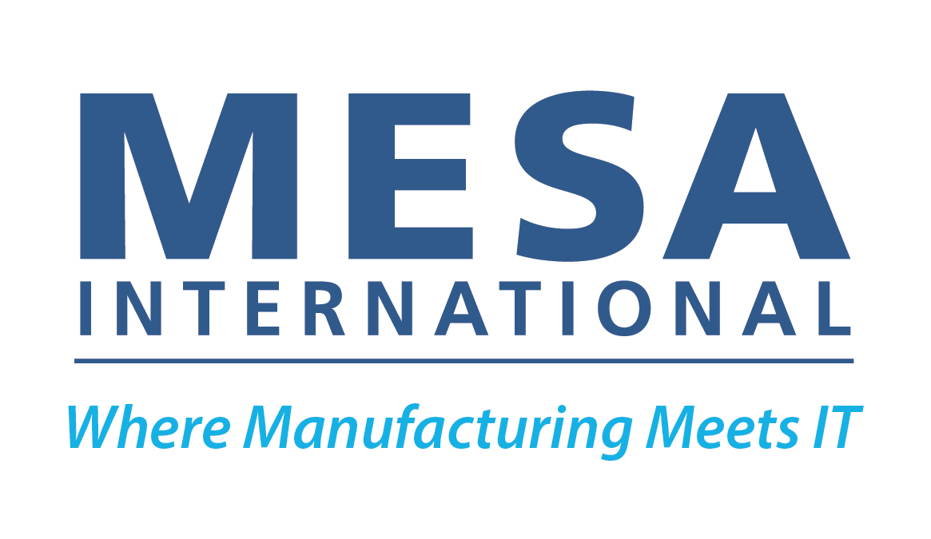

Use Case Submission Form

This form is used to gather the required information to put MESA Smart Manufacturing Model Use Cases into editing and layout. Submit the completed form to Brandy Richardson, MESA Executive Director, at brandy@mesa.org.

Use cases must be free of overt commercialism. Specific product or company names should not appear in the use case and should be replaced with a generic term. Manufacturers come to MESA to learn best practices about manufacturing operations in a neutral, non-commercial environment. They are not interested in advertisements or claims of superiority by any one company or technology. Use cases should not include an opinion or recommendation of another member company or potential member company (or their products/software offerings) in any way. This includes negative or positive comments about other companies' capabilities, strengths, weaknesses, etc. Content should strive for vendor neutrality. Company name can appear by the author name. A company logo can be included on sponsored use cases only.
All submitted content must be devoid of any references to political, ethnic, or religious preference.

Submitted by:
Please include your information so we can contact you with questions about your submission. Information in this section will not be included on the use case.

Sponsors can include their logo. If you are a sponsor and would like your company logo to appear on the use case, please attach it in .png format with a transparent background.

Full Name:*
Company:*
Phone:*
Email Address:*

Are you or the authors willing to present this use case in a webinar for MESA? Yes No

Title of Use Case:*

Subtitle:* (A short 1-2 sentence or 30-40 word tagline about the content.)

What industry vertical(s) is the use case about?* (i.e. automotive, food & beverage, pharmaceutical, oil & gas, etc.)

Summary:* (~100 words. The summary will be used in promotional materials, as well as describe the entry on the MESA website.)

What Challenges are being addressed in the use case?* (3-5 bullets or sentences.30-75 words.)

Smart Manufacturing Solution:* (3-5 bullets or sentences. 50-75 words.)

Describe the Benefits:* (3-5 bullets or sentences. 50-75 words.)

Optional: Include an image/chart/graph to support the use case.
By submitting the image file, you are agreeing that you have appropriate ownership and are allowing MESA to reprint the image. Include a high resolution (300 dpi) version when possible. Keep in mind that text on graphics can be difficult to read if the image needs to be resized. Consider that the graphic may need to be recreated to make it readable.
Image #1 Caption: (up to 25 words.)

Authors:*
Author Name / Company  Please include the full name and company of the content authors as you’d like them to appear on the use case (example: John Doe, ABC Company). Place each author name on a separate line) | Author Email Address  All authors of use cases must agree to the Terms & Conditions of Submission of Work to MESA which can be found here: https://www.surveymonkey.com/r/ZKYVFBK. The Terms & Conditions of Submission of Work to MESA will be sent to the email addresses below for agreement. Email addresses will not be published on the use case.

Which Lifecycles, Cross-Lifecycle Threads and Technologies from the MESA Smart Manufacturing Model will your use case be referencing?* Must select at least one or more items from every column. For more information about the model, visit www.mesa.org/model
Lifecycles | Cross-Lifecycle Threads | Enabling Technologies
Product  Supply Chain  Production  Production Asset  Order-to-Cash  Workforce | Quality  Compliance  Modeling/Sim  Analytics  Digital Twin/Thread  Sustainability  Security | IIoT  Big Data  AI / ML  Wireless  Blockchain  Edge to Cloud  Additive  Robotics  VR / AR  Other (not listed):

FOR INTERNAL MESA INTERNATIONAL USE ONLY
Use Case #:
Reviewers: (MESA will assign reviewers to your use case.)

 | Reviewer Name / Company | Reviewer Name / Company

