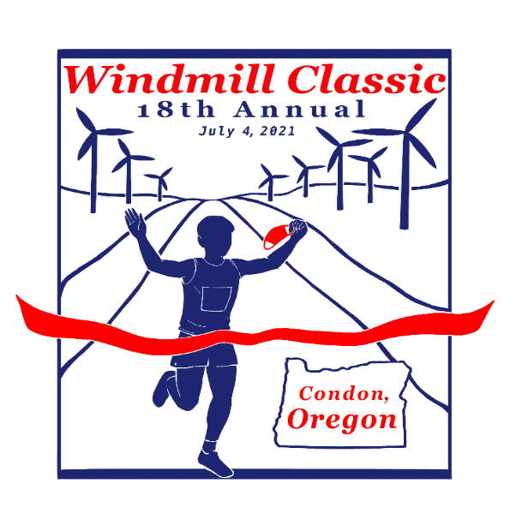

When: Sunday, July 4th at 8 am
Check-In/Sign-Up 6:45 -7:45 a.m.

Where: Sign-Up at Condon City Park

Cost: $25 with T-shirt or $20 without T-shirt

The 8K run starts 4 miles northwest of town on Hwy 206 at the ALLTE Clean Energy (Windmill) Headquarters. The 5k walk starts 2 miles northwest of town at mile marker 38 at the windmill scenic pullover. The finish line is at the City Park at the south-end of Main Street on Hwy 19.

Awards & medals will be given to the top three male and female finishers of run and walk.
The oldest walk competitor will receive the Jack Shannon memorial award. Packet pickup and registration is available at Condon City Park from 6:45-7:45 am on the day of the race.
Contact Kathryn Greiner, 16889 Greiner Lane, Fossil OR 97823 at 541-626-1127 or greinerlane@hotmail.com.

We will have mileage markers along the course at each mile point and will have local enthusiasts provide the water at the halfway-mark aid-station. There will be a bathroom at the City Park, but no honey buckets at the start or on the course. Participants are responsible for their own transportation to the start of the race.

Join us afterwards for Condon’s Fabulous Fourth of July celebration.

Proceeds from the run/walk will help Condon Cross Country Team.

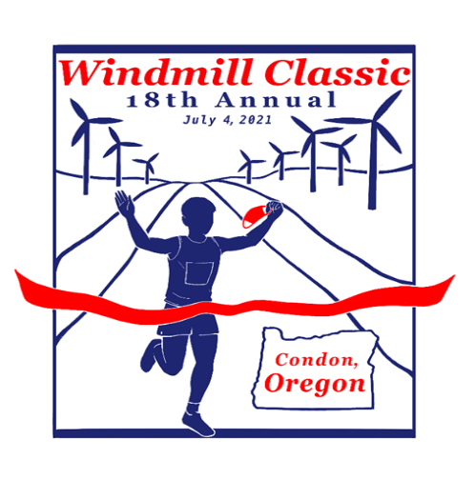

REGISTRATION
CONDON'S 18TH ANNUAL WINDMILL CLASSIC
July 4, 2021

Last Name:_______________ First Name:__________________ Gender:_____

Age:_______________ Address:____________________________________

Circle One: Run or Walk

T-Shirt Size:_________ Registration Cost: $25 with T-Shirt $20 without
Please read and sign-in consideration of my entry being accepted in this event. I., the undersigned intending to be legally bound, do hereby for myself, my heirs, my personal representatives and assigns, wave and release and forever discharge any and all rights and claims for damage which I may hereafter accrue to be against City Of Condon and all other sponsors, or their officials, employees, agents, or successors for any and all damages, claims, injuries or actions sustained or suffered as a result of my participation in the Condon Fabulous 4th 8K windmill run/walk I attest and verify that I have full knowledge of the risk involved in this event and that I am physically fit and sufficiently trained to participate. I also understand that the entry fee paid by me is non-refundable and that I, or a representative, must be present to receive any rewards to which I might be entitled. I have carefully read and understand this waiver.

Signature of Parent or Legal Guardian (if under 18)_____________________

Signature of Participant__________________________________________

Mail checks & forms to:
Kathryn Greiner, 16889 Greiner Lane, Fossil, Oregon 97830 or
Drop off at City Hall, 128 S. Main Street, Condon

Make checks out to Kathryn Greiner

