Please use the below as a sample or guide as to the insurance requirements necessary to participate in the Lodi District Chamber of Commerce event (Farmers Market, Street Faire, etcetera).

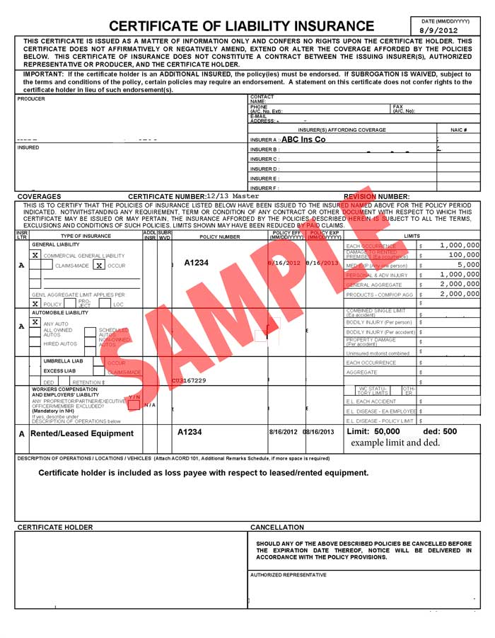
Current Date

Insurance Company Information

Vendor or Insured Person/Company

Each Occurrence = $1,000,000
Damage to Rented = $100,000
Med Exp = $5,000
Personal & Adv Injury = $1,000,000
General Aggregate = $3,000,000
Products-Comp/Op Agg = $2,000,000
Combined Single Limit = $1,000,000

Policy Expiration Date
Policy Effective Date

Policy Number Description of Operation = Bold

Certificate Holder is named as additional insured in regards to the general liability.

Also describe event (i.e. Lodi Farmers Market, Lodi Street Faire, etcetera) and the date(s) of the event(s).
Lettering must be exact. Then add addition information as described.

Lodi District Chamber of Commerce
35 S. School Street
Lodi, CA. 95242

Insurance Company Representative’s
Signature

