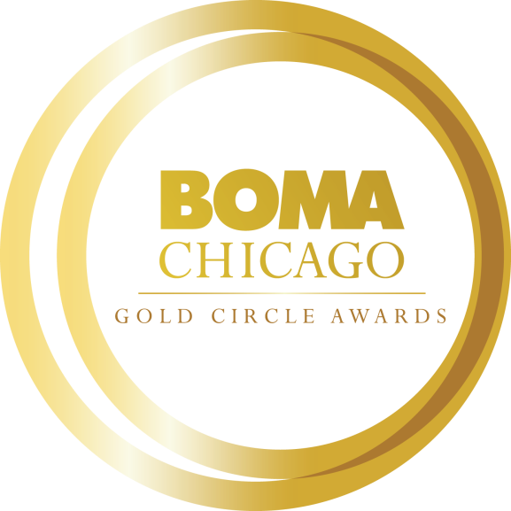
2022-2023 BOMA/Chicago Gold Circle Awards
Award nominations must be submitted online to BOMA/Chicago by 5 p.m. on Friday, October 28.
There is no registration fee to participate.

Categories & Application Links
- Affiliate Member of the Year
- Building Engineer of the Year
- Emerging Leader of the Year
- Janitorial Professional of the Year
- Property Management Professional of the Year
- Security Professional of the Year

The Award Selection Committee
The award selection committee, referred to as the “Gold Circle Panel,” is comprised of one representative each from twenty management companies that have the most BOMA/Chicago members and one BOMA/Chicago Board member. The panel will evaluate each nomination submission to determine finalists in each category, interview finalists, and select award winners for each category.

Predetermined Award Criteria
All nominees and finalists are judged based on predetermined, weighted criteria as indicated on the nomination form and detailed on the FAQ page.

Finalist Selection
The Gold Circle Panel will review nominations and judge each category based on the predetermined criteria as outlined in the Finalist and Winner Selection section of the FAQ page. Panelists for each category will be selected to avoid conflicts of interest because of company or building affiliations. The scores will be tallied by BOMA/Chicago staff and the top three finalists in each category will be determined.
Interviews and Selection
BOMA/Chicago will notify all finalists and arrange an in-person interview with at least three members of the Gold Circle Panel. Panelists for each category will be selected to avoid conflicts of interest because of company or building affiliations. After all interviews have been completed, the scores will be tallied by BOMA/Chicago staff and the winners in each category will be determined.

2022-2023 GOLD CIRCLE AWARDS TIMELINE
September 12 | Nominations Open
October 28 | Nominations Close
November 1 - 11 | Judges review submission forms and select three finalists for each category
November 28 - December 9 | In-person interviews will be conducted
December 14 | Winners decided
February 2023 | Toby/Gold Circle Awards Gala

ELIGIBILITY REQUIREMENTS
To participate in the BOMA/Chicago Gold Circle Awards, nominees must meet the following criteria:
- All nominees must complete and submit all nomination materials as indicated on the nomination forms.
- Individual applicants must be nominated. Self-nominating entries will not be accepted.
- All nominees must be employed in a BOMA/Chicago member building or affiliate company.
- All candidates must have at least five years of experience in commercial real estate.
  - Except for nominees for the Emerging Leader of the Year which are limited to building members with five years or less of experience in the commercial real estate industry.
- One nomination per category will be allowed from each Commercial Real Estate Company for Property Management, Building Engineer, Security Professional and Emerging Leader.
- Commercial Real Estate Companies may each submit one nomination from each of their Affiliate Member contractor companies for the Janitorial Professional of the Year Award.
- BOMA/Chicago Building and Affiliate Members may each submit one nomination for the Affiliate of the Year Award.
- Nominee finalists will be required to participate in a 30-minute in-person interview with select members of the Gold Circle Panel.
- Nominees are not eligible to serve on the Gold Circle Panel.
- Winners will not be eligible to resubmit for a minimum of two years following their recognition. (I.e. 2022 winner could reapply for the 2026 awards.)
ADDITIONAL INFORMATION
For additional information, head over to the Gold Circle Awards section and the FAQ page on the BOMA/Chicago website or contact Caitlin Wright, Marketing and Events Manager at cwright@bomachicago.org.

