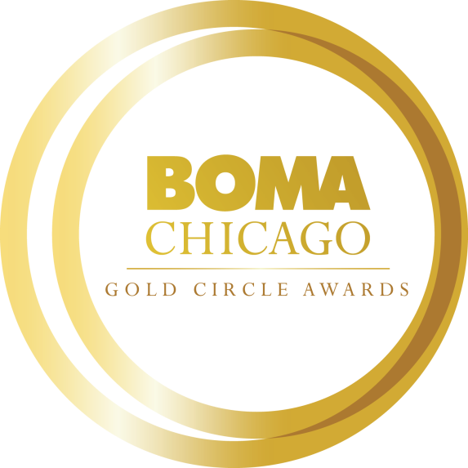
2023 Affiliate of the Year
Gold Circle Award Application

Online Application Process
All Gold Circle Award nomination applications must be submitted electronically to BOMA/Chicago by Friday, October 28. Each Building Member and Affiliate Member may submit one nomination for this award category.

CLICK HERE TO ACCESS THE AFFILIATE MEMBER OF THE YEAR ONLINE APPLICATION

We encourage you to complete the application in this Word document before submitting the application online. When you submit your application online, word count limitations will be strictly enforced. All attachments (photos, PDFs, etc.) can be uploaded to the online form.

Objective
This award is dedicated to honoring exceptional and significant service to BOMA/Chicago by an individual employed by an Affiliate member company with superior customer service and professional expertise.

Nominator Information:
Name:
Title:
Company:
Building:
Email Address:
Phone:
Please describe your role in working with this nominee and evaluating the services performed by the nominee and his/her company in 100 words or less.

Nominee Information: (You may contact the nominee for assistance in completing the following information.)
Name:
Title:
Company:
Building:
Email Address:
Phone:
Total Years in Commercial Real Estate Industry (please provide years only):
Please provide the nominee’s (1) professional bio OR resume and (2) headshot.

Short Answer Questions Please limit your response to no more than 500 words each.
- Please provide an overview of the nominee’s involvement in the Commercial Real Estate Industry and Chicagoland community during the past two years (e.g., BOMA/Chicago, IREM, NAOIP, CoreNet, civic, community, and/or philanthropic, etc.)

- Please specifically describe the professional services this Affiliate Member provided to your building/company and explain the reasons you rate this nominee highly in professional service and competency.

- Please provide an example of a customer service initiative that has had a positive impact on the Affiliate Members' business relations with their customers (e.g. online service call tracking feature, decreased acceptance times for new work orders, etc.).

- What professional accomplishments has the nominee achieved during the past two years? Please provide details about obstacles or challenges the nominee faced and the successful end result.

- How has the nominee demonstrated strength in team development and commitment to your organization? Provide examples of situations where the nominee has shown strong team leadership.

- Has the nominee participated in any training or professional development programs? If so, please provide an overview of the sessions attended, courses completed, or certifications received during the past two years.

Letters of Recommendation
Please provide one letter of recommendation from the following sources:
- BOMA/Chicago Committee Chair who can attest to the nominee’s service to BOMA/Chicago; or
2. Building manager or owner

The recommendation letters are to outline why this nominee should be considered for the Affiliate Member of the Year Award.

Please confirm all nomination materials have been completed/collected before submitting:
- Nomination Form
- Bio or Resume
- Headshot
- Letter of Recommendation

