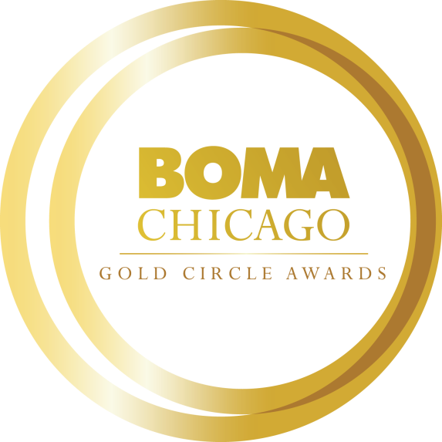
2023 Building Engineer of the Year
Gold Circle Award Application

Online Application Process
All Gold Circle Award nomination applications must be submitted electronically to BOMA/Chicago by Friday, October 28. Each Commercial Real Estate Company may submit only one nomination for this award category.

CLICK HERE TO ACCESS THE BUILDING ENGINEER OF THE YEAR ONLINE APPLICATION

We encourage you to complete the application in this Word document before submitting the application online. When you submit your application online, word count limitations will be strictly enforced. All attachments (photos, PDFs, etc.) can be uploaded to the online form.

Objective
Dedicated to honoring operational excellence among Chicago’s building engineers, this award is open to all engineering professionals overseeing the systems and infrastructure of BOMA/Chicago member commercial buildings.

Nominator Information:
Name:
Title:
Company:
Building:
Email Address:
Phone:
How are you affiliated with the nominee? Please describe in 100 words or less.

Nominee Information: (You may contact the nominee for assistance in completing the following information.)
Name:
Title:
Company:
Building:
Email Address:
Phone:
Total Years in Commercial Real Estate Industry (please provide years only):
Participation in Local 399? (Yes or No)
Please provide the nominee’s (1) professional bio or resume and (2) headshot.

Nominee Building Information
Building Size:
Building Age:
Engineer Staff Size:
Number of Tenants:

Short Answer Questions: (Please limit your responses to no more than 500 words.)
- Please provide an overview of the nominee’s involvement in the Commercial Real Estate Industry and Chicagoland community during the past two years (e.g., BOMA/Chicago, IREM, NAOIP, CoreNet, civic, community, and/or philanthropic, etc.)

- How has the nominee achieved exceptional results in preventive maintenance and repair of the building’s mechanical, electrical, HVAC and plumbing systems using cost-effective, sustainable methods to ensure tenant safety and comfort? (Please note awards such as LEED certification, TOBY Award, BOMA 360 Performance Program, BOMA 7-Point Challenge.)

- Has the nominee participated in any engineering-focused training or professional development programs? If so, please provide an overview of the sessions attended during the past two years and how this training has produced positive outcomes for your building.

- How has the nominee achieved tenant satisfaction at the building he/she is the Building Engineer? Provide examples of how the nominee has contributed to tenant retention programs, building specific services and programs, and tenant engagement initiatives (bringing tenant matters to the management staff to address/direct tenant contact and resolution of tenant issues, etc.).

- What professional accomplishments has the nominee achieved during the past two years? Please provide details about obstacles or challenges the nominee faced and the successful end result.

- Has the nominee helped you prepare for a TOBY Award application process and/or building review effort? If yes, describe participation and outcomes.

Letter of Recommendation
Please provide one letter of recommendation from the building’s General Manager or Property Manager outlining why this nominee should be considered for the Building Engineer of the Year Award.

Please confirm all nomination materials have been completed/collected before submitting:
- Nomination Form
- Bio or Resume
- Headshot
- Letter of Recommendation

