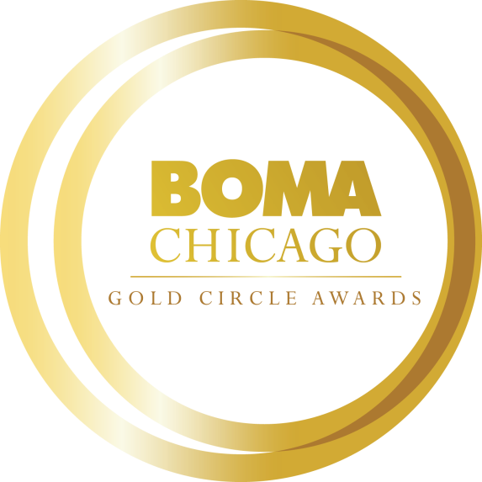
2023 Janitorial Professional of the Year
Gold Circle Award Application

Online Application Process
All Gold Circle Award nomination applications must be submitted electronically to BOMA/Chicago by Friday, October 28. Each Commercial Real Estate Company may submit only one nomination for this award category.

CLICK HERE TO ACCESS THE JANITORIAL PROFESSIONAL OF THE YEAR ONLINE APPLICATION

We encourage you to complete the application in this Word document before submitting the application online. When you submit your application online, word count limitations will be strictly enforced. All attachments (photos, PDFs, etc.) can be uploaded to the online form.

Objective
Open to both building and affiliate members that provide on-site janitorial services to a BOMA/Chicago member building, this award recognizes excellence in janitorial services.

Nominator Information:
Name:
Title:
Company:
Building:
Email Address:
Phone:
How are you affiliated with the nominee? Please describe in 100 words or less.

Nominee Information: (You may contact the nominee for assistance in completing the following information.)
Name:
Title:
Company:
Building:
Email Address:
Phone:
Total Years in Commercial Real Estate Industry (please provide years only):

Please provide the nominee’s (1) professional bio or resume and (2) headshot.

Building Information
Building Size:
Building Age:
Janitorial Staff Size:
Number of Tenants:

Short Answer Questions: (Please limit your response to no more than 500 words each.)
- Please provide an overview of the nominee’s involvement in the Commercial Real Estate Industry and Chicagoland community during the past two years (e.g., BOMA/Chicago, civic, community, and/or philanthropic, etc.)

- How has the nominee achieved exceptional results in maintaining overall cleanliness?

- How has the nominee promoted workplace safety and training for the janitorial team in his/her building?
- How has the nominee advanced sustainability and/or wellness initiatives in his/her building? (Please note awards such as LEED certification, BOMA 360 Performance Program, BOMA 7-Point Challenge, Fitwel.)
- How has the nominee assisted in increasing tenant satisfaction at the building where he/she works? Provide examples of how the nominee has contributed to overall tenant satisfaction (e.g. tenant interactions, training, communication strategies, etc.).

- Provide examples of how the nominee has applied innovative practices and gone above and beyond his/her role in the past two years.

- How has the nominee demonstrated strength in team development and commitment to staff? Provide examples of situations where the nominee has shown strong team leadership.

- Has the nominee helped you prepare for a TOBY Award application process and/or building review effort? If yes, describe participation and outcomes.

Letter of Recommendation
Please provide one letter of recommendation outlining why this individual should be considered for the Janitorial Professional of the Year. A letter of recommendation can be from the property manager, general manager, or customer/client.
Please confirm all nomination materials have been completed/collected before submitting:
- Nomination Form
- Bio or Resume
- Headshot
- Letter of Recommendation

