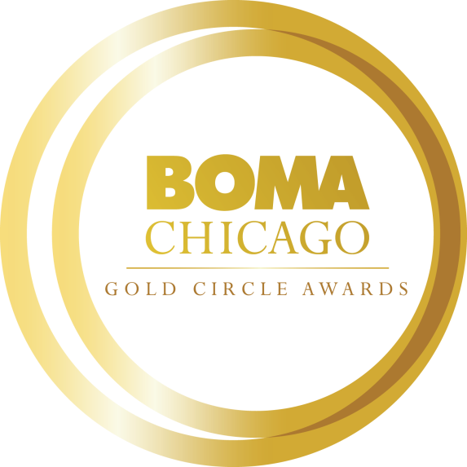

**2023 Property Management Professional of the Year**

**Gold Circle Award Application**

**Online Application Process**

All Gold Circle Award nomination applications must be submitted electronically to BOMA/Chicago by Friday, October 28. Each Building Member and Affiliate Member may submit one nomination for this award category.

[**CLICK HERE TO ACCESS THE PROPERTY MANAGEMENT PROFESSIONAL OF THE YEAR ONLINE APPLICATION**](https://bomachicago.wufoo.com/forms/z5mf5ho1yo87nr/)

We encourage you to complete the application in this Word document before submitting the application online. When you submit your application online, word count limitations will be strictly enforced. All attachments (photos, PDFs, etc.) can be uploaded to the online form.

**Objective**

This award is dedicated to honoring excellence in property management and service to the commercial real estate industry. It’s open to all property management professionals charged with managing the day-to-day operations and maintenance of BOMA/Chicago member buildings.

**Nominator Information:**

Name:

Title:

Company:

Building:

Email Address:

Phone:

How are you affiliated with the nominee? Please describe in 100 words or less.

**Nominee Information:** *(You may contact the nominee for assistance in completing the following information.)*

Name:

Title:

Company:

Building:

Email Address:

Phone:

Total Years in Commercial Real Estate Industry (please provide years only):

**Please provide the nominee’s (1) professional bio or resume and (2) headshot.**

**Nominee Building Information**  
Building Size: Building Age:

Property Management Staff Size: Number of Tenants:

**Short Answer Questions: Please limit your response to no more than 500 words each.**

1. Please provide an overview of the nominee’s involvement in the Commercial Real Estate Industry and Chicagoland community during the past two years (e.g., BOMA/Chicago, IREM, NAOIP, CoreNet, civic, community, and/or philanthropic, etc.)
2. How has the nominee achieved exceptional results in building operations? Please provide specific examples/initiatives implemented during the past two years, as well as statistical or anecdotal examples (e.g., special projects, renovations, etc.)
3. How has the nominee achieved outstanding results in sustainability and increased building efficiency efforts (e.g. building retro-commissioning, LEED Certification, Energy Star, Green Office Challenge, etc.)?
4. How has the nominee achieved tenant satisfaction at the building he/she manages? Provide examples of tenant retention programs, building specific services and programs, and tenant engagement initiatives (sharing results/outcomes to illustrate increased tenant satisfaction/improvement over time is encouraged).
5. What professional accomplishments has the nominee achieved during the past two years? Please provide details about obstacles or challenges the nominee faced and the successful end result.
6. How has the nominee demonstrated strength in team development and commitment to staff? Provide examples of situations where the nominee has shown strong team leadership.
7. Has the nominee participated in the TOBY Award application process and/or been part of a peer review effort? If yes, describe participation and outcomes.

**Letters of Recommendation**

Please provide one letter of recommendation from the two following possible sources:

1. Senior Industry Leader (e.g., BOMA/Chicago Committee Chair) who can attest to the nominee’s service to commercial real estate industry
2. Building Owner

The recommendation letter should outline why this nominee should be considered for the Property Manager of the Year Award.

**Please confirm all nomination materials have been completed/collected before submitting:**

* Nomination Form
* Bio *or* Resume
* Headshot
* Letter of Recommendation