2022 Ligonier Valley Chamber of Commerce Ornament
Get yours now!
Ligonier Valley Chamber of Commerce Office
Town Hall
Monday – Friday 9 a.m. to 4 p.m. daily.
LIMITED QUANTITIES – only $20 each
$26 includes S&H to mail
A perfect Gift!
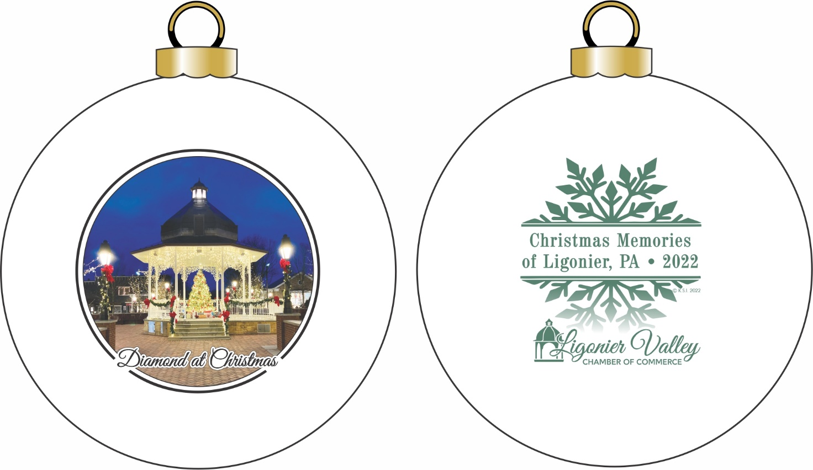

Our goal is to create a unique series of tree ornaments that depict a new theme each year. By doing so, we intend to preserve a different aspect of our town. This year's "Limited Edition" ornament is now available!

Collect the entire series for your children, give them to your employees, or simply collect them for your own enjoyment. These beautiful ornaments are also the perfect gift for friends or family that have moved out of the area. These ornaments are sure to become a cherished keepsake and heirloom. Since they are being produced in a limited quantity, they will be sold on a first come, first serve basis.

